GGE5083

Hydrographic Field Operations

St Andrews Harbour & Passamaquoddy Bay
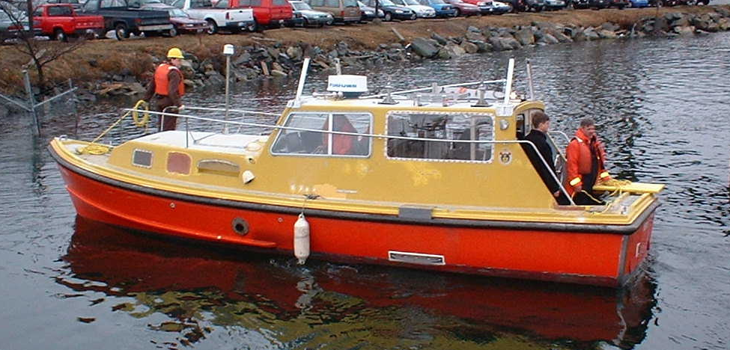29th April – 10th May 2002

Multibeam survey of St Andrews Harbour, approaches and behind Navy Island
- Sidescan survey of St Andrews Harbour
- Subbottom survey of St Andrews Harbour

Report Compiled by: Andreas Adam, Alice Gillam, Kevin Gray, Meredith Hutchison, Claudia Lübke
CONTENTS

1. Introduction
2. Equipment
2.1 Simrad EM3000S Multibeam
2.2 Knudsen 320B/P Sidescan & Knudsen 320M Singlebeam
2.3 RDI ADCP
3. Positioning
3.1 GPS Positioning
3.2 Vertical Control
4. Survey Planning
4.1 Tidal Predictions
4.2 Survey Line planning for multibeam, single beam and subbottom
5. Field Operations: Planning and Products
5.1 Simrad EM3000S Multibeam
5.2 Knudsen 320 B/P Sidescan
5.3 Knudsen 320M Singlebeam
5.4 Data Management
6. Final Products
6.1 Post Processing & Final Map Production
6.2 CARIS Products

References

Acknowledgements

Appendices
A. Processing Manual for producing Final Products
B. Heron Log Sheets
C. Log Sheet for GGE5083 Hydrographic Field Operations

1. INTRODUCTION

The principal area of interest for GGE5083 Hydrographic Field Operations 2002 was St. Andrews Harbour, New Brunswick. The approaches to the harbour and limited deeper water of Passamaquoddy Bay were also included in the multibeam survey only. This area is situated in the North West of the Bay of Fundy (see figure 1.1 below).

The harbour is very shallow, with depth ranges from –3.3m to +2m above chart datum. There is also a very significant intertidal influence. The tide in Passamaquoddy Bay is semidiurnal with a maximum amplitude of approximately 8 metres at spring tide. The main purpose of the project was to familiarize students with several components of a hydrographic survey such as data collection, data processing and error handling.

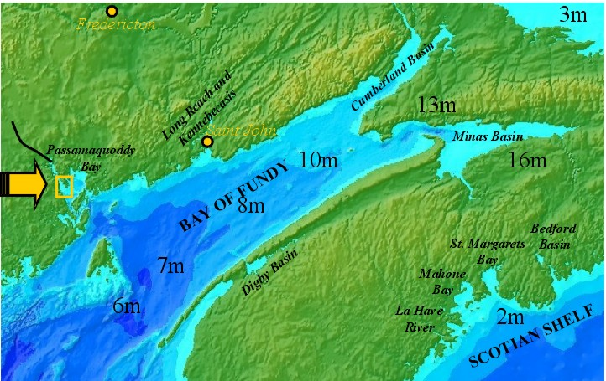
Figure 1.1: The location of the survey, Passamaquoddy Bay, New Brunswick

Although this survey is principally for training purposes the collected data will be used for several applications. The harbour of St. Andrews is a very attractive destination for boaters and other tourists within the summer months. Therefore it is of common interest to update the harbour seafloor to ensure accurate navigational information, especially in an area of such variable water depth and tidal currents. The strong currents in the area result in erosion and could cause the movement of subsurface objects. The final products of survey will also be provided to the City of St Andrews to support future decisions that are related to the harbour, such as dredging and the building of new docks.

The task of the survey was to collect, analyze and process data of a multibeam, a single beam (3.5kHz subbottom profiler), a sidescan and an ADCP system within the harbour. Any additional multibeam data that could be gathered in the deeper waters of Passamaquoddy Bay would also be included. Figure 1.2 shows previous recorded bathymetric multibeam data within the area. But a closer look displays that a lot of this data is very noisy and represents the bathymetry only with a very low resolution. Our first concept for the survey was to fill the gaps of the chart but because of the low quality data, we decided to plan an independent survey with the main emphasis on the harbour. This data will later be used as part of a larger regional survey of the entire Passamaquoddy Bay area.
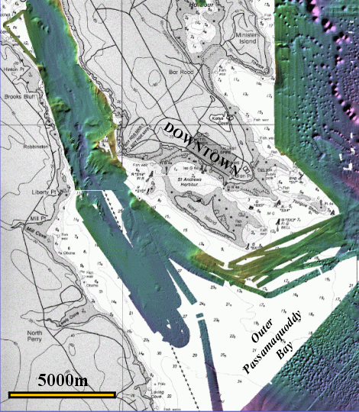
Fig 1.2 Previous surveys in the St Andrews Harbour & Passamaquoddy Bay area

As can be seen in figure 1.3 the harbour is very shallow, making data collection especially with the multibeam only efficient and reasonable at high water. All hydrographic sensor systems were installed on the boat “Heron”, which is being leased from the Canadian Hydrographic Service (CHS). The Heron was docked at the governmental wharf of the Huntsman Marine Science Center in Brandy Cove, St. Andrews. The Huntsman also provided the computer lab for analyzing and processing the data. The field survey was scheduled for 12 days of operation (April 29 – May10, 2002). An additional week was given for processing and production of final reports and products.
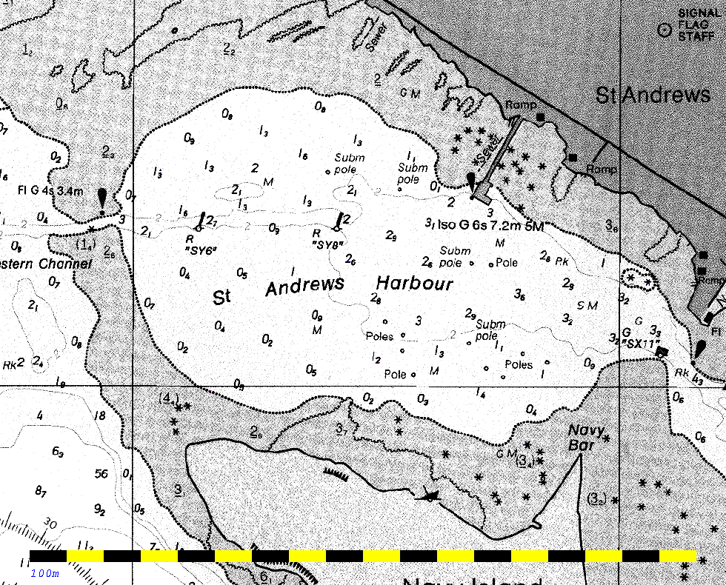
Figure 1.3 St Andrews Harbour. Soundings are in metres above chart datum.

Due to this relatively short time period for a very large area, additional cleaning and processing of the data is still required after the 3-week period. The Ocean and Mapping Group (OMG) will complete further data analysis and processing for future applications.

2.1 SIMRAD EM3000S MULTIBEAM

The EM3000S system consists of:

- an operator station (Sun Ultra 5) which controls the sonar head, and does beam forming and bottom detection.
- processing unit
- sonar head (mills cross, hull mounted)

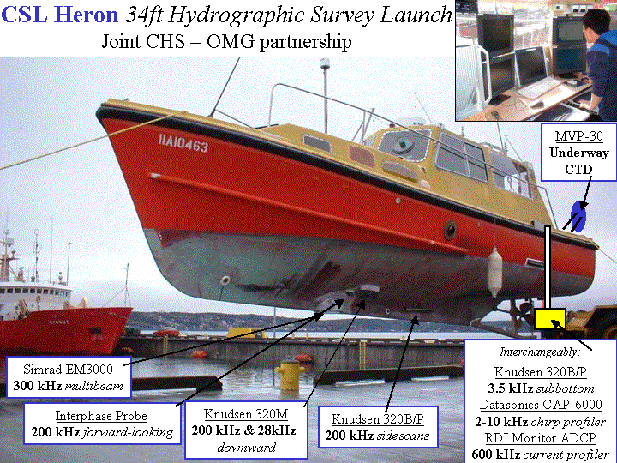
Figure 2.1Heron Equipment Layout

Other equipment needed:
- Motion and heading sensor (SeaPath)
- Positioning system (Landstar, giving differential GPS)
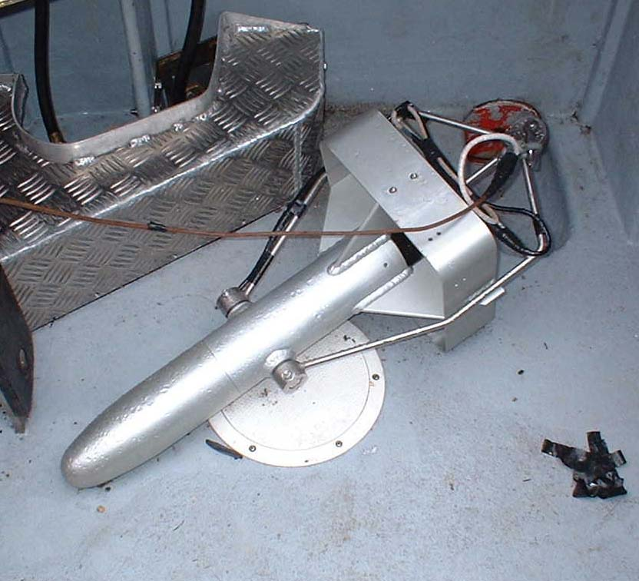
- 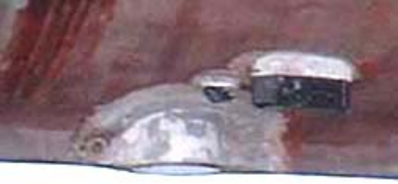Sound velocity profiler (SVP–16): on average during a whole day of surveying we would take an SVP profile before starting, then one every 3-4 hours. The data was uploaded by a laptop, and then downloaded to the Sun Ultra 5.
Figure 2.2 ADCP Profiler Figure 2.3 Multibeam Transducer head
The Sensor:
- Mills cross, two orthogonal line arrays
- frequency: 300kHz
- beam no.: 127
- min-max depth: 0.5-150m
- pulse width: from 0.05 to 0.2 ms, set by the user, and receive bandwidths of 4 to 8kHz
- beamwidth:
  - transmit: 1.5° along track, and 120° across track,

  - receive: 30° along track and 1.5° across track, total effective beamwidth : 1.5 x 1.5°
  - the beamwidths grow with the secant of the relative transducer steering angle (1.5°/cos[steering angle]), where at 60° from the vertical would produce a beam width of 3°, whereas at nadir, the beamwidth would be1.5°.
- pulse length: 0.15ms, or to 0.2ms to extend range. Can also go shorter, to increase resolution near normal incidence, at the expense of accuracy and range of outer beams.
- beam spacing: increases angularly away from broadside with the secant of the beam steering angle (0.9°/cos[steering angle]), i.e. neither equiangular or equidistant. At nadir beam spacing is 0.9°, and at 60°, the spacing is 1.8° apart.
- pitch stabilised
- not roll stabilised, however in calm conditions where there is less than 5° of roll, the beam sector is 130°, however if there is greater than 5° of roll, a sector of 120° is used instead.
- ping rates: up to 25Hz

Measurements made after installation:
- horizontal and vertical position of EM sonar head on boat
- horizontal and vertical position of motion and heading sensors (mounted on top of EM sonar)
- horizontal and vertical position of positioning system (GPS or radio antenna)
- angular orientation of sonar head

Products:
- bathymetry/topography of harbor and surrounding areas
- backscatter of harbor and surrounding areas (ocean bottom type)

2.2 Knudsen 320M Sidescan and 320 BP single beam
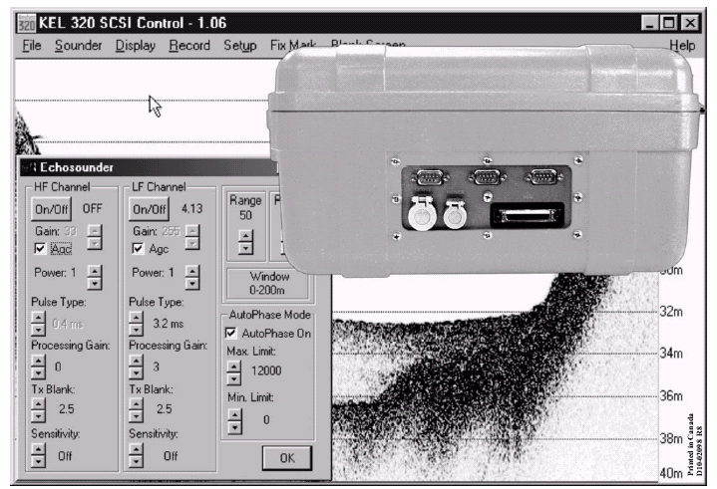
Figure 2.4 Knudsen Display and back of a 320M/P
Knudsen 320M Singlebeams:
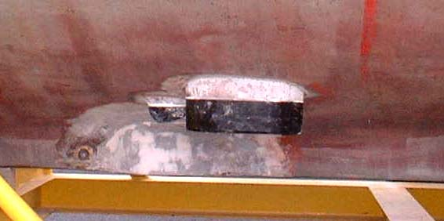
28kHz single beam
- hull mounted
- transmit pulse is CW and 0.1ms
- some subbottom surface penetration, depending on surface type.
Figure 2.5 Singlebeam Transducer

Settings we used for surveying the harbour:
Gain: 47
Power: 8
Pulse: 0.1

Purpose of harbour survey using 28 kHz single beam: to accurately
map / define the harbour bottom, and to compare subbottom penetration
to the 3.5 kHz single beam.

3.5 kHz single beam
- subbottom surface penetration 40-80m depending on surface type
- pulse is a 3ms chirp
- pole mounted on starboard

Settings we used for surveying the harbour:
Gain: 255
Power: 4
Pulse: 3ms (chirp)

Purpose of the harbour survey using 3.5 kHz single beam: to map the subbottom, detecting surface boundaries and surface types.

Knudsen 320 B/P sidescans:
- 200kHz, 0.5deg port
- 200kHz, 0.5deg starboard
- 200kHz, 6deg downward
- hull mounted, starboard and port sides of bow
- swath: > 100m port and starboard
- frequency of transmit: 0.1ms
- resolution: 1cm for 0-100m, 1dm for 100-1000m, 1m for greater than 1000m
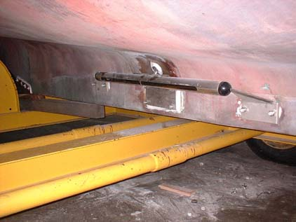
- annotation: date, time, GPS position
- gain: can be automatic, or manually set

settings we used for surveying the harbour:
- gain: 50
- power: 8
- range: 50
Figure 2.6 Sidescan Mounts
Purpose of using the sidescan: to detect the different surface types of the harbour, i.e. mud, gravel, sand etc.
2.3 RDI ACCOUSTIC DOPPLER CURRENT PROFILER

Principles of Operation

Acoustic Doppler Current Profiler (ADCP) is the international, common name for acoustic current measuring instruments, which employ the Doppler principle in order to measure the speed and direction of currents. ADCP was first built in 1984. Over the past decade, contemporary profilers have considerably expanded the ability to make detailed current measurements in challenging field applications. The technology employed can be described as follows. The functionality of ADCP is based on a physical theory called the Doppler shift. It states that whenever a source of sound is moving relative to the receiver, the frequency of the sound at the receiver is shifted from the transmit frequency.

F_{Doppler} = -2F_{Source}(V/C)

In this equation, F_{Source} is the frequency of the transmitted sound, V is the relative velocity between source and receiver, C is the speed of sound and F_{Doppler} is the change in the received frequency at the receiver (Doppler shift).

In case of ADCP, the instrument employs the transmission of high frequency acoustic signals in the water. By this means, the current can be determined by a Doppler shift in the backscatter echo from plankton, suspended sediment, and bubbles, all assumed to be moving with the mean speed of the water. Furthermore, time gating circuitry is employed, which uses differences in acoustic travel time in order to divide the water column into range intervals. Range interval determinations allow the development of a profile of current speed and direction over the entire water column. ADCP’s are deployed from a moving vessel, tow, buoy, or bottom platform. In the latter configuration, it is unobtrusive in the water column. Consequently, it is possible to deploy it in shipping channels, for example.

Main external components are a transducer assembly and a pressure case. In general, the transducer assembly comprises four transducers operating at a fixed, ultrasonic frequency, typically 300, 600, or 1200 kHz. Three of these acoustic beams are used in different directions for measuring the three velocity components, and the fourth beam adds redundancy as well as an error estimate. Lower frequencies give longer ranges, while higher frequencies give shorter ranges with higher resolution. Accordingly, the frequency used depends on the application. Transducers are horizontally spaced 90 degrees apart on the transducer assembly. All of them have the same fixed angle from the vertical, which is referred to as a beam angle (typically 20 or 30 degrees). A transducer assembly may have a convex or concave design. The pressure case, which is attached to the transducer assembly, contains most of the instruments’ electronics.

From each of the four transducers, the ADCP transmits pairs of short acoustic pulses (pings) along a narrow beam. As the pulses travel through the water column, they strike suspended sediment and organic particles referred to as scatterers. These materials reflect some of the acoustic energy back to the ADCP. Consequently, the reflected pulses will be received and recorded. Echoes from shallow depths arrive sooner than those ones from greater ranges. Therefore, profiles are produced by range-gating the echo signal, which means that the reflected pulses are separated by time differences into successive, uniformly spaced volumes called depth cells or bins. These depth cells correspond to successively deeper depth ranges. The Doppler shift, also called frequency shift, as well as the time-lag change between successive reflected pulses are proportional to the velocity of the scatterers relative to the instrument. As a result, a velocity component along each beam is computed. As the beams are positioned orthogonally to one another and at a known angle from vertical, which is usually 20 or 30 degrees, the trigonometric relations are used to compute three-dimensional water velocity vectors for each depth cells. Thus, the ADCP produces vertical velocity profiles composed of water speeds and directions at regularly spaced intervals.

There are some operational limitations of an ADCP, which directly influence the quality of measurements. One of these limitations is the inability to collect data from all the areas of a body of water. Immeasurable areas include top, bottom and side or edge subsections. The inability of an ADCP to collect data from the top (down looking ADCP) or bottom (up looking ADCP) subsection is the result of transducer draft, blanking distance and lag. Transducer draft refers to the fact that ADCPs’ cannot measure the portion of the water column above respectively below the transducers. Blank distance, which is the distance from the transducer to the first cell, refers to a zone directly below respectively above the transducers in which echoes cannot be received by the transducers because of their physical properties. Lag is the distance between successive portions of the pings transmitted by an ADCP. An additional cause of loosing data is the contamination of the near-surface data by side-lobe echoes (side-lob energy from each of the four acoustic beams). This side-lobe interference results from striking back of the bottom by side-lob energy from each of the four acoustic beams. The reflections of the side-lob energy from the bottom are strong and overwhelm echoes from scatterers near the bottom. By using current profilers looking up toward the surface, the small signals that travel straight to the surface can produce sufficient echo to contaminate the signal from the water. This is based on the fact that sound reflects much better from the water surface than it does from the water. Another immeasurable area is the edge subsection. In many instances, depths, e.g. near river edges, are too shallow for an ADCP to measure. On top of that, by using a hull-mounted ADCP, the signal will often strike vertical banks and return a false bottom echo, which leads to wrong estimations, assuming lower depths near the bank than there actually are.

The Acoustic Doppler Current Profiler offers a very popular possibility to determine currents in shallow and deep water. This solid-state sensor provides a high definition of wave direction and resolves waves arriving from several sources. It can be used for many applications in Oceans and Coasts, Navigation, Ports and Harbors, Water Resources, etcetera. Among other things ADCP’s are used to determine tidal streams in a current observation.

2.32 RDI ADCP 600kHz

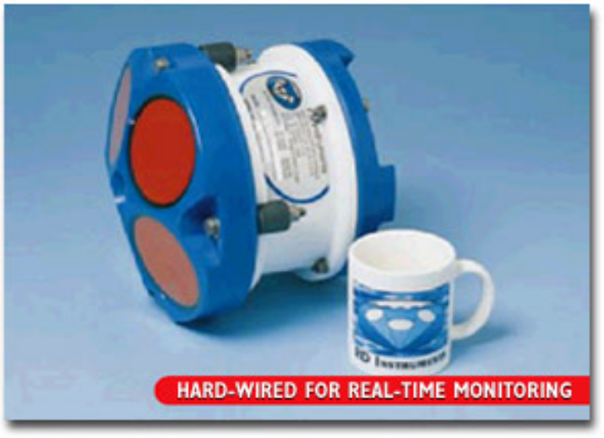

Figure 2.7 RDI ADCP 600kHz

As mentioned before ADCP’s are used to estimate water current profiles in real time. Generally these instruments are very expensive and should be handled with care. The provided Acoustic Doppler Current Profiler for Hydrocamp 2002 is an RD Instruments ADCP 600kHz that can be mounted on the port side of the vessel Heron. This transducer is designed for ranges up to 30 meter and represents the actual current within a very high accuracy (up to 20mm/s). It includes 4 beams that are mounted 20 degrees from the vertical. Table 2.1 represents the instrumental characteristics.

Frequency | 600kHz
Bandwidth | 150 kHz
Configuration | 4-beam, convex
Beam angle | 20 degree
Number of depth cells | 1 to 128
Velocity range (max) | +/- 20 m/s
Accuracy (dependend on chosed depth cell size) | up to 20 mm/s
Table 2.1 Specifications RDI ADCP 600kHz

Several sensors are integrated within the system to estimate an accurate current profile. Included sensors are a Temperature Sensor, an Up/Down Sensor, Heading sensor (Compass), an Attitude Sensor, and optional a pressure sensor. Specifications are given in Table 2.2. These tools give the ADCP the ability to estimate additional informations like orientation. Even so it is usual, especially by using hull mounted instruments, to integrate other external sensor like a motion sensor beside the ADCP to increase the accuracy of the estimated current.

Temperature
Range | -5 – 45 degree C
Uncertainty | 0.4 degree C

Tilt
Range | 15 degree
Uncertainty | 2 degree

Compass
Type | Flux gate
Uncertainty | 5 degree at 60 degree magnetic dip angle
Max tilt | 20 degree
Water Level (optional)
Type | Strain gauge
Range | 0 to 256 meter
Accuracy | 5 m over 0-200 meter depth
Resolution | 0.25 meter

Table 2.2 Specifications of attached sensors

Generally the instrument is controlled by a software package that works as an interface between user and instrument. Basical steps of the use of an ADCP are installation of the sensor, data collection and data management. To set up the hardware the transducer has to be connected to a computer and a power supply. Figure 2.8 shows the required connections. The configuration of the system has to be done by using the provided RDI software or appropriated programs. For more information see RDI Instruments ADCP Manual. After the ADCP is configured and optimized for its specific application it is ready for data collection. Most ADCP packages like WinRiver include data collection utilities as well as data management tools.

References
http://www.frf.usace.army.mil/capefear/adcp.stm.
http://martech.ocean.washington.edu/science_info/adcp.html.
http://www.nortekusa.com/prin-dop.html. http://il.water.usgs.gov/adcp/reports/morlockreport.pdf.
http://www.sontek.com/princop/adp/adppo.htm.
http://www.jodc.jhd.go.jp/goin/adcp/what-adcp.html.
http://co-ops.nos.noaa.gov/glossary/gloss_a.html#ADCP.
Warren D. Forrester, Ph. D. (1983) “Canadian Tidal Manual”

Department of Fisheries and Oceans, Canadian Hydrographic Service, Ottawa, Ont. 1983
pp. 113-124.

3.1 GPS POSITIONING
RTK GPS was utilized to bring horizontal and vertical control to the Heron launch. Code differential GPS was used as a backup to the RTK system. The backup system was utilized much more than was originally planned due to antenna problems with the main RTK system.
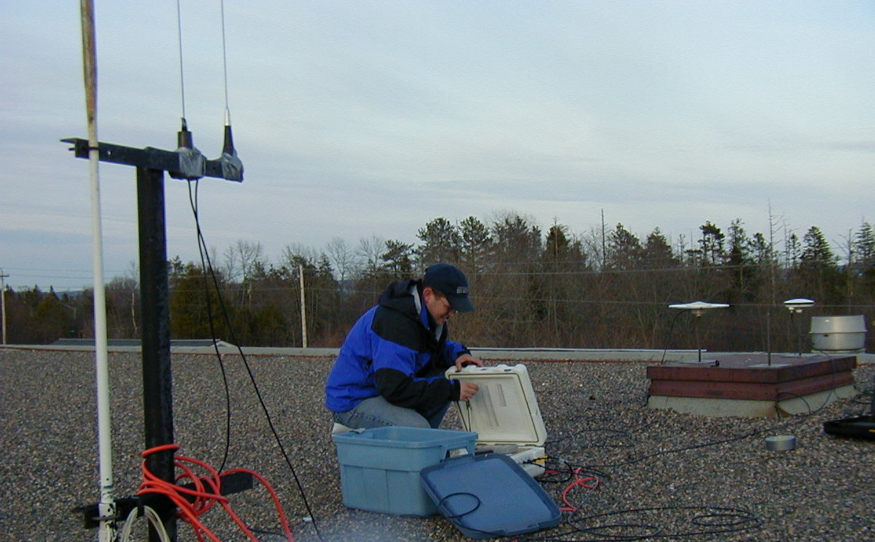Figure 3.1 - RTK Base Station - NBCC Saint Andrews
Three threaded iron rods were permanently attached to the Saint Andrews Community College roof (Figure 3.1). The tops of these iron rods were then coordinated using Trimble GPS receivers. A static baseline method was used by occupying the stations on the rooftop simultaneously with a setup on a High Precision Network (HPN) point in Oak Bay. This HPN point was established and maintained by Geomatics Canada. The Oak Bay HPN station is approximately 16 kilometres from the NBCC, which translated into a minimum two-hour occupation.

These threaded iron bars, once positioned, were the points that the survey was based upon. Two separate RTK base stations were placed atop the NBCC roof. The Ashtech system (figure 3.2) consisted of a receiver, power supply, transmitter, and antennas for the receiver and transmitter. The intention of this system was for it to be used as a method to verify the data being gathered by the SeaPath system. The SeaPath base station is an all in one system, the main unit acting as both a receiver and a transmitter. There are also few options to configure on the SeaRef base station making it a very low maintenance system. The SeaRef base station setup is similar to the Ashtech setup in figure 2.

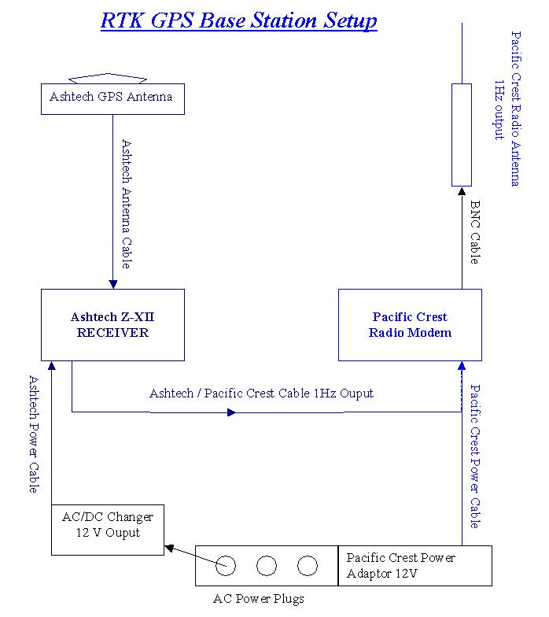
Figure 3.1 RTK Ashtech Base Station [GGE5083, 2001]

The Ashtech GPS antenna of the roving unit (figure 3.3) was set up on the forward starboard roof mount atop the Heron launch. The broadcasted corrections it received via the radio antenna were recorded on Heron 2 PC through a HyperTerminal. The SeaPath roving unit had two GPS antennas mounted on the fore and aft portside roof mounts. This enabled the system to not only provide horizontal and vertical positions but vessel heading as well.
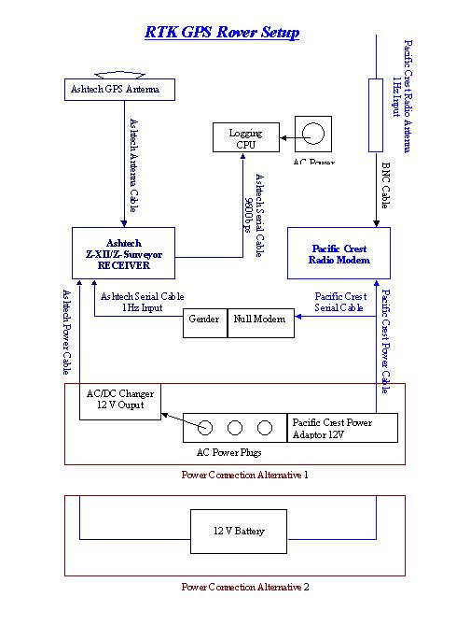
Figure 2.3 - Ashtech Rover Setup [GGE5083, 2001]
The broadcasted corrections that were of interest in the NMEA string were the GGA and the VTG codes. The GGA is the Global Positioning System Fix Data. The GGA string includes the following qualifiers:
$GPGGA,hhmmss.ss,llll.ll,a,yyyyy.yy,a,x,xx,x.x,x.x,M,x.x,M,x.x,xxxx*hh

- UTC of Position
- Latitude
- N or S
- Longitude
- E or W
- GPS quality indicator (0=invalid; 1=GPS fix; 2=Diff. GPS fix)
- Number of satellites in use [not those in view]
- Horizontal dilution of position (HDOP)
- Antenna altitude above/below mean sea level (geoid)
- Meters (Antenna height unit)
- Geoidal separation (Diff. between WGS-84 earth ellipsoid and mean sea level. geoid is below WGS-84 ellipsoid)
- Meters (Units of geoidal separation)
- Age in seconds since last update from diff. reference station
- Diff. reference station ID#
- Checksum

The VTG string is the actual track made good and speed over ground. The string is setup in a similar manner and includes the following information:

$GPVTG,t,T,,,s.ss,N,s.ss,K*hh

- Track made good
- Fixed text 'T' indicates that track made good is relative to true north
- Not used
- Not used
- Speed over ground in knots
- Fixed text 'N' indicates that speed over ground in knots
- Speed over ground in kilometers/hour
- Fixed text 'K' indicates that speed over ground is in kilometers/hour
- Checksum

Unfortunately due to antenna problems, the SeaPath system was only in full operation on May 10, the last day of field operations. Therefore the SimRad system utilized the DGPS positioning signal from the LandStar system. The Canadian Coast Guard also broadcasts a signal that was available to us. The LandStar and CCG systems require a roving unit only, for the CCG corrections are broadcast from a permanent base station in St. John and the LandStar corrections are broadcast from a geosynchronous satellite positioned over the United States.
Though the Ashtech Z12 and SeaPath receivers output elevations with reference to the ellipsoid and the tides are related to the chart datum. All the heights could be related to one another by transforming all in reference to the geoid. This was done in interest of calculating the dynamic draft of the vessel.
Data from May 10 was selected due to the fact that it was the only day where there was both SeaPath and Ashtech data collected simultaneously. A data set of 36 points was selected, one observation every five minutes. This interval was imposed by the tide gauge’s sampling rate. The resulting data is presented in figure 3.4.
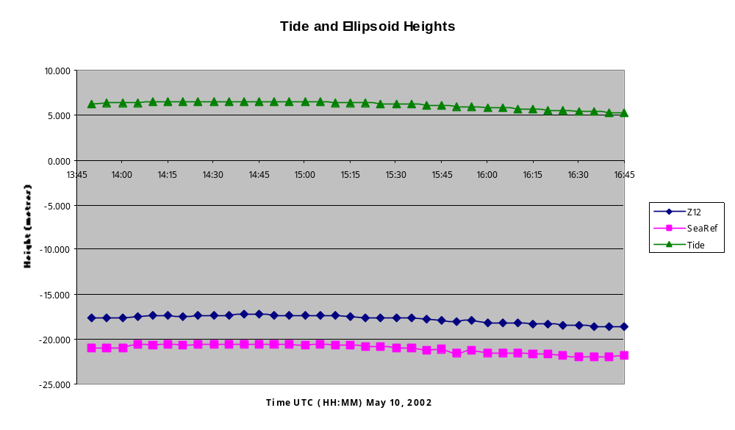Figure 3.3 - Ashtech, SeaPath and Tide Elevations
The geoid / ellipsoid separation for each point was calculated using the CGEOID2000 program. This software was developed by Natural Resources Canada. By entering a latitude and longitude for each point, a separation value is output unique to that position. For example, in Saint Andrews harbour the separation value varies by approximately eight centimetres from one end to the other.
The geoide / chart datum separation was taken from CHS monument sheets for control points in the Saint Andrews area. This separation was found to be 3.810m. By differencing the SeaPath ellipsoid heights (which were in relation to the transducer head) with the tide elevations, the dynamic draft of the vessel could be calculated (see figure 3.5).
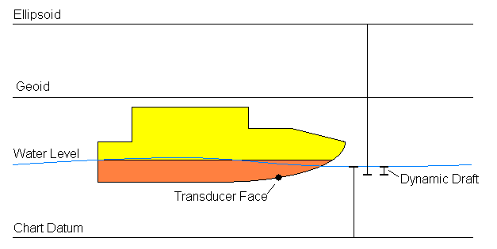Figure 3.4 Relating the Surfaces
The draft of the vessel was calculated for each five-minute interval fix. The draft varies with the vessels speed. The resulting draft calculations are represented visually in figure 6.

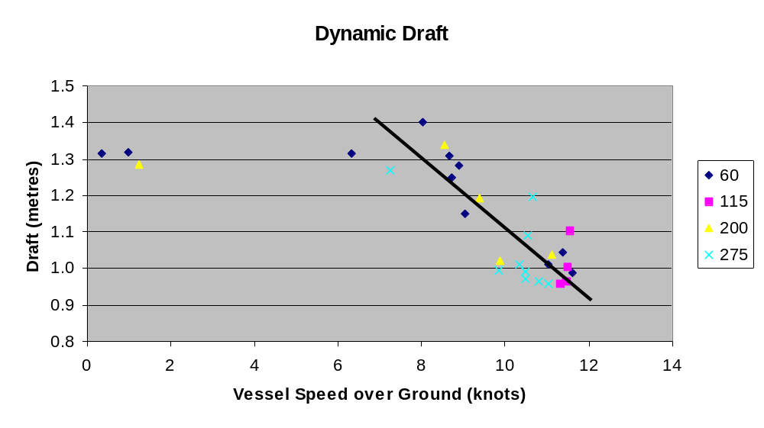Figure 3.5 Dynamic Draft Chart

As the figure 3.6 illustrates, the draft of the vessel decreases as the speed of the vessel increases. This is consistent with hull of the Heron. Unfortunately there were not more data points under six knots. From looking at this data, once the vessel speed reaches six knots the hull begins to lift. The typical cruising speed for the multibeam survey was in the range of 10-11 knots, which would led us to believe the draft to be entered into the SimRad system should be 0.995 – 1.000 metres.
There was also an attempted to calculate the draft manually by means of a bar-check. The bar check is a six foot length of steel that is suspended directly under the transducer by two graduated steel chains. The bar-check was successful 3.2 Vertical Positioning

Importance of vertical control
One of the most significant aspects of a hydrographic survey is estimating the vertical position. Even so that there are several other applications, the main goal of related projects is to provide final products that can be used as aids for navigation. Items like nautical charts or tidal tables give the user an idea how the water of interest looks like and which are the significant characteristics one has to take care about. Therefore hydrographic work increases the safety in navigation. Because of the fact that navigating in shallow water is far more critical than it is in deeper one, the required accuracy changes from region to region and is depth-dependent.

The IHO (International Hydrographic Office) has developed a couple of standard specifications that has to be achieved to collect acceptable data for particular requests. It is very difficult to define reliable depth information. Factors like tide or wind changes the shape and depth of a body of water almost every second. As a result the collected data of a survey only represents the water depths at a specific time. To solve this problem all data has to be referred to a standard reference surface, or datum. Generally the standard chart datum defines the surface below which the water level will seldom fall, so that the represented depth is the minimum depth one can expect in an area. In Canada chart datum represents LLWLT (Lower Low Water, Large Tide), which can be explained as an average of the lowest low waters, one from each of 19 years of predictions.

During the survey the actual height of the water with respect to chart datum has to be permanently detected to be able to reduce the soundings to the reference surface. Usually a temporary tide gauge, which is installed within the area of interest, is used to record the water level information. For reliability and safety purposes it is a good procedure to install two tide gauges or at least to compare the detected tide with the predicted one that can be obtained by using the internet, tide tables or by ordering tidal predictions at hydrographic services (e. g. CHS (Canadian Hydrographic Service)).

An alternative solution of the vertical position estimation is RTK (Real Time Kinematic). This GPS (Global Positioning System) system provides accuracy within one centimeter. Here, the reference surface is an ellipsoid (WGS-84) so that the recorded information has to be reduced to chart datum. So it is a very gentle and very accurate method that eliminates several inaccuracies of tidal, draft or heave detection for example. The disadvantage of RTK is its limitation for offshore surveys (today it can only be realized in onshore areas) and its sensibility (very unstable). It also depends on the actual satellite constellation, so that there can be time gaps where RTK isn’t achievable.

Fundamentals
St. Andrews Harbour can be characterized as a very shallow area with a great tidal activity of up to 8 meter. Therefore navigating within this area can be very critical. As a result the necessary vertical accuracy of our survey is being defined as IHO Special Order. This standard allows only an inaccuracy of estimated depths of 30 cm. Table 3.1 gives a precise overview of the requirements. I

Formula: d=(a2+(b*d)2)1/2 , a = 0.25m, b = 0.75%
Depth [m] | Accuracy [m]
5 | 0.25
10 | 0.26
15 | 0.27
20 | 0.29
Table 3.1 IHO Special Order Accuracies

To achieve the required precision we planned to use a floating tide gauge, which provides the actual depth with an accuracy of 1 millimeter. For reliability purposes a pressure gauge was also installed. Unfortunately the provided pressure sensor was damaged so that we couldn’t use it for check purposes. Consequently we expected to compare the RTK solutions with the tide gauge results to control the correctness of the estimated depths (for detailed information see GPS Positioning).
Float Tide Gauge
Theory
The float gauge is a very precise and reliable sensor that detects the actual water depths by direct measurements. Hence, no calibration over its range of operation is being needed although its zero adjustment must be regularly monitored. Its requirement for accurate operation is a rigid stilling well which can really be a problem at some locations. A typical installation is shown in Figure 3.6. The stilling well is attached to a pole of a wharf by well clamps. The goal of this vertical enclosure with limited access to the outside water is to damp out the rapid vertical oscillation of the water surface and to prevent that the suspension cable slips over or jumps off the pulley wheel. The dog house protects the sensor and the receiver unit against the weather and interference from curious passers by. The sensor itself works in a way that the float transmits the water level information to the sensor by a thin cable which is attached at one end of the float, passes over the pulley wheel of the sensor and is attached at the other end to a counterweight. The depth information then is send from the sensor to the receiver where it is stored in a digital format.

Dog House
Wharf
Well Clamps
Stilling Well
Sensor
Weight
Float
Receiver
Figure 3.6Tide Gauge Installation
Water Level

Installation and Setup
Location decision
Before we could actually install the tide gauge we had to decide where the optimal locality for the instrument is. Requirements for a preferred place are nearby the survey area, an almost vertical construction (can easily be checked by holding a plumb close to the pole) like a pole to attach the stilling well and a possibility to set up the doghouse. Additional it is very important to check if the location does not get dry at LLW (Lower Low Water), which is the lowest tide in a month. Predicted tidal information can be used to control the last condition. With respect to the mentioned factors we decided to choose 3 crossbeams that were attached to the poles of the public wharf of St. Andrews Harbour as the tide gauge installation locality. Because of the fact that the fixation of the well to the crossbeams has to be very robust and that the movement of the well has to be minimized, we decided to install the well at lower low water to have maximum access to the crossbeams.

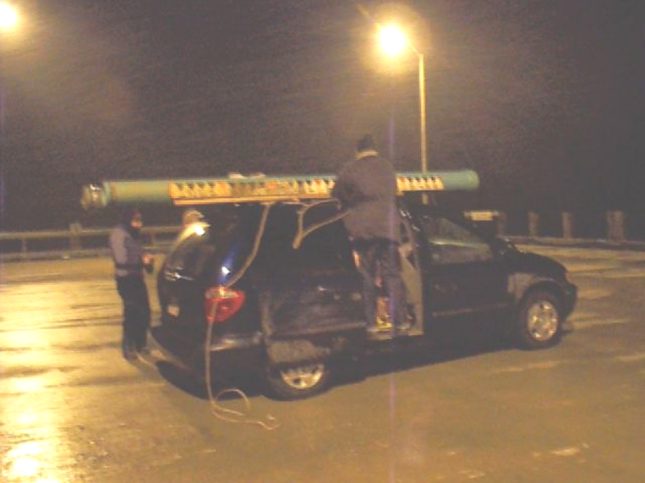
Figure 3.7 Arrival at St. Andrews Harbour public wharf

Hardware Installation
First step of installation was the attachment of the stilling well to the construction. After arriving at the wharf we put the 3 pieces of the well together and bolted screws into the well at the connection points to increase the stability. The screws has to be very short to prevent the float, the weight or the suspension tape to get caught with them. To join the well and the crossbeams we used well clamps (metal strips). Additional wooden constructions were built around the well on each crossbeam to enforce the connection. While attaching the clamps a plumb was used to control the vertical mounting of the well. Next step of installation was the stabilized buildup of the dog house. We built a wooden platform to increase the solidity and screwed the house on it. Now the technical hardware had to be installed. The sensor was screwed on a wooden construction so that the wheel was exact in the horizontal center of the stilling well. Then the suspension tape had to be lengthened with respect to the expected tide and the position of the wheel above high water. While attaching the tape to the float and the counter weight it has to be handled with care since it easily snaps when it is kinked. When the suspension tape was applied to the sensor wheel, the sensor was connected to the receiver that was positioned right beside the instrument. Electricity for the sensor and the receiver unit was supplied by using one of the wharf power sockets. Figure 3.8 shows the final constellation inside the dog house.

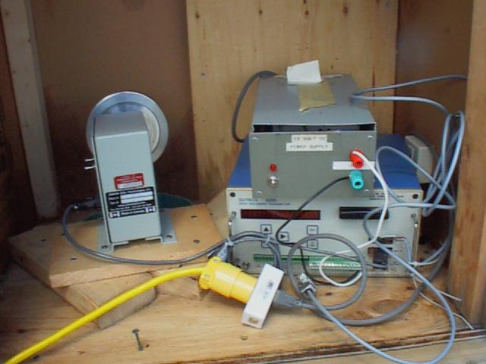
Power supply
Receiver
Stilling well
Float gauge
Adapter
Figure 3.8 Tide gauge configuration

Setting up the system
There are two important things that have to be estimated before the actual setup can be started. The first is the scale parameter of the used wheel. It is necessary to know or to estimate the relation between rotation and water level height. Often the manufacturer provides the scale of the wheel. If not the scale can be estimated by relating manual readings of the water level change (e.g. on a staff gauge) to the water level readings of the gauge. In our case the scale of the used wheel were given by the manufacturer so that a calibration was not essential. Even so it is recommended to control the given scale to other water level detection sources like staff gauges or RTK measurements. We checked the correctness of the scale by comparing the tidal measurements of the gauge to manual water level readings that has been done besides the gauge. The other very important aspect is the instrumental offset. The tidal readings have to be referred to chart datum so that it is mandatory to set the actual tidal reading to chart datum. In St. Andrews Harbour the CHS provides a couple of benchmarks (BM) whose elevation with respect to chart datum has already been determined. We established 3 points on the wharf and verified their elevations by leveling them in. For redundancy purposes we based our leveling on two BM’s. The final locality and height above chart datum of the new points can be seen in Appendix 1-A. To set the tide gauge readings to chart datum the offset of the sensor has to be set to the offset that is manually measured (can be done by using a measuring tape and measuring the vertical distance from the point to the water level) from one of the established points. In doing so one has to take care about the synchronized reading and entering of the offset. When this has been done, the tide gauge is ready to record true water level readings of chart datum (For detailed explanations of setting up the system see Sutron 8200 – Setup).

Data download and processing
The recorded tidal data has to be downloaded from the provided Receiver Sutron 8200 by using an external device, usually a laptop (For detailed information see Sutron 8200 – Download data). To make sure that the actual tide is really continuously recorded we downloaded the data each day. The created file is usually in ASCII format. Its structure is:

Header
Date (YYYY/MM/DD) Time (HH:MM:SS) Height
…

Accordingly it can easily be analyzed by using Microsoft Excel or other similar software. But the main aspect of collecting the tidal data is its use for reducing the soundings. To make this file utilizable for the JHC software several changes have to be made. The software expects a specific data structure that can be described as:

JulianDay Hour Minute Height
…

We used Microsoft Excel to make the changes in the original file. Once the new file is saved as an ASCII file it has to be converted into a binary one. Using the JHC software command binTide can easily do this. The command structure is:

binTide Input (ASCII-File) Output (Bin-File)
Now the used JHC software can import the Bin-File.

Sutron 8200 – Data Recorder and Transmitter

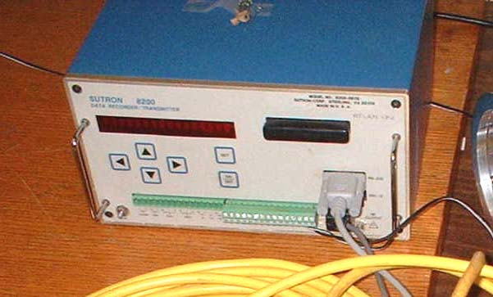

Figure 3.9 Sutron 8200 Receiver

Handling and Operation

Communication
The two common ways to setup the Sutron 8200 are the use of the Front Panel and the use of an external PC. Others are the integration of a Ram Memory Card on which the setup parameters can be saved and the utilization of a Remote PC that provides a system to set up the receiver by using a telephone and LOS modems.

Front Panel
The 6 keys built in the Front Panel can be used to enter the setup information for the recorder and the enabled sensors. It also provides a way to go through the Menu tree for several modifications.
Set
ON
OFF
Display
Ram Card Socket
Serial I/O port
SDI-12 I/O port
Keypad
Terminal Strips
Figure 3.10 Sutron 8200 – Front Panel

Main items of the front panel
Display: Shows messages to set up and walk through the system.

Keypad: Buttons: On/Off - Turns the receiver on and off
Up/Down - Changes the active Item within one layer.
Right - One Layer down within the hierarchy.
Left - One Layer up within the hierarchy.

Terminal Strip: Provides an interface for several external sensors and devices and an external power supply.

Ram Card Socket: Support of PCMCIA cards that can be used to store little programs, setups or data.

Serial I/O Port: Port to connect an external device like a laptop.

SDI-12 I/O Port: Port to connect SDI-devices.

Front Panel Main Menu Tree

Sutron8210 xxxx
UnitID
Date
Time
Recording
Alarm
VIEW DATA => LIVE READINGS
=> NEWEST READINGS
=> OLDEST READINGS
SYSTEM SETUP => MEASUREMENT SCHEDULE
=> ENABLE SENSORS
=> CONFIG SENSORS
=> ALARM OPTIONS
DUMP DATA
EEROM SETUP
PROTOCOL SETUP
MODEM SETUP
GOES
INSPECT SYSTEM

External Link
An external device like a Laptop can be connected to the receiver as a communication platform. Requirements are a serial port and a standard commercial communication package like PROCOMM.

PROCOMM
Start: DOS command line
ENTER ‘procomm’
The receiver is automatically detected and the Main Menu comes up.

If it doesn’t possible errors are:
Power supply – Make sure that the receiver gets power. Press the On/Off
button of the Front Panel. If the Display doesn’t come up, no
power is being provided.
Connection - Make sure that the receiver is connected to the COM port of the
Laptop.
Interface - The I/O interface of the receiver might be damaged.
Help: A Help Menu comes up by pressing Alt+F10

Software Main Menu Tree
All Main Menu Items are related to a letter, which can be seen in front of each item. By entering the related letter and pressing ENTER you are going downward within the Menu Tree. To going upward press ESC

UNIT NAME
SET DATE
SET TIME
RECORDING STATUS
CLEAR ALARM
VIEW SENSOR DATA
SYSTEM SETUP OPTIONS
UPLOAD/DOWNLOAD DATA
EEROM SETUP OPTIONS
PROTOCOL SETUP OPTIONS
MODEM SETUP OPTIONS
GOES RADIO SETUP
INSPECT SYSTEM
APPLICATION MENU
EXIT

System Setup
Steps of setting up the system are based on using an external device and the communication software PROCOMM. All configurations of the receiver and the attached sensors (tide gauge, pressure gauge, etc.) are done within the program.

Setting of Unit Name, Date, Time

Unit Name: Press ‘N’ to bring the cursor into the unit name field that is being displayed. Enter the new name and press ENTER to lock the new name.

Date: Press ‘D’ to bring the cursor into the date field that is being displayed. Enter the new date in MM/DD/YY. Enter the first part and lock it by pressing ENTER. The cursor will automatically jump to the next part.

Time: Press ‘T’ to bring the cursor into the time field that is being displayed. Enter the hours and press ENTER to set the minutes. Press ENTER.

The time for all data collection systems has to be synchronized. Therefore it is reasonable to initialize UTC time.

Sensor Setup

Enable appropriate sensors
Press ‘S’ to go to System Setup Options. Then press ‘E’ to go to Enable Sensors. In the upcoming window enable all appropriated sensors as given in the Sutron 8200 Manual.
If required change the name of each sensor.

Configure and calibrate sensors
Press ‘S’ to go to System Setup Options. Then press ‘C’ to go to Configure Sensors. In the upcoming window select a sensor and change the configuration (Measure, Log, Average, Interval) and calibration (Value, Slope, Offset, Elevation, Right Digits) as required.

Measurement Setup
Press ‘S’ to go to System Setup Options. Then press ‘M’ to go to Measurement.
Schedules. In the upcoming window set the recording parameters (Interval, Time, etc.) as required.
Data Download
Steps of downloading the recorded data are based on using an external device and the communication software PROCOMM.

Step 1 Connect the receiver with the laptop and run PROCOMM
Step 2 Open a Log by using ‘ALT+F1’. Enter a file name and press ENTER (no more than 8 digits!!!).
Step 3 Press ‘U’ to go to Upload/Download Data.
Step 4 Press ‘D’ to change the required Start Date of the actual record file. Change start date of record as required; press ENTER.
Step 5 Press ‘S’ to send the recorded information to the serial port.
Step 6 Press ‘A’ for ASCII file or ENTER for binary file.
Step 7 Close Log by using ‘Alt+F1’.
Step 8 Exit by ESC; X; ALT+X (Return to DOS)

Notation: File is saved in Folder C:\

Now the data is saved in a file as named and can be used for tidal analysis as mentioned in the previous chapter.

Results and Conclusions

Experience report
As mentioned before the vertical control, especially on hydrographic surveys in areas with high tidal activities, is a very important requirement. Unfortunately, we had major problems with our vertical control. At the beginning of our survey we detected that the suspension tape of the float gauge snapped. A new tape had to be ordered from Quebec so that we could not get any data from the tide gauge before the fourth survey day. To prevent loosing three days of collecting data we had to find alternative vertical positioning control. One solution was the use of the RTK solutions. The difficulty here was that the signal between the base station and the rover station was not continuously and that the GPS system sometimes only provided DGPS solutions with decimeter accuracy. Consequently the data of GPS was not usable for most of the time. Even so we were able to filter the RTK data of our second survey day in a way that it made results with accuracy better than five centimeters available. On day number three, because of the unreliability of GPS we decided to read the tides manually every five minutes within the survey time. Finally on day number four we set up the tide gauge again and were able to record all tidal data by using the receiver. Since then, for the last days of survey the tide gauge provided very accurate and reliable water surface measurements.

Tide Gauge observation

As one can see in Figure 3.11, the estimated tidal heights above chart datum match very well with the predicted heights. There is an offset between predicted and real tide that changes every day and achieves a maximum of round about 10 centimeter. This inequality is a result of the influences of wind, currents or other environmental factors. By comparing the times of maximum tides one can identify an almost identical tidal stand, which shows that the tidal prediction is very accurate. The graph also shows that the data of the RTK as well as the manual readings and the tide gauge readings provides a very good continuous representation of the tide.

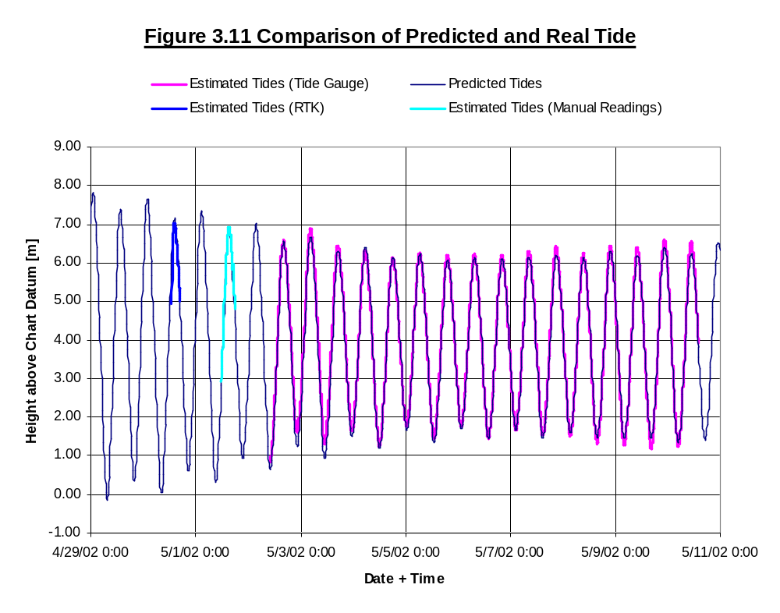
when calculating the draft of the single beam (found to be 40 cm) but attempts were unsuccessful in measuring the multibeam draft.

RTK Observation
Tidal Data for April 30th
As mentioned before we had no continuous tide gauge data available on April the 30th. Therefore the data of the Searef RTK solution had to be used for the vertical control. AS one can see in Figure 3.12 the original RTK data is relatively noise. It also shows a constant shift between 18:45 and 19:45. We assume that for this time the GPS solutions got worst so that for this time interval only DGPS solutions were achievable. To adjust this noisy data we first filtered out the outlier. To do so we estimated the fourth polynomial of the graph and set a misclosure vector. All records that were outside these boundaries are declared as outliers and were filtered out. Then the fourth polynomial was recomputed and the outlier hunt was started again but with a smaller misclosure vector. We repeated this steps until the misclosure vector became insignificant. The final adjusted trendline were used to compute the tidal information.

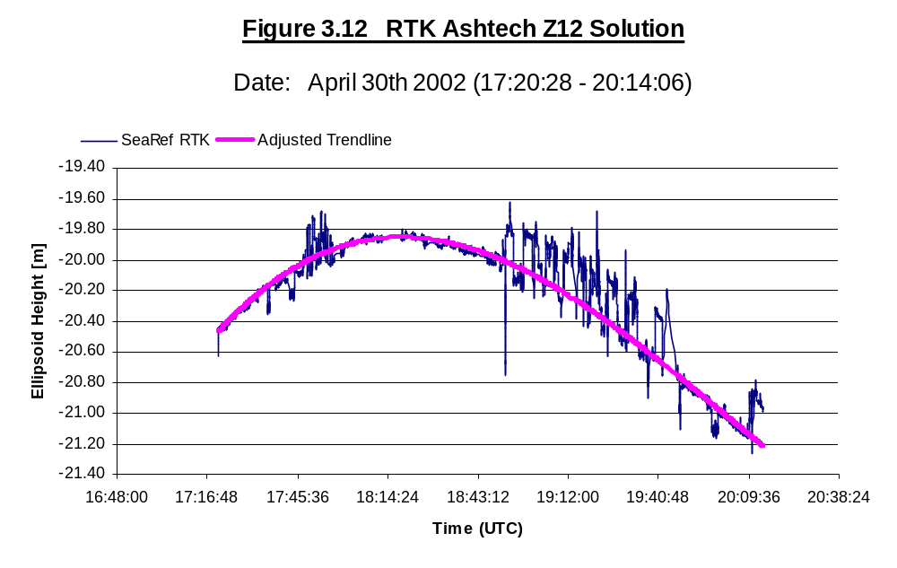
Tide Gauge and GPS data on May 10th
Figure 3.13 gives an overview of the different kinds of vertical observations. The SeaRef RTK provides the vertical height with respect to the WGS-84 ellipsoid while the Ashtech Z-12 RTK results reflects the geoid heights. Reason for that is an integrated geoid model in the Ashtech receiver. All tide from the tide gauge are in Chart datum. As one can see in the graph below the offset between geoid, ellipsoid and chart datum are almost constant. The relatively small area that has been covered at this day can explain this. While using RTK solutions one has also to take care that there are influences of draft and squat of the ship. These effects should be filtered out if one want to use the RTK solution for tidal purposes.

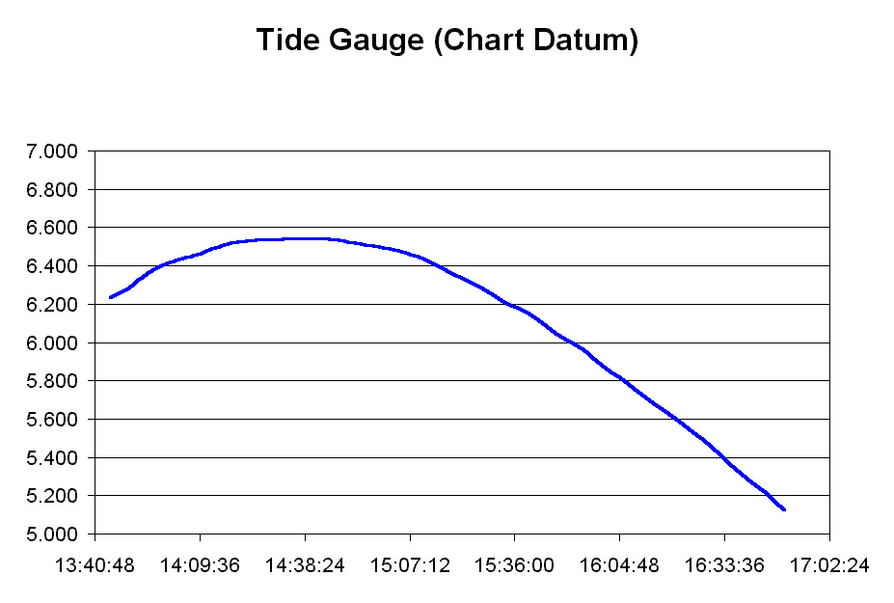
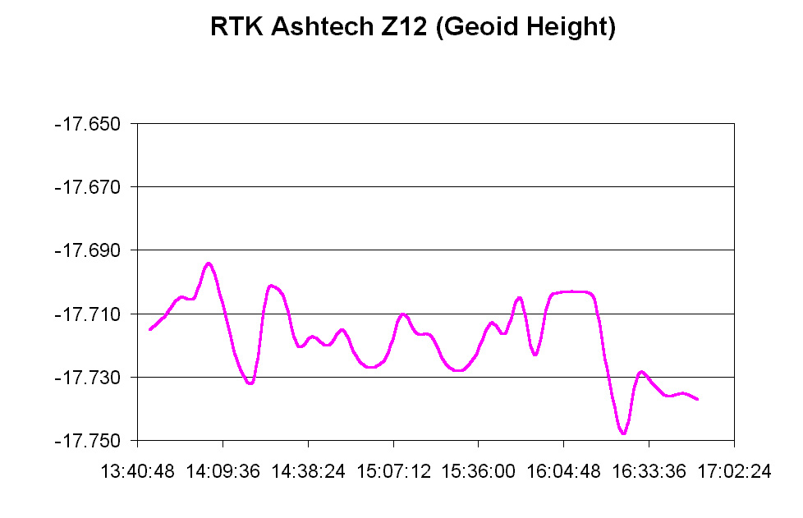
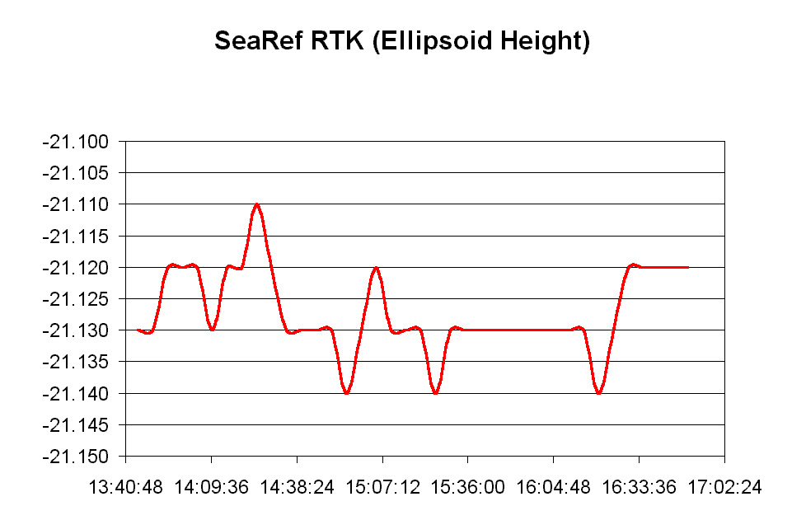
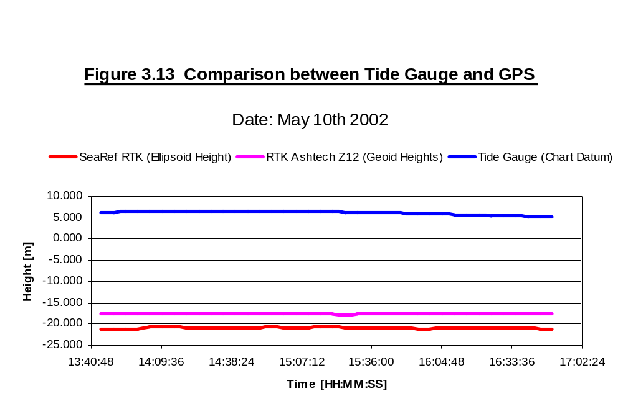

Comparison between charted depths of the CHS and the estimated depths with respect to chart datum
For analyzing purposes and for error analyzation we decided to compare our new estimated depth data with the old original CHS data that is being used to represent sounding depths on nautical charts of St. Andrews Harbour. Figure 3.14 shows the result of the comparison and represents the statistical distribution of the difference between CHS soundings und estimated soundings. The mean is 0.48 meter with an average variation of 0.78 meter. The differences are relatively large with a peak of up to 2. 75 meter. Reason for this distribution can be the long time period between both surveys of ca. 20 years and the improvement of survey instruments like today’s use of multibeam systems. It has also to be mentioned that there is a difference between our analysis of the data and the data investigation of the CHS. Our depths reflect the average depths of each position while the CHS, for safety purposes picks the shallowest one as the represented depth. Nevertheless because of the improvements in hydrographic surveys within the last decade and the permanent material transportation in the water we suppose that our measurements represent the real bathymetry more accurate than the old CHS data.
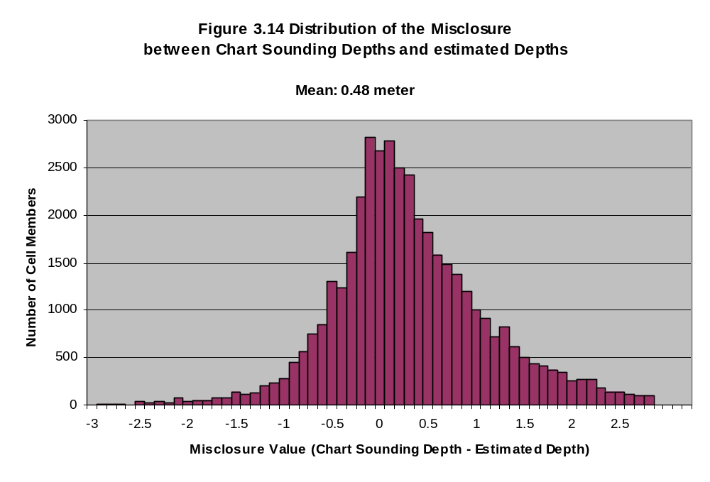
Conclusion
Vertical Control plays a very important roll within a hydrographic survey. Even there are modern positioning systems like GPS the most reliable realization of a tide measuring system is still the traditional float gauge. Today the inconsistency of GPS, its sensibility to distance from base station, transmitter path and other influences makes it not utilizable for hydrographic vertical control purposes. May be in a couple of years with the combination of GPS, GLONASS and Galileo data the use of RTK is more reliable then today. For our survey all tidal measurements were just based on the float gauge record. For redundancy and control purposes one should have at least two different continuous tide measuring systems. We think that that in future surveys the use of an additional pressure gauge, the integration of 2 float gauges or even a staff gauge can solve this problem of depending on only one system.
Appendix
Vertical Control Points (ChartDatum)

St. Andrews, NB, Canada - Public wharf
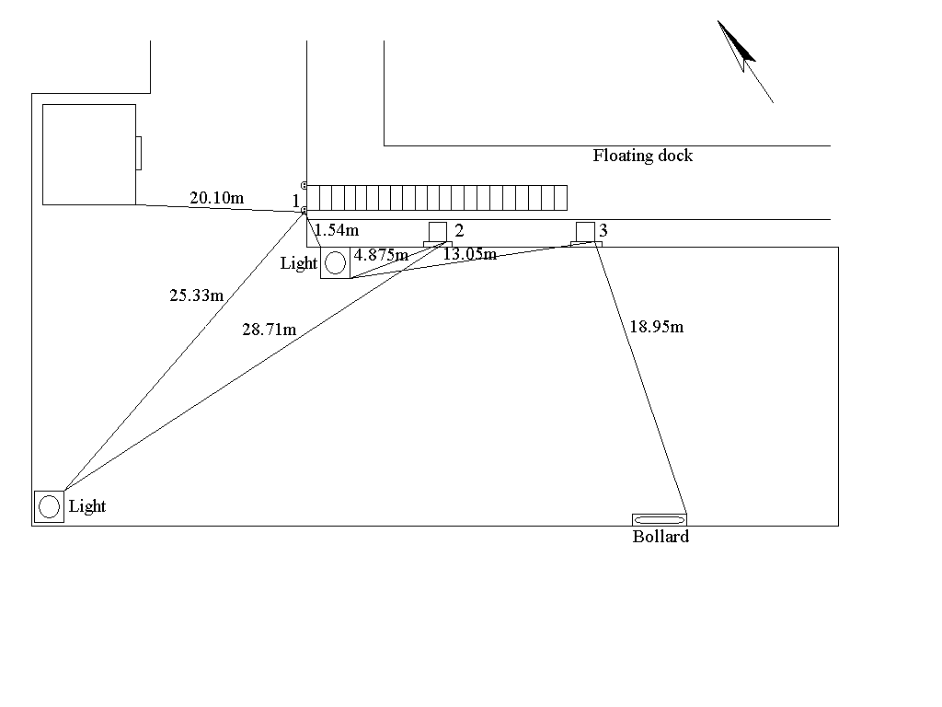
Point 1 – Description:
- southern bolt of floating dock
- attachment plate
Height (ChartDatum): 8.717 m
Point 2 – Description:
- southeast corner of steel pole
- part of floating dock buoyancy system
Height (ChartDatum): 9.048 m
Point 3 - Description:
- southeast corner of steel pole
- part of floating dock buoyancy system
Height (ChartDatum): 9.042 m
4.0 TIDAL PREDICTIONS
Tidal predictions for the two weeks:
Week 1 | high tide | Week 2 | high tide
Monday | 14:10 | Sunday | 7:50
Tuesday | 15:25 | Monday | 8:40
Wednesday | 16:15 | Tuesday | 9:35
Thursday | 17:10 | Wednesday | 10:25
Friday | 18:10 | Thursday | 11:10
Saturday | 19:15 | Friday | 12:10

4.2 SURVEY LINE PLANNING
Multibeam:
Inside the harbour and harbour entrances:

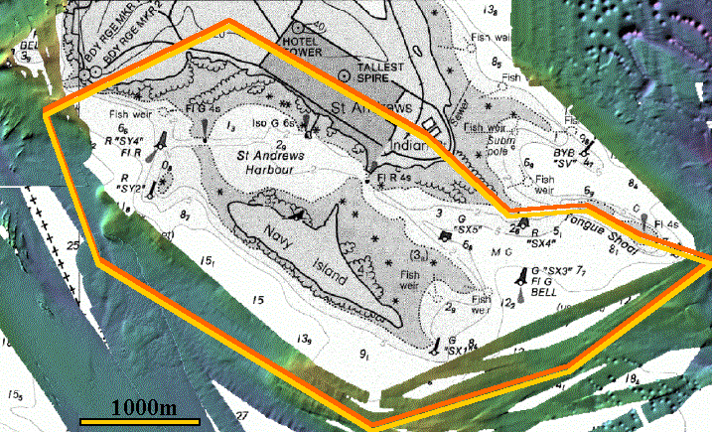

The plan:
- run contoured lines around inside and outside harbour
- 200 % coverage inside the harbour, 100% coverage outside the harbour
- spend 4 days of 4 hour high-tide windows inside the harbour, and the rest of those days surveying at entrances and around Navy Island
- possibility that at least one day might be wasted
What we did:
- ran contoured lines as planned
- had 200 % coverage both inside and outside of harbour
- the harbour survey was almost completed in the 4 days of high tide windows, not quite, due to complications, however, we completed the harbour surrounds outside of these times throughout the two weeks of surveying
- not all of the planned area to survey outside of the harbour was completed, due to days lost because of technical problems, bad weather conditions (particularly strong wind), and the need of high tide windows to complete shallow harbour entrances. Engine/fume problems also contributed to time loss.

Single beam (28 & 3.5 kHz) and sidescan of harbour

The plan:
- we planned to survey the harbour including inter-tidal areas with a line spacing of 50m
- the harbour survey was to be completed in the 4 hour high tide windows, and the deeper section was to be done outside of this time
- the survey was expected to be completed in 2 days, allowing for lost time due to weather/technical problems
- an SVP profile every 2nd line
- any excess time spent running 80m lines in the deeper pock marked areas for subbottom profiles

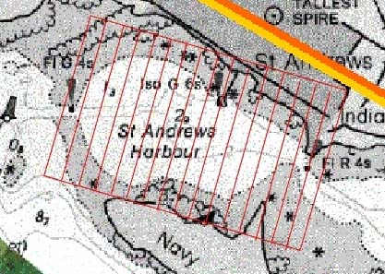

What we did:
- we decided to shorten the line spacing to 40m, so that the nadir region of sidescan lines would be overlapped, and so wouldn’t be seen in the final product
- we were able to work a bit past the high tide window for the harbour survey, however on the second day, we lost half of that window while trying to get SeaRef working, and line running was hampered by windy conditions.
- on the second day, extreme wind conditions prevented us from surveying the end and intertidal regions of the harbour, and on the last part of the 3rd check line, the 3.5 kHz singlebeam sonar hit a submerged buoy, snapping the support rods, preventing us from completing the latter on another day. Time was also lost due to engine/fume problems.
- We over estimated the frequency of taking SVP profiles, and decided that they were only needed to be taken every 3-4 hours, due to changing tidal or weather conditions.
- We were unable to complete (or start) the subbottom survey of the deeper pock marked areas, because we ran out of time, and we lost the use of the 3.5 kHz singlebeam.

ADCP of Harbour
The plan:
- To spend 12 hours (two shifts of 6 hours) zigzagging across the harbour, taking SVP’s every 4th or 5th line
- This was to take place on Sunday 5th of May, when the high tide window was too early in the morning

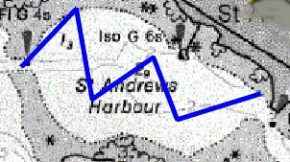
What happened:
- During initial testing, the ADCP worked intermittently and then not at all. It was found to have a leak, which is thought to have originated from overtightening of the screws. When the electrical current was passed through the instrument the electronics were destroyed.
- Thus, we were unable to complete the survey, due to the lack of a working ADCP
5.1 SIMRAD EM3000S MULTIBEAM: PLANNING AND PRODUCTS
Problems in multibeam data include:
- Long period heave, caused by fast deceleration or acceleration of the Heron
- Temporary loss of heading
- The swath width doesn’t account for loss of outlying beams caused by rough sea conditions (could have been a problem if we had only 100% coverage) – can see gaps in the mosaic product.
- Timing problems causing linear rock outcrops to be misaligned

Problems in detail:
Long period heave (figure 5.1) is only visible after processing the data, and is the result of the heave filter algorithm taking into account not only real heave (short period movement), but also the squat or lift of the vessel as it rapidly slows down or speeds up. This can be solved by not rapidly changing speeds, or by making the filter only use short period heave data from the motion sensors (SeaPath).

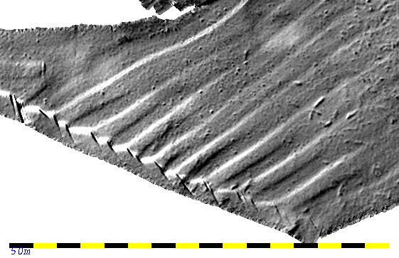
Figure 5.1 Long Period Heave

Temporary loss of heading, and loss of all positioning (figure 5.2) in this case was probably caused by a loose connection somewhere … and is visible as lines are being driven at sea. The only solution was to stop the line, get the heading back, and do the line again, then delete the unwanted lines during the processing stage.

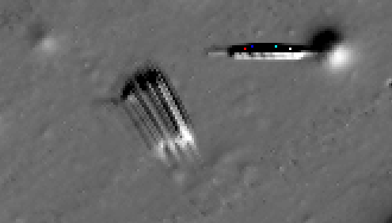
Figure 5. 2 Temporary Loss of Heading

The swath width (figure 5.3) of the multibeam sonar depends on the water depth, but outer beams can be lost sometimes due to bubbles in the water, rough conditions at sea, where the transducer pings, and the receiver has rotated by more than 5 deg, causing it to drop the outer beams. This means that even though it looks like we should get say, 10m swath width, occasionally, fragments of lines have less, which could cause gaps in the final image if coverage was only 100%. For us, this didn’t occur with our bathymetric data, however we did get gaps in our mosaic product. To solve this, line spacings could be made closer in rough conditions, or gaps filled later, or the gaps could be cosmetically filled later.

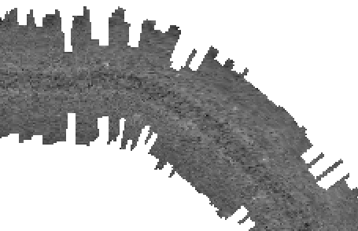
Figure 5. 3 Varying Swath Widths

Timing problems (figure 5.4) would normally be detected by completing a patch test, we did one, but didn’t get around to fully processing it. This problem occurred mainly on the western harbour entrance, where linear rock outcrops occurred. This could have also been caused by dropped DGPS positioning, as this data was collected during the initial trials of the various GPS systems. To solve this problem, the completion of the patch test processing should be done, and if this doesn’t correct the data, then further analysis of the day’s positioning data is needed – also calculating the shift of each line, and working out the time differences, and finding where these errors would have occurred.

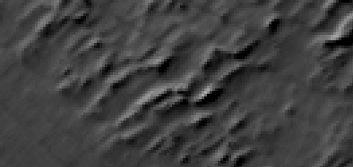
Figure 5. 4 Timing Problems
Final Products:
- Bathymetric map of:
- Just the harbour
- Harbour, entrances and behind Navy Island
- Backscatter image of:
- Just the harbour
- Harbour, entrances and behind Navy Island
Bathymentric data:
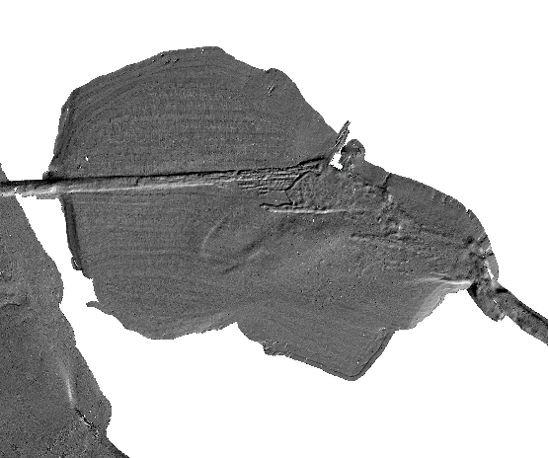
The image can be sun-illuminated, showing fine detail such as mooring blocks, shoals, rock outcrops and pock marks, or can be coloured according to depth, a final product of the merged combination of both of these can be produced.

Figure 5.5 Map of Harbour with Pock Marks and Mooring insets

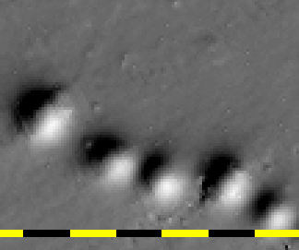
Moorings Pockmarks
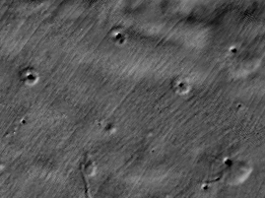

Backscatter data:
Dark areas define highly reflective surfaces, for example rock, sand or gravel, pale areas indicate soft sediments, for example mud. A map of the multibeam back scatter can be used to find where mud or gravel occurs in the harbour, which also indicates depositional behavior, or strong vs. weak currents.

Below (figure 5.6): map of harbour, and inset of the same mooring area as for the bathymetry data, showing how backscatter data does not preserve as much detail.
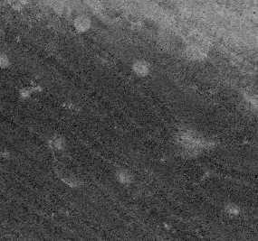
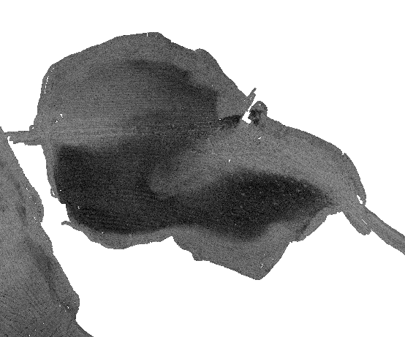
Figure 5. 6 Backscatter

