Shippagan Acquisition and Processing Log

John E. Hughes Clarke
Anya Duxfield
Beth-Anne Martin

This log is designed to keep a verbose record of all activities to trace down data corruptions or logging inconsistencies…

Ultimately will add an overview of the project aims and a descrition of the tools …

Wednesday July 02nd

Tide gauge physical installation by John.

Anya and Beth-Anne arrive and setup all computer gear in Cottage.

Heron trucking delayed due to truck scheduling issues.

Thursday July 03rd

Heron arrives by truck. Launched almost immediately using Shippagan travel lift. Short field outing to ensure all sonars working…. Tie up at Coastguard base.

Tide gauge instrumented and set operating.
Arbitrary datum established, close to old tide board……

Friday July 04th
Skipper: Theo Gionet
Operators: John Hughes Clarke, Anya Duxfield and Beth-Anne Martin

General Comments:
Doing standard 160m line spacing in southern end of Shippagan Bay, into Lameque Bay. Short Day to start establish processing procedures and allow Berth Anne to get back to F’ton.
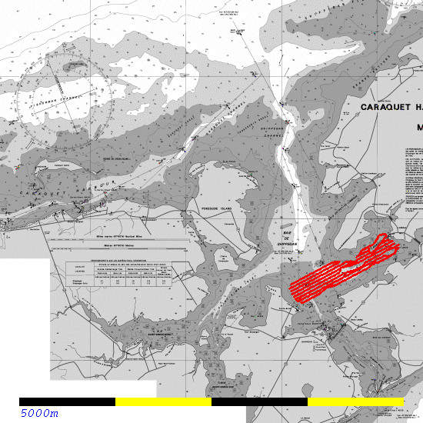

Data Acquisition:
ADT | Line Offset | EM # | KSUB # | KSS # | ADCP# | Comments
 |  |  |  |  |  | No field log kept on first day.

Tide gauge subsequently found to have been sticking….

Saturday July 05th

Skipper: Theo Gionet
Operators: Anya Duxfield

General Comments:
Continuing Shippagan Bay 160m line spacing , entering into St. Simon Bay. Full day with good data quality.
MVP got snagged on something and broken.

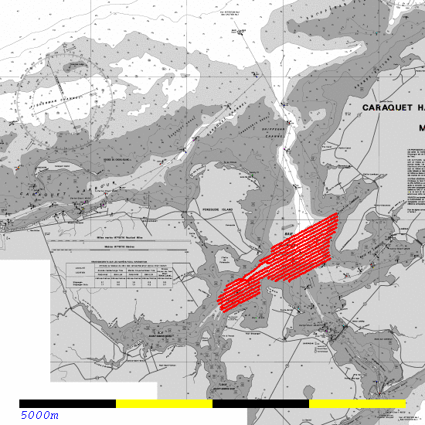

Data Acquisition:
ADT | Line Offset | EM # | KSUB # | KSS # | ADCP# | Comments
0845 | 2800 | 0500 | 0001 | 0001 | 000
0905 | 2960 | 0501 | 0002 | 0002 | 001
0922 | 3120 | 0502,0503 | 0003 | 0003 | 002
0940 | 3280 | 0504 | 0004 | 0004 | 003
0952 | 3440 | 0505 | 0005 | 0005 | 004
1012 | 3600 | 0505,0507 | 0006 | 0006 | 005
1045 | 3440 | 0508 | 0007 | 0007 | 006
1050 | 3280 | 0509 | 0008 | 0008 | 007
1110 | 3120 | 0510 | 0009 | 0009 | 008 | GPS position in regulous erratic. XTD probably
1112 | 3120 | 0511 | 0010 | 0010 | 009
1125 | 2960 | 0512 | 0011 | 0011 | 010
1145 | 3760 | 0513 | 0012 | 0012 | 011
1216 | 3920 | 0514,0515 | 0013 | 0013 | 012
1315 | 4080 | 0516,0517 | 0014 | 0014 | 013
1425 | 4240 | 0518 | 0015 | 0015 | 014
1457 | 4400 | 0519 | 0016 | 0016 | 015
1520 | 4560 | 0520 | 0017 | 0017 | 016
1537 | 4720 | 0521 | 0018 | 0018 | 017

Sunday July 06th

Skipper: Theo Gionet
Operators: John Hughes Clarke

General Comments:
Continuing Shippagan Bay 160m line spacing , seastate deteriorating as head out mouth of Bay.

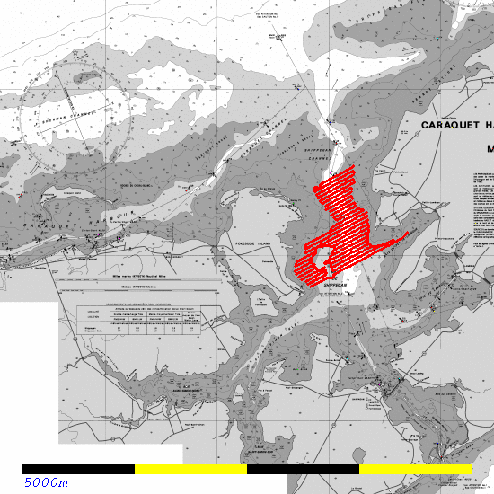

Data Acquisition:
ADT | Line Offset | EM # | KSUB # | KSS # | ADCP# | Comments
0820 | transit | 0001 | 0001 | 0001 | 000
0844
 |  | 02003 |  |  |  | Bad (wrong survey)
0850 | 4880 | 0004 | 0002 | 0002 | 001
 |  |  |  |  |  | Reset times
0918 | 5040 | 0005 | 0003 | 0003 | 002
 |  |  |  |  |  | Major diversion around aquaculture
 | 5200 | 0007 | 0004 | 0004 | 003
 | 5360 | 0008 | 0005 | 0005 | 004
1024 | 5520 | 0009 | 0006 | 0006 | 005
1030 | 5680 | 0010 | 0007 | 0007 | 006
1035 | 5840 | 0011 | 0008 | 0008 | 007
1041 | 6000 | 0012 | 0009 | 0009 | 008
1042 | 6160 | 0013 | 0010 | 0010 | 009
 |  | 0014 | 0011 | 0011 |  | Coast transit
1115 | 5200 | 0015 | 0012 | 0012 | 010
1125 | 5360 | 0016 | 0013 | 0013 | 011
1137 | 5520 | 0017 | 0014 | 0014 | 012
1146 | 5680 | 0018 | 0015 | 0015 | 013
 | 5840 | 0019 | 0016 | 0016 | 014
1204 | 6000 | 0020 | 0017 | 0017 | 015
1215 | 6320 | 00210 | 0018 | 0018 | 016
1230 | 6480 | 0022 | 0019 | 0019 | 017
1245 | 6540 | 0023 | 0020 | 0020 | 018
1310 | 6700 | 0024 | 0021 | 0021 | 019
1322 | 6860 | 0025 | 0022 | 0022 | 020
 | 7020 | 0026 | 0023 | 0023 | 021
1340 | 7180 | 0027 | 0024 | 0024 | 022
1348 | 7340 | 0028 | 0025 | 0025 | 023
1353 | 7500 | 0029 | 0026 | 0026 | 024
 | 7660 | 0030 | 0027 | 0027 | 025
1411 | 7820 | 0031 | 0028 | 0028 | 026
1420 | 7980 | 0032 | 0029 | 0029 | 027
1431 | 8140 | 0033 | 0030 | 0030 | 028
1441 | 8300 | 0034 | 0031 | 0031 | 029
1450 | 8460 | 0035 | 0032 | 0032 | 030
1510 | 8520 | 0036 | 0033 | 0033 | 031

Monday July 07th

Skipper: Theo and then Alcide
Operators: Anya Duxfield and Beth-Anne Martin

General Comments:
Partial Weather Day, Transit EM data in St. Simon Bay only….
First experience of Alcide.

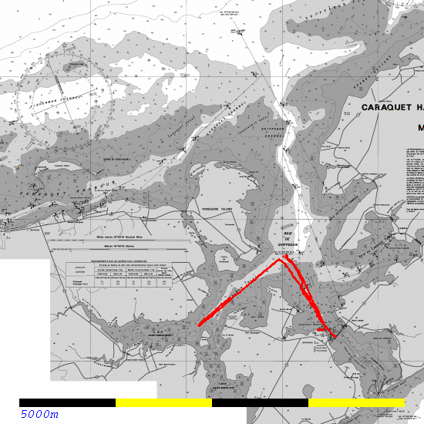

Data Acquisition:
ADT | Line Offset | EM # | KSUB # | KSS # | ADCP# | Comments
 |  | 001 | 001 | 001 | 000 | Transit
1030 |  | 001
 |  | 002
1100 |  | 003
1115 |  | 004
1130 |  | 005 |  |  |  | Transit
 |  | 001 |  |  |  | Transit
1400 |  | 002 |  |  |  | StSimon
1430 |  | 003 |  |  |  | “”
1445 |  | 004 |  |  |  | “”
1510 |  | 005 |  |  |  | “”
1530 |  | 006

Tuesday July 08th

Skipper: Alcide Degrace
Operators: Beth-Anne Martin

General Comments:
Partial Weather Day, Transit EM data in St. Simon Bay only….

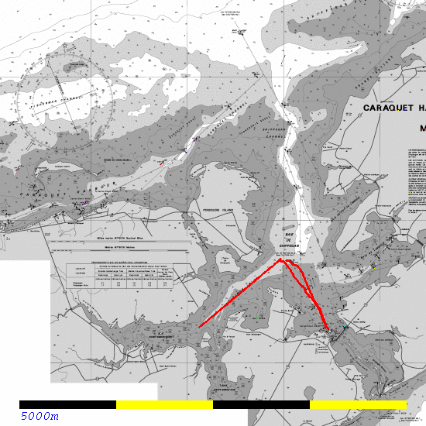

Data Acquisition:
ADT | Line Offset | EM # | KSUB # | KSS # | ADCP# | Comments
0830 |  | 001 |  |  |  | Transit
1915 |  |  |  |  |  | SVP done
1940 |  | 002 |  |  |  | St-Simon
1030 |  | 003 |  |  |  | Transit

Wednesday July 09th

Skipper: Alcide Degrace
Operators: Anya Duxfield

General Comments:
Stared off trying to build out of Bay, but weather precluded….

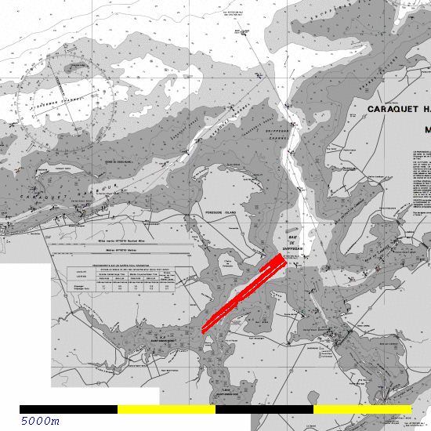

Data Acquisition:
ADT | Line Offset | EM # | KSUB # | KSS # | ADCP# | Comments
0830 |  | 0901 |  |  |  | Transit
 |  | 0902
0935 |  | 0903 |  |  |  | St-Simon
0955 |  | 0904
1020 |  | 0905
1015 |  | 0906
1115 |  | 0907
1157 |  | 0908
 |  | 0909
 |  | 0910
 |  | 0911
 |  | 0912
 |  | 0913
 |  | 0914
 |  | 0915 | Dud
 |  | 0916
 |  | 0917
 |  | 0918
 |  | 0919
1309 |  | 0920
 |  | 0921
 |  | 0922
 |  | 0923
 |  | 0924
 |  | 0925
 |  | 0926
 |  | 0927
 |  | 0928 |  |  |  | Transit

Thursday July 10th

Skipper: Alcide Degrace
Operators: Beth-Anne Martin

General Comments:
Marginal Weather Day. Just Multibeam on Northern Shippagan Bay.
Transverse lines???? Not terribly useful.

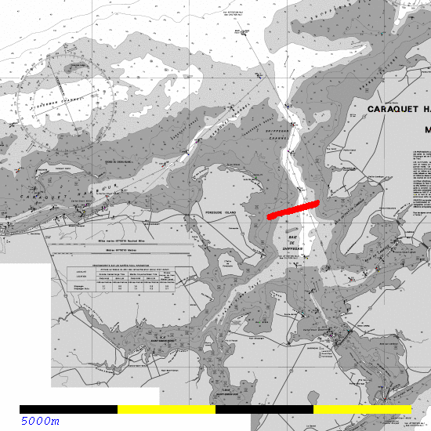

Data Acquisition:
ADT | Line Offset | EM # | KSUB # | KSS # | ADCP# | Comments

Friday July 11th

Skipper: Alcide Degrace
Operators: Beth-Anne Martin and Jennifer Coppola

General Comments:
Starting splitting 160m lines in Shippagan Bay.
Problem with the EM3000. Program froze and sonar would not work. Called Anya and John and John called the simrad people. Turns out SVP dip was corrupted which caused the program to not allow the sonar to ping. Picked another dip and program was fine. Wondering why there is no error message to tell us that the file was corrupted instead of just deactivating everything???
Sidescan accidently set on 10m range all day!

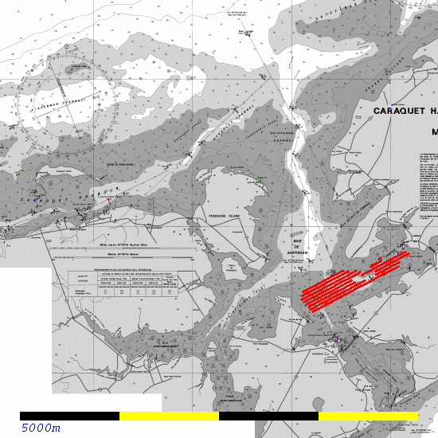

Data Acquisition:
ADT | Line Offset | EM # | KSUB # | KSS # | ADCP# | Comments
 |  | 001 | 001 |  | 000 | Dud
1300 | 1440 | 002 | 002 | 001 | 001
1320 | 1600 | 003 | 003 | 002 | 002
1325 | 1760 | 004 | 004 | 003 | 003
1335 |  | 005 | 005 | 004 | 004
1342 |  | 006 | 006 | 005 | 005
1355 |  | 007 | 007 | 006 | 006
1410 | 1600 | 008 | 008 | 007 | 007
1425 | 1760 | 009 | 009 | 008 | 008
1437 | 1920 | 010 | 010 | 009 | 009
1450 | 2000 | 011 | 011 | 010 | 010
1505 | 2220 | 013 | 012 | 011 | 011
1517 | 2280 | 014 | 013 | 012 | 012
1530 | 2560 | 015 | 014 | 013 | 013
1545 |  | 016 |  |  |  | Transit

Saturday July 12th

Skipper: Alcide Degrace
Operators: Beth-Anne Martin and Jennifer Coppola

General Comments:
Continuing Shippagan Bay splitting 160m line . But only at midday did they realize that 10m sidescan range setting was wrong….
Stayed out late to redo a lot of lines…
Lines at 10m range scale (< # 19) deleted…
ADCP pin broke at 1900…..
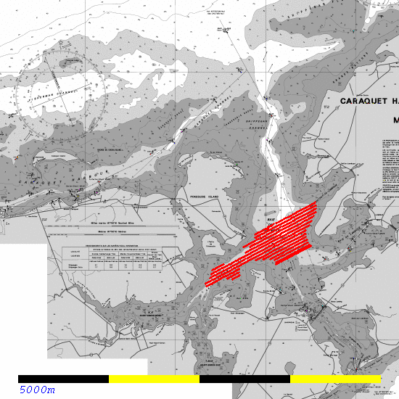

Data Acquisition:
ADT | Line Offset | EM # | KSUB # | KSS # | ADCP# | Comments
0907 | 2640 | 002 | 001 | 001 | 014 | ADCP prefix is jul11. fixed in processing
0919 | 2720 | 003 | 002 | 002 | 015 | Dud
0922 |  | 004 | 003 | 003 | 016
0933 | 2880 | 005 | 004 | 004 | 017
0944 |  | 006,007 | 005 | 005 | 018 | Dud
0946 | 3040 | 008 | 006 | 006 | 019
0959 |  | 009 | 007 | 007 | 020
1001 | 3200 | 010 | 008 | 008 | 021
1013 | 3360 | 011 | 009 | 009 | 022
1030 | 3040 | 012 | 010 | 010 | 023
1042 | 3200 | 013 | 011 | 011 | 024
1048 |  | 014 | 012 | 012 | 025 | Dud
1050 | 3360 | 015 | 013 | 013 | 026
1102 | 3520 | 016 | 0014 | 0014 | 027
1130 | 3680 | 017 | 015 | 015 | 028
1226 | 3840 | 018 | 016 | 016 | 029
1254 | 4000 | 019 | 017 | 017 | 030
1319 | 4000 | 020 | 018 | 018 | 031
1331 | 4160 | 021 | 019 | 019 | 032
 | 4320 | 022 | 020 | 020 | 033
1411 | 4480 | 023 | 021 | 021 | 034
1427 | 4640 | 024 | 022 | 022 | 035
EVENING
1500 | 4160 |  |  | 023 | 000
1515 | 4000 |  |  | 024 | 001
1745 | 4000 |  |  | 001 | 002
1805 | 3840 |  |  | 002 | 003
1730 | 3600 |  |  | 003,004 |  | Pin off
1915 | 3520 |  |  | 005

Sunday July 13th

Skipper: Alcide Degrace
Operators: Beth-Anne Martin and Jennifer Coppola

General Comments:
V. early morning (to avoid Shippagan Festival) Redoing those sidescan lines run with 10m range setting.
Sidescan only (ADCP pole U/S) no point in redoing MB and subbottom.

Data Acquisition:
ADT | Line Offset | EM # | KSUB # | KSS # | ADCP# | Comments
0625 | 3360 |  |  | 0001
0640 | 3200 |  |  | 0003
0600 | 3040 |  |  | 0004
0715 | 3360 |  |  | 0005
0725 | 3200 |  |  | 0006
0742 | 3040 |  |  | 0007
0755 | 2880 |  |  | 0008
0805 | 2720 |  | 0001 | 0009
0815 | 2640 |  | 0002 | 0010 |  | Done redoing July 12th
0835 |  |  |  | 0011 |  | Redoing July 11th now
0855 |  |  |  | 0012
0905 |  |  |  | 0013
0913 |  |  |  | 0014
0925 |  |  |  | 0015
0933 |  |  |  | 0016
0945 |  |  |  | 0017
1000 |  |  |  | 0018
1015 |  |  |  | 0019
1026 |  |  |  | 0020
1041 |  |  |  | 0021
1056 |  |  |  | 0022
1109 |  |  |  | 0023

Monday July 14th

Skipper: Theo Gionet
Operators: Anya Duxfield

General Comments:
Doing alternate 160 line spacing for fill ins for July 06th

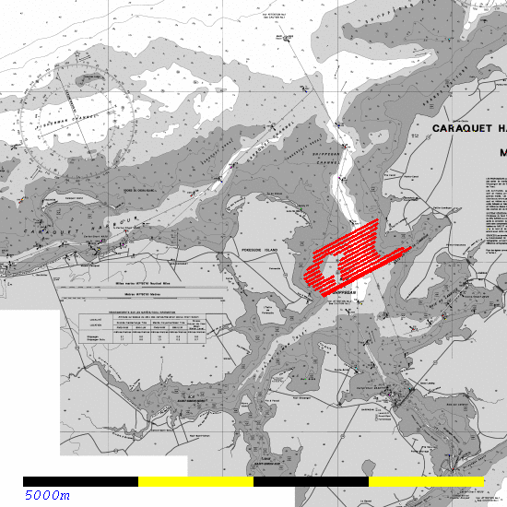

Data Acquisition:
ADT | Line Offset | EM # | KSUB # | KSS # | ADCP# | Comments
 |  | 1 |  |  |  | Transit
 |  | 2
 |  | 3
1115 |  | 1400 | 001 | 001 | 000
 |  | 1401 |  |  |  | Turn
1135 |  | 1402 | 002 | 002 | 001
 |  |  |  |  |  | Seaweed in Prop
1137 |  | 1403 | 003 | 003 | 002
1200 |  | 1404 | 004 | 004 | 003
 |  | 1405 | 005 | 005 | 004
 |  | 1406 | 006 | 006 | 005
1249 |  | 1407 | 007 | 007 | 006
1249 |  | 1408 | 008 | 008 | 007
1300 |  | 1409 | 009 | 009 | 008
13? |  | 1410 | 010 | 010 | 009
13? |  | 1411 | 011 | 011 | 010
1330 |  | 1412 | 012 | 012 | 011
1345 |  | 1413 | 013 | 013 | 012
1400 |  | 1414 | 014 | 014 | 013
1425 |  | 1415 | 015 | 015 | 014
1430 |  | 1416 | 016 | 016 | 015
1437 |  | 1417 | 017 | 017 | 016
1442 |  | 1418 | 018 | 018 | 017
 |  | 1419 | 019 | 019 | 018
 |  | 1420 | 020 | 020 | 019
1503 |  | 1421 | 021 | 021 | 020
 |  | 1422 | 022 | 022
1515 |  | 1423 |  |  |  | Transit
 |  | 1424

Tuesday July 15th

Skipper: Theo Gionet
Operators: Anya Duxfield

General Comments:
Starting to work out of mouth of Bay doing every 80m line.

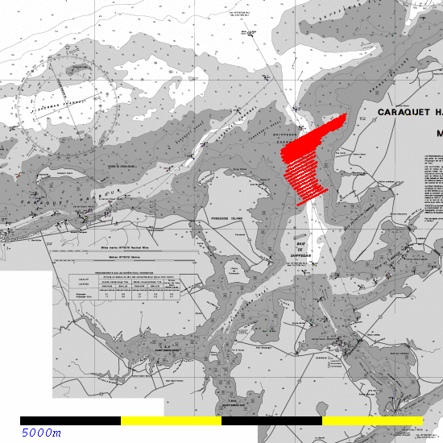

Data Acquisition:
ADT | Line Offset | EM # | KSUB # | KSS # | ADCP# | Comments
0830 |  | 1500 |  |  |  | Transit
0935 | 6720 | 1501 | 001 | 001 | 000
 | 6880 | 1502 | 002 | 002 | 001
 | 6880 | 1503 | 003 | 003 | 002
 | 7040 | 1504 | 0047 | 004 | 003
1000 | 7200 | 1505 | 005 | 005 | 004
1012 | 7360 | 1506 | 006 | 006 | 005
1019 | 7520 | 1507 | 007 | 007 | 006 | Dud
 | 7520 | 1508 | 008 | 008 | 006 | Dud
1024 | 7520 | 1509 | 009 | 009 | 007
1026 | 7680 | 1510 | 010 | 010 | 008
1037 | 7840 | 1511 | 011 | 011 | 009 | Dud
 | 7840 | 1512 | 012 | 012 | 010
 |  |  |  |  |  | In to pick up pole mounts
 |  |  |  |  |  | Launchpad froze
1240 |  | 0001 |  |  |  | Transit
 | 8000 | 1514 | 014 | 014 | 011
1330 | 8160 | 1515 | 015 | 015 | 012
 | 8320 | 1516 | 016 | 016 | 013
 | 8480 | 1517 | 017 | 017 | 014 | Grounded
1350 | 8610 | 1518 | 018 | 018 | 015
 | 8800 | 1519
 | 8880 | 1 | 019 | 019 | 017
 | 8960 | 2 | 020 | 020 | 017 | EM3000 short
 | 9040 | 3 | 021 | 021 | 018
 | 9120 | 4 | 022 | 022 | 019
 | 9200 | 5 | 023 | 023 |  | EM3000 short
 | 9280 | 6 | 024 | 024 | 020
 | 9360 | 7 | 025 | 025 | 021
 | 9440 | 8 | 026 | 026 | 022
1551 | 9520 | 9 | 027 | 027 | 023
1601 |  | 10 | 028 | 028 | 024

Wednesday July 16th

Skipper: Theo Gionet
Operators: Beth-Anne Martin

General Comments:
Working out of mouth of Bay at 80m line spacing. Until seastate built up too much.

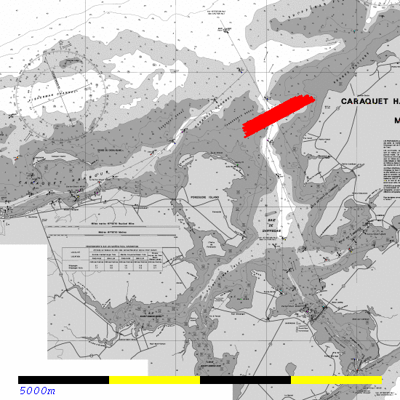

Data Acquisition:
ADT | Line Offset | EM # | KSUB # | KSS # | ADCP# | Comments
0900 |  | 1601 |  |  |  | Transit
0915 |  | 1602
 |  | 1603
1335 | 9680 | 1601 | 001 | 001 | 000 | Shippagan Bay
1100 | 9760 | 1602 | 002 | 002 | 001
1120 | 9840 | 1603 | 003 | 003 | 002
1137 | 9920 | 1604 | 004 | 004 | 003
1220 | 10000 | 1605 | 005 | 005 | 004
1235 | 10080 | 1606 | 006 | 006 | 005
1255 | 10160 | 1607 | 007 | 007 | 006
1313 | 10240 | 01608 | 008 | 008 | 007
 |  |  |  |  |  | GPS stopped. Frozen position on Regulous. Returned and continued.
1320 | 10240 | 1609 | 009 | 009 | 008
1335 | 10320 | 1610 | 010 | 010 | 009
1415 | 12 | 1611 |  |  |  | Shippagan_bay_bathy
1430
 |  | 1612 |  |  |  | Transit
 |  | 1613
 |  | 1614

Thursday July 17th

Skipper: none available
Operators: none

General Comments:
No acquisition due to Alcide’s illness and Theo being called in to replace on lifeboat.

Windy anyway….

Friday July 18th

Skipper: none available
Operators: none

General Comments:
No acquisition due to Alcide’s illness and Theo being called in to replace on lifeboat.

Windy anyway….

John at Cottage rationalizing processing…..

Saturday July 19th

Skipper: Theo Gionet
Operators: John Hughes Clarke and Russ Parrott

General Comments:

Light winds from the east that didn’t blow up at all, all day.

Couldn’t log into heron3 as user em3000? I think this is an old problem that we’ve seen before, something in the em3000 user configuration corrupted. Got around the problem by logging in as user root and su’ing in as user em3000. Had to ”xhost +” as root and then “setenv DISPLAY” as em3000 and run a script that referred to the esoStartup_launchpad command.

Ran a few transit lines out of the Bay, including one continuous ADCP line. Checked data and motion WAS applied at this time. …

Extended last line of Beth-Annes to the West onto the Pokesudie shoal. That line and second line had 3.5 kHz NOT on. Noticed that although heading was being listed in the real time read-out, it was not being applied in Merlin (ship always pointing N)?.
Half way through third line, the roll/pitch/heave froze….

*** turns out had frozen from the start ***
DO not use em3000 lines 1901 -1902 – 1903

Restarted Launchpad and reran deep water section of first 2 lines in case had frozen earlier. All seems to be better now…

Ran another 2 lines building out from mouth of Shippagan Bay.

Then moved over to new QTC area to the N of Caraquet Island. Ran 4 lines out there.

:Logged a little transit and then though, not valuable. Transit home is now ~1.5 hours from QTC area, allowing lots of time for writing CD’s.
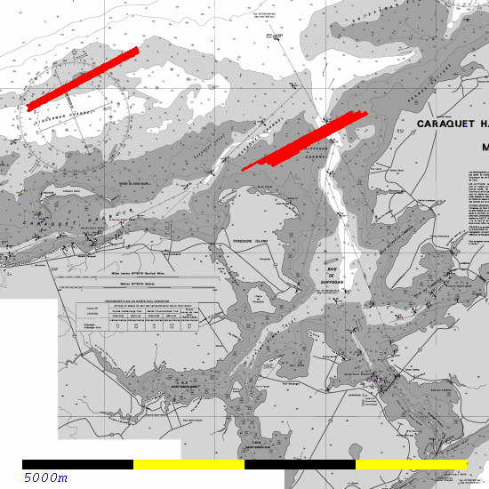

Data Acquisition:
ADT | Line Offset | EM # | KSUB # | KSS # | ADCP# | Comments
 |  | 0001 |  |  |  | Transit
0845 |  | 0002
 |  | 0003
 |  | 0004 |  |  | 000
 |  | 0005
 |  |  |  |  |  | Extending B-A’s last line
1942 | 10320 | 1901 | 0001 | 0001 | 001 | No heading, no 3.5
1952 | 10400 | 1902 | 0002 | 0002 | 002 | No 3.5
1015 | 10480 | 1903 | 0003 | 0003 | 003 | Bad bathy
 | 10400 | 1904 | 0004 | 0004 |  | Redo centre, replace 3.5
 | 10480 | 1905 | 0005 | 0005 | 004
 | 10560 | 1906 | 0006 | 0006 | 005
 | 10640 | 1907 | 0007 | 0007 | 006
1145 | 10720 | 1908 | 0008 | 0008 | 007
1204 | 10800 | 1909 | 0009 | 0009 | 008
 |  | 1910 |  |  | 009
1300 | North most | 1911 | 0010 | 0010 | 010
1325 | -1 | 1912 | 0011 | 0011 | 011
1350 | -2 | 1913 | 0012 | 0012 | 012
1410 |  | 1914 | 0013 | 0013 | 013 | Forgot to SOL
 |  | 1915 | 0014 | 0014 | 014

Sunday July 20th

Skipper: none available
Operators: none

General Comments:
No acquisition due to Alcide’s illness and Theo being called in to replace on lifeboat.

John at Cottage rationalizing processing…..

Monday July 21st

Skipper: Serge Lemay
Operators: Anya Duxfield and Beth-Anne Martin

General Comments:
Started survey at noon due to Serge working at the Coast Guard base until then. Overcast with temperatures at about 26 degrees C. Light southerly winds. Used July 16 SVP dip. Redid corrupted sidescan lines from July 12th and 15th running the EM3000 and the Knudsen sidescan. Also filled holes in Saint Simon inlet with the EM3000.

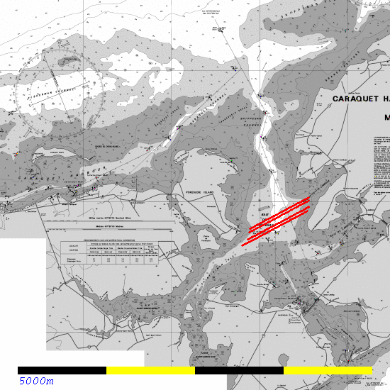

Data Acquisition:
ADT | Line Offset | EM # | KSUB # | KSS # | ADCP# | Comments
12:45 |  | 2100 |  | 001 |  | Shippagan_July21
13:10 |  | 2101 |  | 002
13:30 |  | 2102 |  | 003
13:50 |  | 2103 |  | 004 |  | Test line in Merlin for Serge
14:15 |  | 2104 |  | 005
14:30 |  | 2105 |  |  |  | SaintSimon_inlet
14:50 |  | 2106
15:22 |  | 2107
15:35 |  | 2108
15:40 |  | 2109
 |  | 2110 |  |  |  | Transit
 |  | 2112

Tuesday July 22nd

Skipper: Serge Lemay
Operators: Anya Duxfield

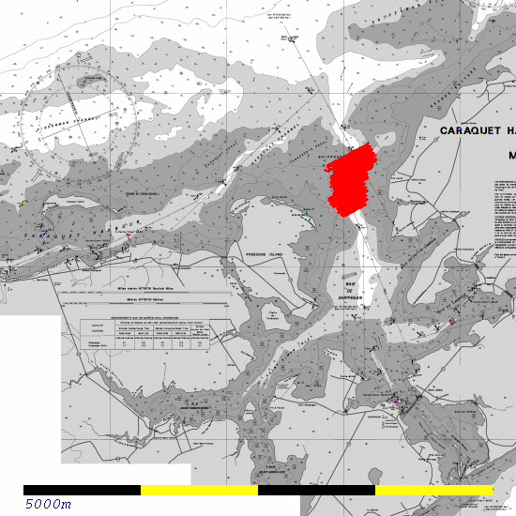

General Comments:
- Overcast. Stiff SW (10- 15knots) breeze with a significant chop. Raining.
- Predicted lower high tide at 1130.
- EM3000 user requires the CDE environment to logon. Can be found under options before logging in.
- Checked the motion, which initially did appear to be frozen upon first loading the Launchpad, shut it down and relaunched it appeared ok.
- Boat speed on average: 7 knots.
- Heading values on the F180 fluctuating 1.54 – 0.30 for most of transit.
- Logged a transit line with ADCP from the end of the narrow channel out to Buoy EG4.
- Both Heron 1 and Heron 2 needed to be rebooted to find SCSI device and COM2 respectively.
- 0910 just past Buoy EG14 I think it may be a little too choppy for QTC. Continuing to EG5 for a looksee.
- 0930 EG5 weather conditions moderate and quality of sidescan appear to be suffering.
- 0940 EG4 weather state too rough, data quality marginal.
- Turning around to do the insert lines in Shippagan Bay.
- 1030 SVP profile.
- 1035 repeat of problem with the SVP profile being rejected by Merlin, and Merlin shutting down. Edited the top two values. Reloaded the profile which was accepted this time.
- GPS into both Merlin and Regulus frozen see line 2208.
- Restarted line.

Data Acquisition:
ADT | Line Offset | EM # | KSUB # | KSS # | ADCP# | Comments
0840 | Transit | 001 |  |  | 000
 |  | 002
 |  | 003
 |  | 004
0930 |  | 005 |  |  | 001
0945 |  | 006 | 001 | 001 | 002
0950 |  | 007 | 002 | 002 | 003 | SVP-16 july22a_SVP.asvp
1042 | 7920 | 2200 |  |  | 004
1050 | 7840 | 2201 |  |  | 005
1100 | 7760 | 2202 |  |  | 006
 | 7680 | 2203 |  |  | 007
1125 | 7600 | 2204 |  |  | 008
1135 | 7520 | 2205 |  |  | 009
1146 | 7440 | 2206 |  |  | 010
1154 | 7360 | 2207 |  |  | 011
 | 7280 | 2208 |  |  | 012
1208 | 7280 | 2209 |  |  | 013
1217 | 7200 | 2210 |  |  | 014
1229 | 7120 | 2211 |  |  | 015
1247 | 7040 | 2212 |  |  | 017
1257 | 6960 | 2213 |  |  | 018
1306 | 6880 | 2214 |  |  | 019
1311 | 6800 | 2215 |  |  | 020
1320 | 6720 | 2216 |  |  | 021
1330 | 6640 | 2217 |  |  | 022
1338 | 6560 | 2218 |  |  | 023
1345 | 6480 | 2219 |  |  | 024
1354 | 6400 | 2220 |  |  | 025
1403 | 6320 | 2221 |  |  | 026
1412 | 6240 | 2222 |  |  | 027
1418 | 6160 | 2223 |  |  | 028
1425 | 6080 | 2224 |  |  | 029
1431 | 6000 | 2225 |  |  | 030
1438 | 5920 | 2226 |  |  | 031
1445 | 5860 | 2227 |  |  | 032
1450 | 5760 | 2228 |  |  | 033
1500 | 5680 | 2229 |  |  | 035
 |  |  |  |  | 036 | Transit
Wednesday July 23rd

Skipper: Serge Lemay
Operators: Beth-Anne Martin

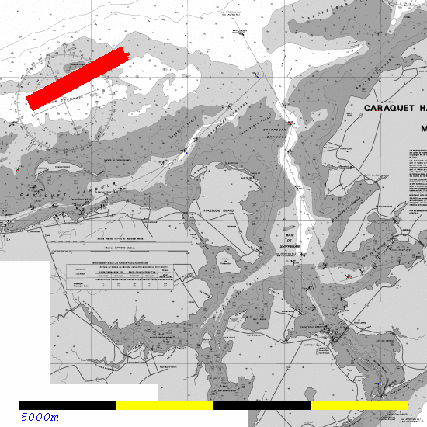

General Comments:
Radiator cap was broken. A new part was ordered from Bathurst. Should be here late on Thursday.
Data in the QTC area was collected.
Weather was cloudy with some sunny periods. Light winds throughout the day. Water was very calm. Excellent surveying conditions.
Performed circles to bring the heading value for the f180 down to 0.5
Transit out to QTC area was approximately 1.5 hours at 1500rmps.
Transit line collected on the way to the QTC.
SVP done outside of Shippagan Channel.
10 lines of QTC collected.
Low frequency subbotom was not collected for the first 5 minutes of the first line of the QTC.
The em3000 at the end of line 2307 was left on too long.
Transit back to Marina was approximately 1 hour at 2000rmps with the ADCP bar up.

Data Acquisition:
ADT | Line Offset | EM # | KSUB # | KSS # | ADCP# | Comments
8:45 |  | 2301 |  |  |  | Transit
9:15 |  | 2302
10:30 | 5200 | 2303 | 001 | 001 | 000 | QTC area. No LF for first 5 minutes
10:55 | 5120 | 2304 | 002 | 002 | 001
11:20 | 5040 | 2305 | 003 | 003 | 002
11:45 | 4960 | 2306 | 004 | 004 | 003
12:10 | 4880 | 2307 | 005 | 005 | 004
12:35 | 4800 | 2308 | 006 | 006 | 005 | Left em3000 on for too long at end of line
1:00 | 4720 | 2309 | 007 | 007 | 006
1:25 | 4640 | 2310 | 008 | 008 | 007
1:45 | 4560 | 2311 | 009 | 009 | 008
2:10 | 4480 | 2312 | 010 | 010 | 009

Thursday July 24th

Skipper: Serge Lemay

Operator: Anya Duxfield

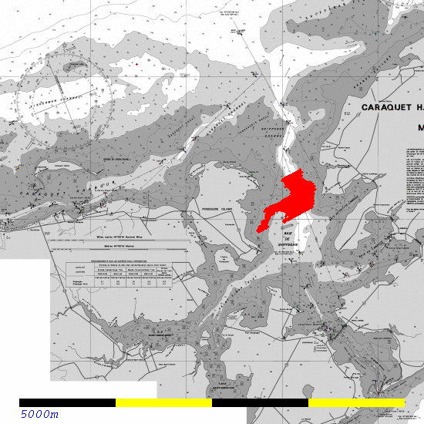

General Comments:
Transited out to QTC seastate was not calm enough to gather quality sidescan. Returned to the completion of the interleaving lines in Shippagan Bay.

Worked down towards and around the large aquaculture site. A few of the lines seems to be have come adrift since our last survey in this area. Ending lines a little earlier to avoid drifting lines on the surface.

Wind was also blowing us into the site therefore required cautious drivng.

Friday July 25th

Skipper: Serge Lemay
Operators: Beth-Anne Martin

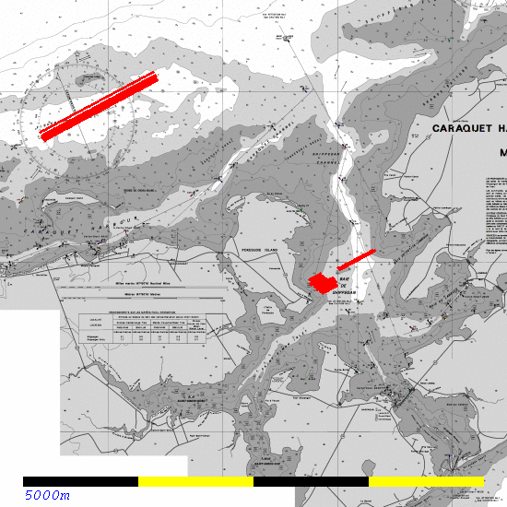

General Comments:
Weather was sunny with some clouds in the morning and periods of heavy rain in the afternoon. Southwest winds of 15-20 knots in the morning. Changed to Northwest in the afternoon.
Performed circles to bring the heading down to 0.5
Transit out to QTC area.
An SVP dip was successfully done at the mouth of Shippagan Channel.
QTC data was collected.
Some problems with the GPS occurred which made Aldeberan freeze it’s position. After happening twice, and both times being while communicating on the radio, a test was performed at the end of a line. It appears that whenever someone on the boat transmits on the radio, the GPS signal is lost. No similar problems are found when receiving a radio signal.
Two lines were restarted due to heavy rain that made noise in the sidescan.
We left the QTC area shortly thereafter since the rain did not seem to affect the em3000 or the ADCP.
Data acquisition was done on the interleaving lines in Shippagan Bay. All the westerly lines beside the aquaculture site were collected as well as 2 on the easterly side.

Data Acquisition:
ADT | Line Offset | EM # | KSUB # | KSS # | ADCP# | Comments
8:35 |  | 2501 |  |  |  | Transit
8:40 |  | 2502
8:42 |  | 2503
8:45 |  | 2504
8:52 |  | 2505
9:02 |  | 2506
10:10 | 4400 | 2507 | 001 | 001 | 000 | Shippagan_July25
10:30 | 4320 | 2508 | 002 | 002 | 001
10:55 | 4240 | 2509 | 003 | 003 | 002
11:20 | 4160 | 2510 | 004 | 004 | 003 | Lost GPS
11:40 | 4160 | 2511 | 005 | 005 | 004 | Started last line in middle
11:50 | 4080 | 2512 | 006 | 006 | 005 | Lost GPS again
12:05 | 4080 | 2513 | 007 | 007 | 006 | Started in middle again
12:25 | 4000 | 2514 | 008 | 008 | 007 | Ignore line
12:35 | 4000 | 2515 | 009 | 009 | 008
1:00 | 3920 | 2516 | 010 | 010 | 009 | Ignore line
2:10 | 3680 | 2517 |  |  |  | Interleave
2:15 | 3600 | 2518 |  |  |  | Small lines on West side of  aquaculture
2:20 | 3520 | 2519 |  |  |  | “
2:25 | 3440 | 2520 |  |  |  | “
2:27 | 3360 | 2521 |  |  |  | “
2:32 | 3280 | 2522 |  |  |  | “
2:37 | 3200 | 2523 |  |  |  | “
2:41 | 3120 | 2524 |  |  |  | “
2:45 | 3040 | 2525 |  |  |  | “
2:50 | 2960 | 2526 |  |  |  | “
2:55 | 2880 | 2527 |  |  |  | “
3:07 | 3520 | 2528 |  |  |  | Long lines on eastern side
3:15 | 3440 | 2529 |  |  |  | “

Saturday July 26th

Skipper: Serge Lemay
Operators: Beth-Anne Martin and Travis Wert

General Comments:
Spent the day with the Brook Ocean Technology people. The MVP cable was fixed by removing 15 metres. Problems arose when the BOT folks dropped the fish and bent the temperature pin. Expect another 2 weeks for it to be repaired. BOT people also took back the switch that triggers the winch to stop, as it appears to be malfunctioning. Gas was aquired in the late afternoon. No data acquisition was done since the day was spent with the BOT people.

Data Acquisition:
ADT | Line Offset | EM # | KSUB # | KSS # | ADCP# | Comments

Sunday July 27th

Skipper: Serge Lemay
Operators: Travis Wert and Jonathan Beaudoin

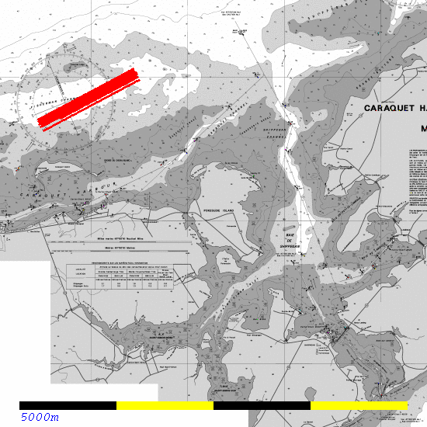

General Comments:
Weather was sunny then later overcast and rainy. Data acquisition was done in the QTC area after a 1.5 hour transit.
The F180 appears to be malfunctioning and giving strange orientations like 120 degree rolls and speeds of 4000 km/h. The orientation system was changed for the EM3000 to the secondary system before line 3200.
After the orientation system was changed, the numbering went back to 1 for the raw.all files.
Line 3200 was done in 2 parts due to the interference with the with the GPS from the radio.
ADCP stopped acquiring any velocity information. Upon inspection of the device, it was found that the protective cover had been bent on one side and was rattling considerably. It was removed which will hopefully account for the errors in the instrument.
The date of JUL015 was used for the ADCP files. These were changed in processing.

Data Acquisition:
ADT | Line Offset | EM # | KSUB # | KSS # | ADCP# | Comments
10:21 | 3920 | 1 | 1 | 1 | 0
10:47 | 3840 | 2 | 2 | 2 | 1
11:10 | 3760 | 3 | 3 | 3 | 2
11:36 | 3680 | 4 | 4 | 4 | 3
12:00 | 3600 | 5 | 5 | 5 | 4
12:25 | 3520 | 6 | 6 | 6 | 5
12:48 | 3440 | 7 | 7 | 7 | 6
13:13 | 3360 | 8 | 8 | 8 | 7 | F180 errors
13:52 | 3280 | 2 | 9 | 9 | 8
14:16 | 3200 |  | 10 | 10 | 9 | Stopped at 14:20
 |  |  |  |  |  | Apply MEV6 to real time SIMRAD data
14:30 | 3200 | 4 | 11 | 11 | 10/11 | ADCP errors
 | 3200 | 5 | 12 | 12 | 12 | ADCP errors

Monday July 28th

Skipper: Serge Lemay
Operators:

General Comments:
No acquisition today due to 30-40 knot winds with gusts of up to 50 knots from the West.

Data Acquisition:
ADT | Line Offset | EM # | KSUB # | KSS # | ADCP# | Comments

Tuesday July 29th

Skipper: Serge Lemay
Operators: Anya Duxfield

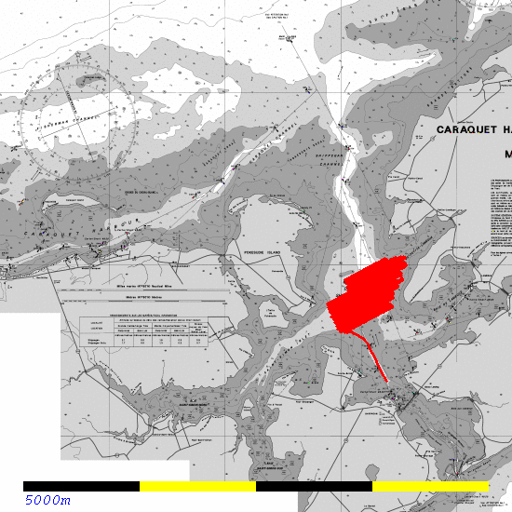

General Comments:
Sunny but the previous days high winds had produced quite a lot of chop. So it was rock and roll in Shippagan Bay working on completing the interleaving lines.
Made the decision to attempt to use the F180 because still did not have a heading string into the MRU. Unfortunately the F180 went down several times during the day, it seems just after I had made the decision that it had been fault free for so many lines we could safely go back to using it. So these lines are a mixture of F180 and MRU

Data Acquisition:
ADT | Line Offset | EM # | KSUB # | KSS # | ADCP# | Comments
1000 | 3120 | 2900 |  |  | 001 | MRU000_adcp transit.
0940 | 3040 | 2901 |  |  | 002 | MRU
0950 |  | 2902 |  |  | 003 | F180
 |  | 2903 |  |  | 004 | F180
 |  | 2904 |  |  | 005 | F180
 |  | 2905 |  |  | 006 | F180
 |  | 2906 |  |  | 007 | F180
 | 2640 | 2907 |  |  | 008 | F180
 | 2560 | 2908 |  |  | 009 | F180
 | 2480 | 2909 |  |  | 010 | F180
 | 2400 | 2910 |  |  | 011 | Lost F180 @ end of line.
 | 2320 | 2911 |  |  | 012 | MRU
 | 2240 | 2912 |  |  | 013 | MRU
 | 2160 | 2913 |  |  | 014 | MRU
 | 2080 | 2914 |  |  | 015 | F180
 | 2000 | 2915 |  |  | 016 | F180
 | 1920 | 2916 |  |  | 017 | F180
 | 1840 | 2917 |  |  | 018 | F180
 | 1760 | 2918 |  |  | 019 | F180
 | 1680 | 2919 |  |  | 020 | F180
 | 1600 | 2920 |  |  | 021 | F180 lost half way thru line
 | 1600 | 2921 |  |  | 022 | MRU
 | 1520 | 2922 |  |  | 023 | MRU
 | 1440 | 2923 |  |  | 024 | MRU
 | 1360 | 2924 |  |  | 025 | MRU
 | 1280 | 2925 |  |  | 026 | MRU
 | 1200 | 2926 |  |  | 027 | MRU
 | 1120 | 2927 |  |  | 028 | MRU
1530 | TRANSIT | 2928 |  |  | 029 | MRU
Wednesday July 30th

Skipper: Serge Lemay
Operators: Anya Duxfield

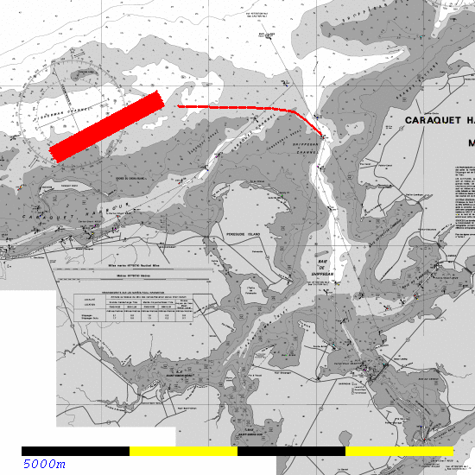

General Comments:
First time the weather has been in my favour for surveying the QTC area. Calm and warm.

Due to the problems with the F180 over the past few days we have opted to use the MRU -6. With Travis Wert’s help the VTG and VDA strings have been added to the telegrams for the Merlin and the Regulus software packages making the MRU’s solution a little more robust. However, I saw no issues with the F180 all day, I did delete all of the *.rd files stored on the internal flash card, which Jonathan Beaudoin informed me after consultation with Coda is very small (this could have been our problem all along).

Sync’ed the computer times.

Apart from that it was a very good day gathering the expected 10 lines on the QTC.

Disk space on all computers Heron 1, 2 and 3 getting tight, backup and deletion is required. CD burning seems to be going smoother since the purchase of Maxwell CD-R 700MB discs being purchased.

Data Acquisition:
ADT | Line Offset | EM # | KSUB # | KSS # | ADCP# | Comments
 |  | 3000 |  |  | 000
 |  | 3001
 | 3120 | 3002 | 001 | 001 | 001
 | 3040 | 3003 | 002 | 002 | 002
1110 | 2960 | 3004 | 003 | 003 | 003
1135 | 2880 | 3005 | 004 | 004 | 004
1200 | 2800 | 3006 | 005 | 005 | 005
1225 | 2720 | 3007 | 006 | 006 | 006
1246 | 2640 | 3008 | 007 | 007 | 007
1315 | 2560 | 3009 | 008 | 008 | 008
1323 | 2480 | 3010 | 009 | 009 | 009
1405 | 2400 | 3011 | 010 | 010 | 010
 | TRANSIT | 3012 |  |  |  | ADCP up

Thursday July 31th

Skipper: Serge Lemay
Operators: Beth-Anne Martin

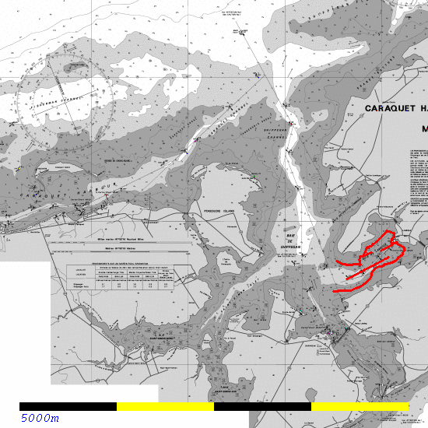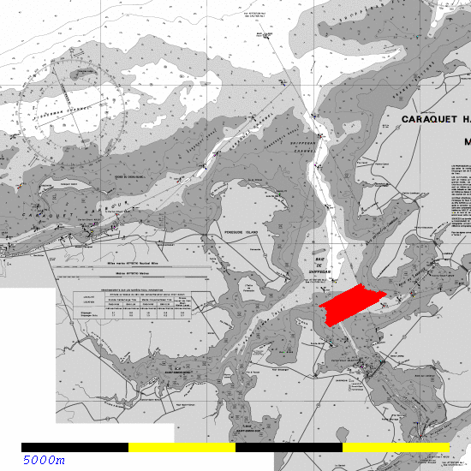

General Comments:

Early start due to Serge attending a funeral in the afternoon. Very calm in the morning and foggy. High tide allowed for the drying line in Lameque to be done. All instruments were run.
Motion sensor was changed to port 3 in case of errors in the F180 again. F180 was monitored the whole day without any problems noted.
Attempted to survey the QTC area however bad conditions forced us to stay in the harbour. Shippagan bay interleave was finished.
EM3000 line 3120 was stopped in the middle due to a call on the radio which caused a loss of GPS signal. 3121 is the continuation of that line.

Data Acquisition:
ADT | Line Offset | EM # | KSUB # | KSS # | ADCP# | Comments
6:55 |  | 3100 | 001 | 001 | 000 | Lameque Dry-line
 |  | 3101 | “ | 002 | “
 |  | 3102 | “ | “ | “
8:10 |  | 3103 | 002 | 003 | 001
8:15 |  | 3104 | 003 | 004 | “
8:30 |  | 3105 | 004 | 005 | 002 | Filling in Lameque holes
8:40 |  | 3106 | 005 | 006 | 003
9:00 |  | 3107 | 006 | 007 | 004
10:00 | 1040 | 3108 |  |  |  | Interleve
10:15 | 1040 |  |  |  | 005
10:30 | 0960 | 3110 |  |  | 006
10:40 | 0880 | 3111 |  |  | 007
10:45 | 0800 | 3112 |  |  | 008
10:55 | 0720 | 3113 |  |  | 009
11:05 | 0640 | 3114 |  |  | 010
11:15 | 0560 | 3115 |  |  | 011
11:25 | 0480 | 3116 |  |  | 012
11:37 | 0400 | 3117 |  |  | 013
11:40 | 0320 | 3118+3119 |  |  | 014
11:55 | 0240 | 3120 |  |  | 015 | Call on radio, lost GPS
12:15 | 0240 | 3121 |  |  | 016 | Back-tracked
12:17 | 0160 | 3122 |  |  | 017
12:30 | 0080 | 3123 |  |  | 018
12:45 | 0000 | 3124 |  |  | 019

Friday August 1st

Skipper: Serge Lemay
Operators: Beth-Anne Martin

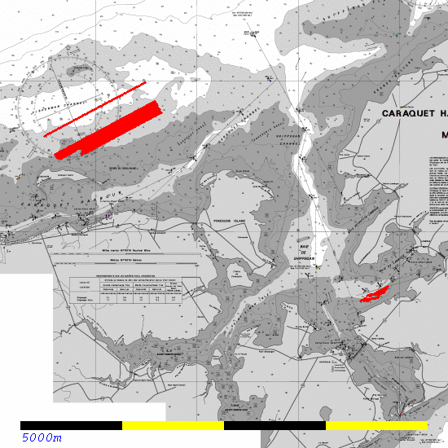

General Comments:
Weather was sunny and very calm. Excellent surveying conditions.
Left Marina at 7:45 to get gas at the coast guard base.
Using F180 again since there were no problems with it yesterday. No problems again today.
Began by filling in the lower area of Lameque bay. Had to divert around a mussel farm.
Went to QTC area next. One of the ADCP pins was bent shortly after putting it in the water when we got to the QTC area. Serge hammered it back in place. Did not occur again.
SVP dip was done. 4 dip attempts were done before we got a successful one.
Sidescan began numbering back at 1 after line 7. Probably due to restarting the program??
QTC lines are no longer full length as we are getting into shallow water on the western side.

Data Acquisition:
ADT | Line Offset | EM # | KSUB # | KSS # | ADCP# | Comments
8:50 | 1280 | 0100 | 001 | 001 | 000 | Lameque Bay
 |  | 0101 | 002 | 002 | 001 | Diverted for buoys
9:00 | 1280 | 0102 | 003 | 003 | 002
9:10 | 1200 | 0103 | 004 | 004 | 003
9:15 | 1120 | 0104 | 005 | 005 | 004
9:20 | 1200 | 0105 | 006 | 006 | 005
9:25 | 1120 | 0106 | 007 | 007 | 006
11:00 | 3360 | 0107 | 008 | 001 | 007 | Sidescan began number at 1 again.
11:30 | 2320 | 0108,0109,0110 | 009 | 002 | 008
11:55 | 2240 | 0111 | 010 | 003 | 009
12:20 | 2160 | 0112 | 011 | 004 | 010
12:45 | 2080 | 0113 | 012 | 005 | 011 | Stopped for Buoy rope
1:02 | 20800 | 0114 | 013 | 006 | 012
1:10 | 19202000 | 0115 | 014 | 007 | 013
1:35 | 18401920 | 0116 | 015 | 008 | 014
1:52 | 17601840 | 0117 | 016 | 009 | 015
2:10 | 16801760 | 0118 | 017 | 010 | 016
2:30 | 1680 | 0119 | 018 | 011 | 017

Saturday August 2nd

Skipper: Serge Lemay
Operator: Anya Duxfield

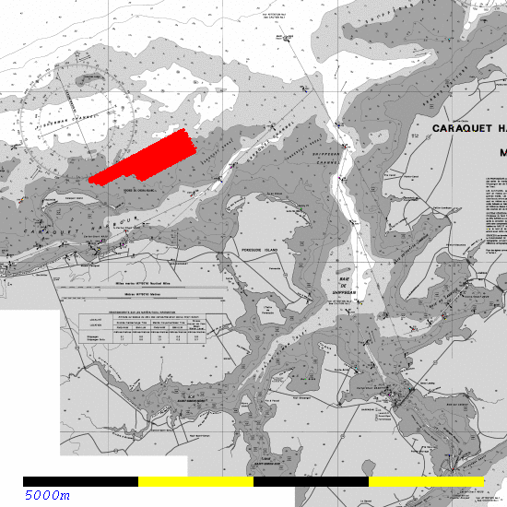

General Comments:
Weather overcast, 22 celcius, low seastate and small breeze.
Marine weather report suggested a perfect day to collect data on QTC. However lines driven towards the east into a slight roll that the overnight breeze had created caused some stripeing in the sidescan.

Using F180 for motion and position, no problems at all today.

Diesel fumes into the boat at times was very bad today.

SVP-16 refused to co-operate at all today, I think the batteries need changing will change tomorrow. Decided after four attempts to use August 1 profile, I saw no refraction problems in EM3000 data.

Caraquet Shoal is very shoal even with the high tide (0900 ~140cm) it was not prudent to collect the short lines centre bottom of the QTC area today. Chart seems slightly inaccurate, missing some shoal areas to the north of the Caraquet Shoal. Completed QTC area today…apart from three very short lines up against the shoalest area of Caraquet shoal.

Data Acquisition:
ADT | Line Offset | EM # | KSUB # | KSS # | ADCP# | Comments
 | 480 | 0200 | 001 | 001 | 000
 | 560 | 0201 | 002 | 002 | 001 | Sidescan 002 not good quality
 | 640 | 0202 | 003 | 003 | 002
 | 720 | 0203 | 004 | 004 | 003
 | 800 | 0204 | 005 | 005 | 004
 | 880 | 0205 | 006 | 006 | 005
 | 960 | 0206 | 007 | 007 | 006
 | 1040 | 0207 | 008 | 008 | 007
 | 1120 | 0208 | 009 | 009 | 008
 | 1200 | 0209 | 010 | 010 | 009
 | 1280 | 0210 | 011 | 011 | 010 | Good sidescan
 | 1360 | 0211 | 012 | 012 | 011
 | 1440 | 0212 | 013 | 013 | 012 | Ran out of disk space on Heron 2
 | 1440 | 0213 | 014 | 014 | 013
 | 1520 | 0214 | 015 | 015 | 014
 | 1600 | 0215 | 016 | 016 | 015
 | 1680 | 0216 | 017 | 017 | 016

Sunday August 3rd

Skipper: Serge Lemay
Operators: Anya Duxfield

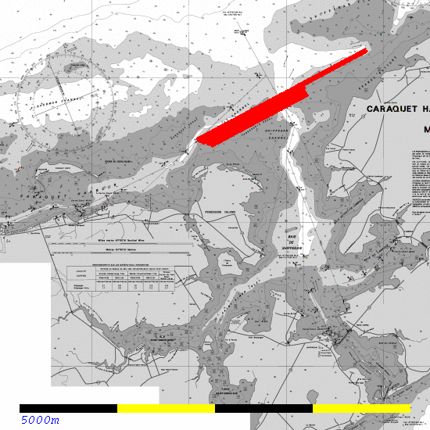

General Comments:
An extension was started at the mouth of Shippagan Channel.
80 metre line spacing still.
SVP profile used from August 1st.
Attempted to change batteries on the SVP however, the power connector wires were torn away from their soldering points. SVP is now out of commission until fixed.

Data Acquisition:
ADT | Line Offset | EM # | KSUB # | KSS # | ADCP# | Comments
9:40 | 10960 | 300 | 001 | 001 | 000
10:15 | 11040 | 0301 | 002 | 002 | 001
 | 11040 | 0302 | 003 | 003 | 002 | VHF
10:45 | 11120 | 0303 | 004 | 004 | 003
11:10 | 11200 | 0304 | 005 | 005 | 004
11:30 | 11280 | 0305 | 006 | 006 | 005
12:02 | 11360 | 0306 | 007 | 007 | 006
12:30 | 11440 | 0307 | 008 | 008 | 007
12:57 | 11520 | 0308 | 009 | 009 | 008
 | 11520 | 0309 | 009 | 009 | 008
13:40 | 11600 | 0310 | 010 | 010 | 009
13:56 | 11600 | 0311 | 010 | 010 | 009
 | 11680 | 0312 | 011 | 011 | 010
 | 11680 | 0313 | 011 | 011 | 010

Monday August 4th

Skipper: Theo Gionet
Operators: Anya Duxfield and Beth-Anne Martin

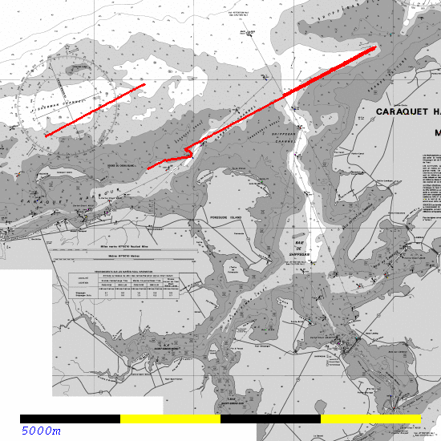

General Comments:
Half day due to no skipper in the morning.
Foggy with a slight breeze from the East and a temperature of 28 degrees C.
Using the july 30 SVP profile since SVP is not working. Minimal refraction was found using that day’s data.
Line 3200 was redone in the QTC area as there appeared to be a missing line.
The rest of the lines were building out of the channel. One complete line was surveyed and another was completed to the middle of the channel where we will pick it up another day.

Data Acquisition:
ADT | Line Offset | EM # | KSUB # | KSS # | ADCP# | Comments
 | 3200 | 0400 | 001 | 001 | 000 | QTC
 |  | 0401 | 002 | 002 | 001 | Base
 | 11760 | 0402 |  |  | 001
 | 11760 | 0403 | 003 | 003 | 001
 | 11760 | 0404 | 003 | 003 | 001
 | 11840 | 0405 | 004 | 004 | 002

Tuesday August 5th

Skipper: Theo Gionet
Operators: Beth-Anne Martin

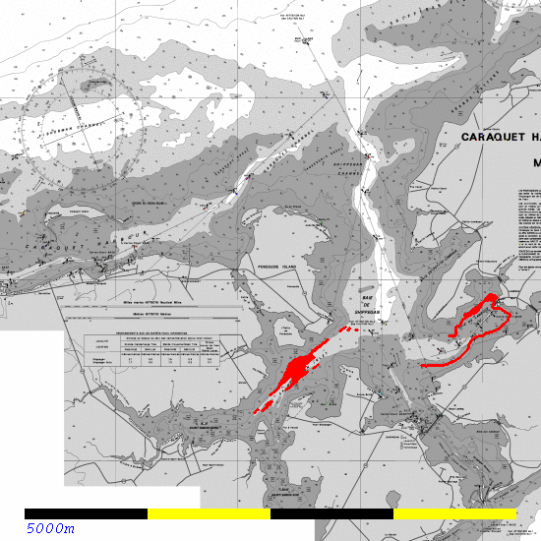

General Comments:
Cloudy day with moderate winds in the morning, building up to higher easterly winds in the afternoon.
Using the July 30th SVP profile again.
A continuation was done in the Lameque dryline project to fill in a gap between the drying line from the 31st and the 4th of July. All instruments were run.
Multiple holes were then filled in the Saint-Simon Baie region and an extension was done on the northern part of the bay to get 100% multibeam coverage. ADCP was also used.
Returned to the marina an hour early due to high winds and waves.

Data Acquisition:
ADT | Line Offset | EM # | KSUB # | KSS # | ADCP# | Comments
8:50 |  | 0500 | 001 | 001 | 000 | Lameque Dryline
 |  | 0501
9:30 |  | 0502 | 002 | 002 | 001
9:35 |  | 0503 | 003 | 003 | 002
9:50 |  | 0504 | 004 | 004 | 003
10:15 |  | 0505 |  |  | 004
10:20 |  | 0506 |  |  | 005
 |  | 0507 |  |  | 006
 |  | 0508 |  |  | 007
 |  | 0509 |  |  | 008
10:45 |  | 0510 |  |  | 009
 |  | 0511 |  |  | 010
10:55 |  | 0512 |  |  | 011
 |  | 0513 |  |  | 012
11:00 |  | 0514 |  |  | 013
 |  | 0515 |  |  | 014
11:05 |  | 0516 |  |  | 015
11:10 |  | 0517 |  |  | 016
 |  | 0518 |  |  | 017
11:15 |  | 0519 |  |  | 018
11:20 |  | 0520 |  |  | 019
11:25 |  | 0521 |  |  | 020
11:27 |  | 0522 |  |  | 021
 |  | 0523 |  |  | 022
11:35 |  | 0524 |  |  | 023
12:15 |  | 0525 |  |  | 024
12:35 |  | 0526 |  |  | 025
12:40 |  | 0527 |  |  | 026
12:50 |  | 0528 |  |  | 027
1:00 |  | 0529 |  |  | 028
1:07 |  | 0530 |  |  | 029
1:15 |  | 0531 |  |  | 030
1:28 |  | 0532 |  |  | 031
1:30 |  | 0533 |  |  | 032
1:37 |  | 0534 |  |  | 033
1:43 |  | 0535 |  |  | 034
1:50 |  | 0536 |  |  | 035
1:56 |  | 0537 |  |  | 036
2:03 |  | 0538 |  |  | 037
2:09 |  | 0539 |  |  | 038
2:13 |  | 0540 |  |  | 039
2:17 |  | 0541 |  |  | 040
2:21 |  | 0542 |  |  | 041
2:25 |  | 0543 |  |  | 042
2:28 |  | 0544 |  |  | 043
2:31 |  | 0545 |  |  | 044
2:35 |  | 0546 |  |  | 045
2:40 |  | 0547 |  |  | 046

Wednesday August 6th

Skipper: Theo Gionet
Operators: Beth-Anne Martin

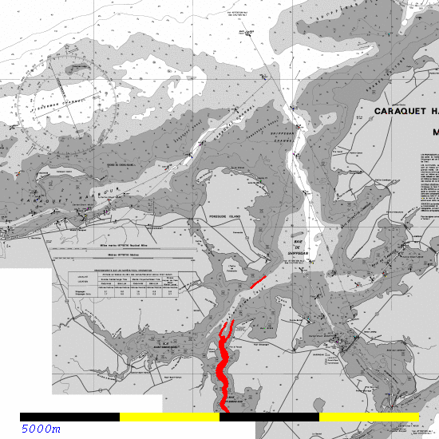

General Comments:
Rainy day with winds up to 30 knots from the East. Working in Saint-Simon Sud since it is very sheltered.
Using SVP profile from July 29th.
Running all instruments down the bay. Collected only em3000 and adcp for a while to obtain 100% coverage.
Interesting features found in the bay. Appear to be well defined sand waves.
Went back to the marina at noon due to the high wind and waves.

Data Acquisition:
ADT | Line Offset | EM # | KSUB # | KSS # | ADCP# | Comments
9:00 |  | 0600 |  |  | 000
9:07 |  | 0601 |  |  | 001
9:20 |  | 0602 | 001 | 001 | 002
 |  | 0603 | 001 | 001 | 002
9:59 |  | 0604 | 002 | 002 | 003
 |  | 0605 | 002 | 002 | 003
10:50 |  | 0606 | 003 | 006 | 004
11:05 |  | 0607 | 004 | 004 | 005
11:20 |  | 0608 | 005 | 005 | 006
11:35 |  | 0609 | 006 | 006 | 007
11:50 |  | 0610 |  |  | 008
11:55 |  | 0611 |  |  | 008
12:00 |  | 0612 | 007 | 007 | 009

Thursday August 7th

Skipper: Theo Gionet
Operators: John Hughes Clarke (morning), Anya Duxfield and Beth-Anne Martin (afternoon)

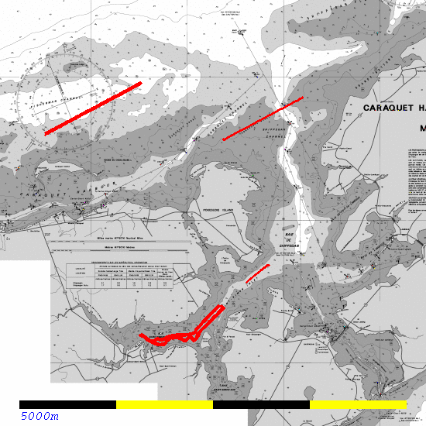

General Comments:
Weather was cloudy and foggy with moderate winds from the East.
The morning was done by John with Mike and Katherine from DFO.
An extension was done on the Western side of Baie Saint-Simon.
The afternoon was spent filling in gaps in the data. A corrupted line was found in the QTC so offset 3120 and 3040 were re-surveyed.
Another gap was found in the channel so offset 10880 was run. All instruments were run everywhere except during the transit which was only the em3000.
SVP from July 29th was used.
John worked on the MVP in the evening. Should be finished by noon tomorrow.

Data Acquisition:
ADT | Line Offset | EM # | KSUB # | KSS # | ADCP# | Comments
 |  |  |  |  | 000 | Transit
 |  | 1 |  | 1 | 000
 |  | 2 | 1 | 2
 |  | 3 | 2 | 3 | 001
 |  | 6 | 3 | 4 | 002
 |  | 7 | 4 | 5 | 003
 |  |  |  |  | 004
1:42 |  | 8 |  |  | 005
1:45 |  | 9
1:47 |  | 10
 |  | 11
 |  | 12
 |  | 13
 |  | 14
2:40 | 3120 | 15 | 5 | 6 | 006 | QTC
3:05 | 3040 | 16 | 6 | 7 | 007
3:50 | 10880 | 17 | 7 | 8 | 008 | Shippagan Base

Friday August 8th

Skipper: Theo Gionet
Operators: John Hughes Clarke

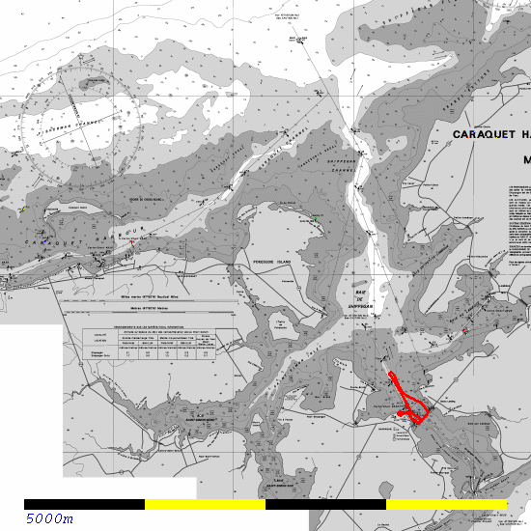

General Comments:
MVP was reinstalled and tested. Appears to be functioning normally
Transit data was collected along the channel leading to the Coast Guard base.

Saturday August 9th

Skipper: Theo Gionet
Operators: John Hughes Clarke

General Comments:

12 hour tidal cycle was done in Shippagan Bay using the MVP and the ADCP.

Sunday August 10th

Skipper: Theo Gionet
Operators: John Hughes Clarke

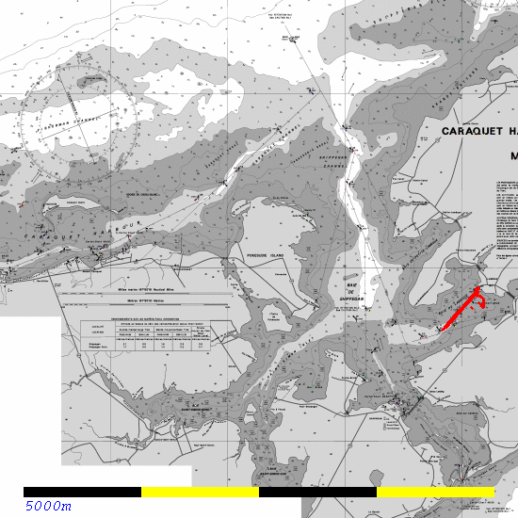

General Comments:
100 % multibeam coverage was achieved in Lameque Bay.
Mooring line was caught in the propeller. John dove under it and cut the propeller free. No lasting damage done to the boat.

Monday August 11th

Skipper: Theo Gionet
Operators: John Hughes Clarke

General Comments:
12 Hour tidal cycle was done in Lameque Bay. MVP and ADCP were used.

