Grand Manan Hydrographic Survey

Cruise Report
C.S.L. Heron
July 18-28, 2002
Grand Manan, New Brunswick

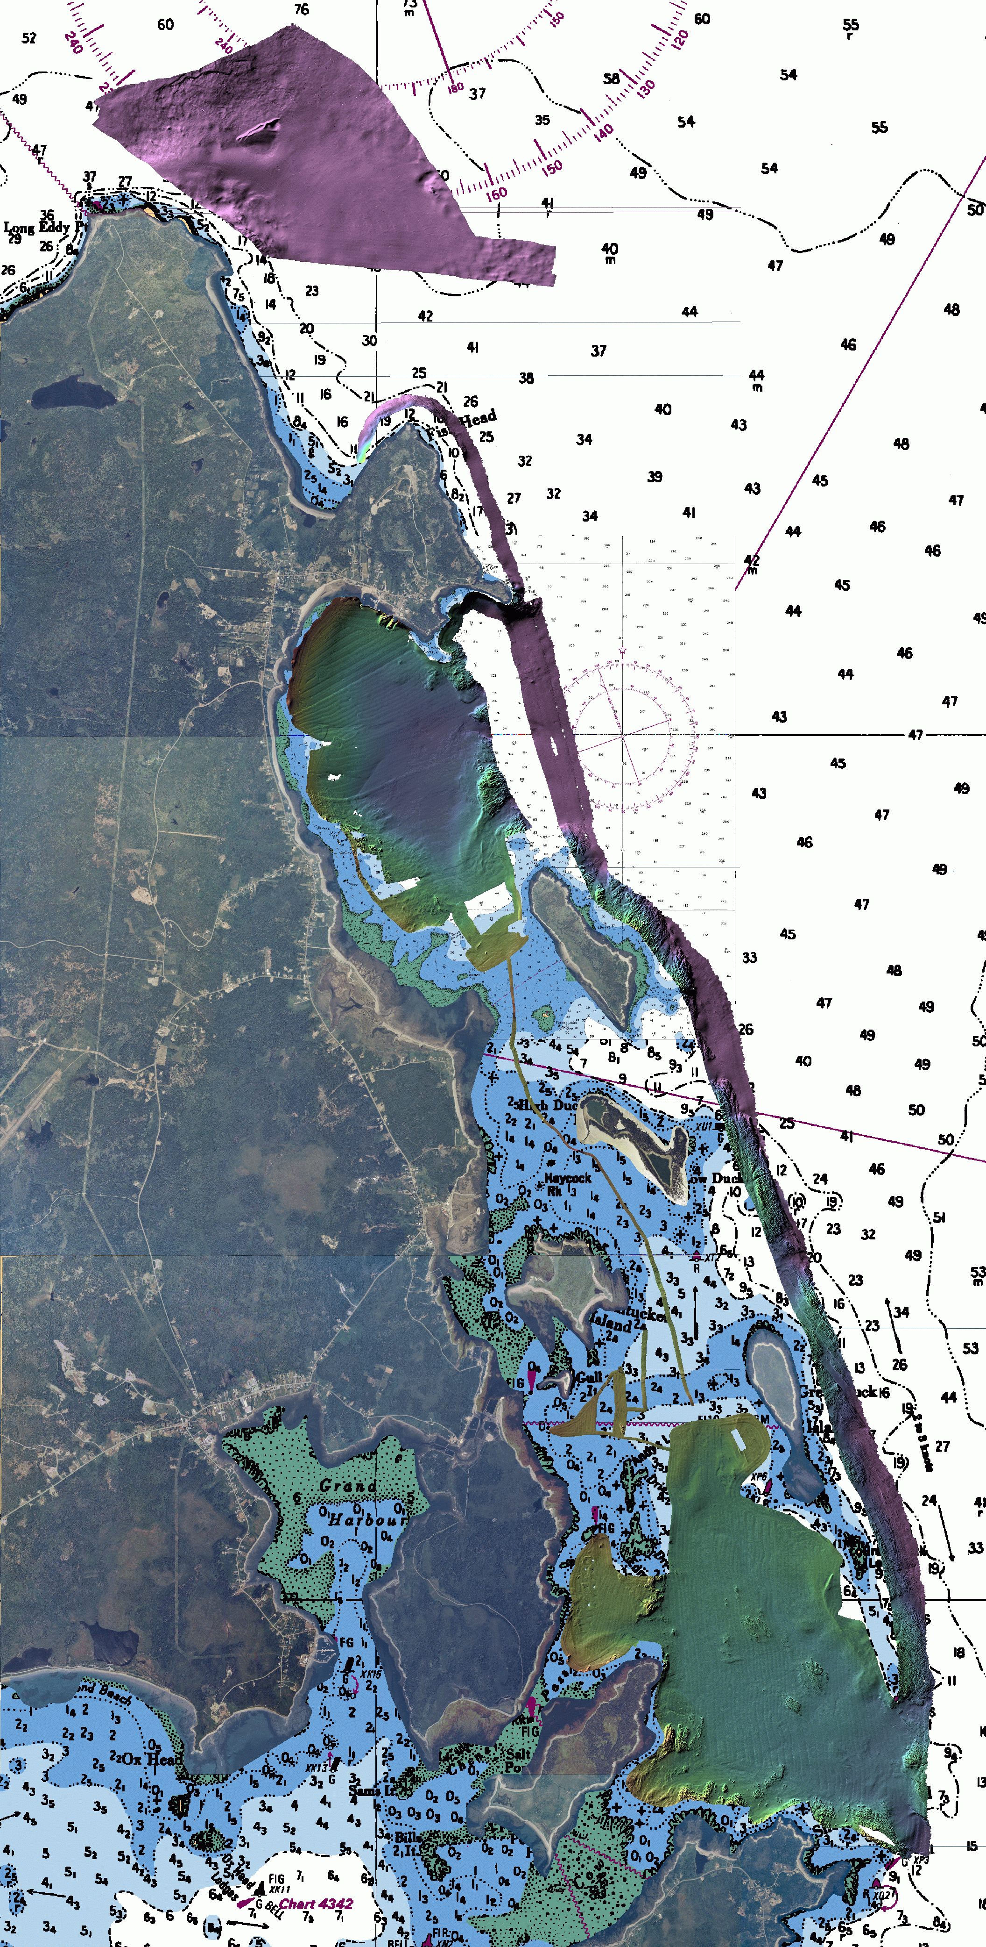

 |  |  | 

Jennifer Coppola
GGE 5083

Table of Contents

1.0 Background 4
1.1 Location of Surveys 4
1.2 Survey Objective and Partners 4
1.3 Previous Work 5
2.0 Survey Parameters 6
2.1 Tidal Control 6
2.2 Horizontal Positioning 6
2.3 Geodetic Measurements 6
3.0 Personnel and Equipment 7
3.1 Personnel 7
3.2 Equipment 7
3.2.1 Echosounder 7
3.2.2 MVP-30 7
3.2.3 MRU-6 8
3.2.4 Gyrocompass 8
3.2.5 DGPS 8
4.0 Survey Operations 8
4.1 Patch Test 8
4.2 Survey Areas 8
4.2.1 Northern Head 8
4.2.2 Long Island Bay 10
4.2.3 Duck Island Sound 10
4.3 Transit Lines 10
5.0 Data Processing 11
5.1 Multibeam Bathymetry and Backscatter Processing 11
5.2 Tide Corrections 11
6.0 Final Products 13
7.0 Log Summary 15

List of Figures

Figure 1. Location of Grand MANAN. …………………………………….………………4

Figure 2. Location of CHS Survey Monument 1980-3…………………………….…….6

Figure 3. Location of Survey Areas…………………………………………………….…9

Figure 4. Comparison Between Observed and Predicted Tide Heights……………12

figure 5. Processed Bathymetry and Backscatter for Northern Head………….13

Figure 6. Processed Bathymetry and Backscatter for Long Island Bay………...14

Figure 7. Processed Bathymetry and Backscatter for Duck Island Sound…..…14

List of Tables

Table 1. Average difference between observed and predicted tides. 11

1.0 Background

1.1 Project Location

Grand Manan is a small island situated in the mouth of the Bay of Fundy (Figure 1). The island’s main industries are fishing and aquaculture, and tourism. Aquaculture, namely salmon and scallop, occurs around the island, in and around Duck Island Sound, and on the western side of the island. The island is also a popular excursion for tourists, who, among other things are attracted to the naturalness of the island, and the chance to view seabirds, porpoises, seals, and many species of endangered whales.

A 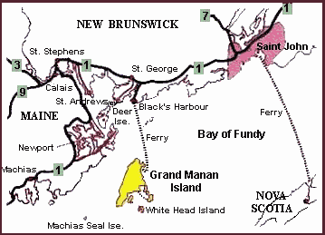  http://new-brunswick.net/new-brunswick/grdmanan/location.html | B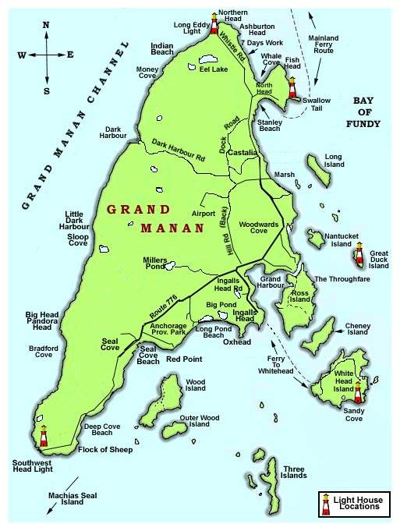  http://www.rootsweb.com/~nbgrandm/map.htm
Figure 1. A) Grand Manan is located in the mouth of the Bay of Fundy. B) Map of Grand Manan.

1.2 Survey Objective and Partners

The survey was conducted from July 18th to July 28th, 2002 by the Ocean Mapping Group (OMG) of the University of New Brunswick (UNB). The vessel used was the CSL Heron, a 34-foot long hydrographic survey launch on loan to OMG by the Canadian Hydrographic Service.

The objective of this survey was to collect multibeam and backscatter data. Data was gathered in three different areas along the Eastern and Northern coasts of Grand Manan Island, for three different clients:

- Around the aquaculture sites of Duck Island Sound for Peter Lawton of the Department of Fisheries and Oceans, St. Andrews.
- Offshore Northern Head for David Johnston of Duke University and The Grand Manan Seabird and Whale Association.
- Within Long Island Bay for Russell Parrot of the Canadian Geological Survey.

Each of these clients desired information on the surveyed areas for their different research interests.

1.3 Previous Work

In preparation for the construction of the new ferry terminal in North Head, Grand Manan Island in 1999, dredged material from the site was placed on the seafloor adjacent to the west side of the existing terminal. Materials taken deeper from within the excavated hole were used to cap the dredged sediments. From May 6-18, 2002, the CCGS JL Hart and hydrographic survey launch Plover, under direction of the Geological Survey of Canada (GSC), conducted a survey of the sediment deposition site. The purpose of the survey was to examine whether material had leached from the disposal area. Data was collected with multibeam and sidescan sonar, sub-bottom profiler, seafloor photographs, underwater video transects, and seafloor samples. Specific equipment used are listed as follows:
- Simrad MS992 dual frequency (120 and 330 kHz) sidescan sonar
- IKB Seistec sub-bottom profiler and Track Point II acoustic positioning system
- Simrad EM3000 multibeam sonar
- 0.1 m³ vanVeen sediment grab sampler
- 35 mm camera
- Underwater video system

2.0 Survey Parameters

2.1 Tidal Control

The Bay of Fundy has tides that range up to 9 metres in height. Accurate measurement of tides for this survey, therefore, is of the utmost importance, as they have a direct impact on the accuracy of bathymetric measurements. To measure the tides, a measuring tape was fixed to a ladder at the North Head wharf. Measurements were taken every 5 minutes. The accurate height of the tape was found by leveling from Canadian Hydrographic Control Monument 1980-3, located in the cement curbing of the ramp on the north side of the building at the head of Conner’s Cannery Wharf (Figure 2). The point from where tide measurements were taken was found to be 7.996 metres above chart datum.
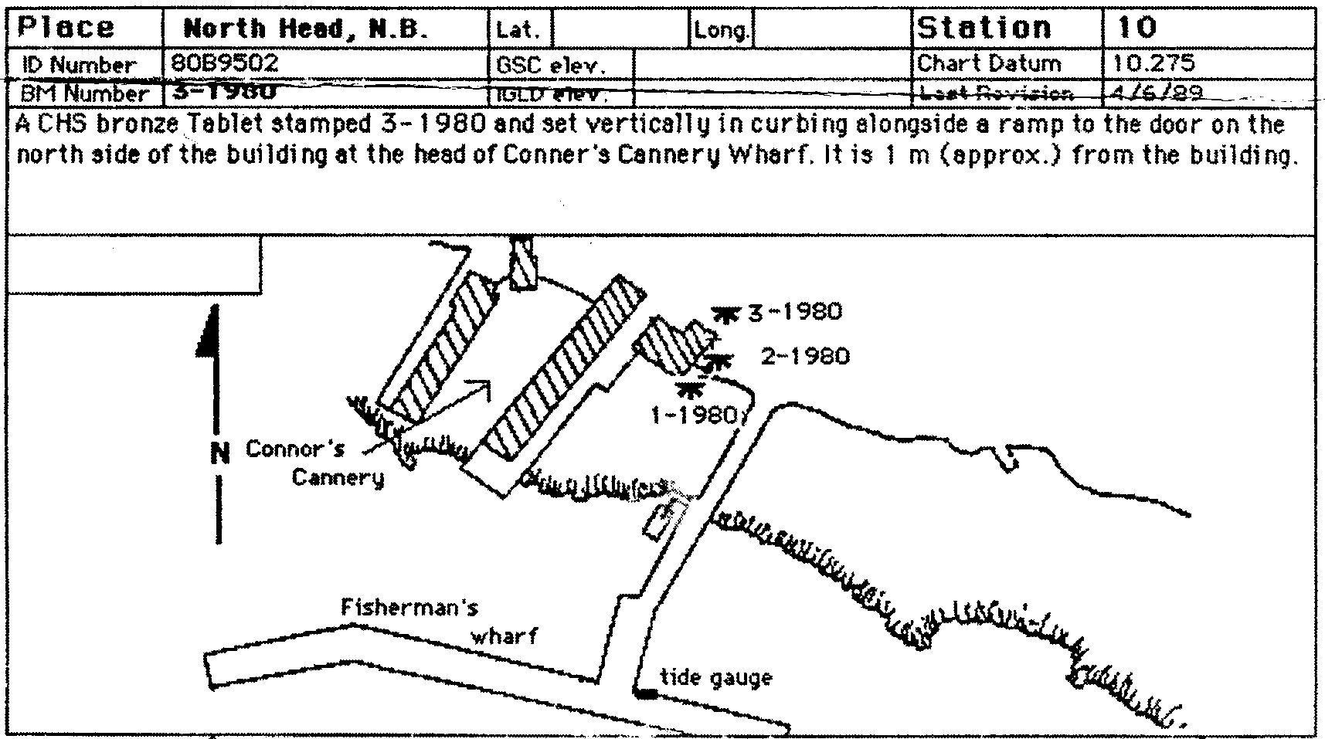
Figure 2. Location of CHS Monument 1980-3 beside Conner’s Cannery Wharf.

2.2 Horizontal Positioning

Horizontal positioning was determined using differential GPS from the Canadian Coast Guard. Thales’ LandStar was used as a back-up system.

2.3 Geodetic Measurements

Parameters

Ellipsoid: WGS-84
Datum: WGS-84
Projection: New Brunswick Orthogonal Mercator
Units: Metres

3.0 Personnel and Equipment

3.1 Personnel

John Hughes Clarke Supervisor
Anya Duxfield Survey Leader
Jennifer Coppola Surveyor, Data Processor
Loren Fleet Heron Captain
Tom Tide observer
Aaron Tide observer

3.2 Equipment

The major equipment used onboard were the following:
- Simrad EM3000 kHz Multibeam Echosounder
- Brook Ocean Technology Moving Vessel Profiler (MVP-30)
- MRU 6 for motion compensation
- S.G. Brown SGB 1000S Gyrocompass
- Trimble GPS with Coast Guard and LandStar differential ability
- Alderbaran II electronic chart

3.2.1 Echosounder

The Simrad EM3000 forms 127 echosounder beams, with a beamwidth of 1.5 degrees, and swath angle of 65 degrees to either side. The EM3000 provides bathymetric data, and backscatter data that provides information similar to a sidescan sonar image. The backscatter images give information on the character of the seafloor roughness. Areas of high backscatter are indicative of consolidated surfaces, and are represented on backscatter images as lighter areas. Conversely, areas of low backscatter indicate of unconsolidated surfaces, and are represented by darker areas on backscatter images.

3.2.2 MVP-30

The MVP measures the pressure (depth), temperature and salinity of the water column. This data is used to create a sound velocity profile, which is, in turn, used to correct refraction issues of the echosounder beams. The MVP was deployed using a winch system mounted to the stern of the boat. It was lowered, under manual control, to within a few metres above the bottom.

3.2.3 MRU-6

The MRU-6 is an inertial attitude sensor that determines the heave, pitch, and roll of the vessel. The instrument also includes a magnetic heading sensor. The attitude information is combined with GPS positioning, which allows attitude corrections to be applied at the correct time, to the correct beam pings, with accuracy to 0.01 degrees.

3.2.4 Gyrocompass

The SGB 1000S gyrocompass gives reference to true north. Output was fed into the echosounder interface and Alderbaran to show the real-time heading of the vessel.

3.2.5 DGPS

Horizontal positioning for navigation and bathymetric purposes was determined using DGPS from the Canadian Coast Guard. Thales’ LandStar was used as a back-up system. Output from the receiver was fed into the echosounder operating system and Alderbaran for positioning.

4.0 Survey Operations

4.1 Patch Test

Prior to surveying, a patch test is required to ensure the correct transducer alignments and offsets are applied in the software. Four lines were run over the same track in Flagg Cove, the first at high speed, and the second two at low speed. The reciprocal lines were run to test roll, pitch, and yaw offsets, time delay, and gyrocompass misalignments. The corrections were calculated and applied to the MRU or Simrad. Two additional lines were then run to test the corrections.

4.2 Survey Areas

Surveys of three different areas of Grand Manan were performed: offshore Northern Head, Long Island Bay, and Duck Island Sound. The locations of the survey areas, as well as their approximate dimensions, are shown in Figure 3. Day to day, the survey areas chosen were dictated by weather and tides, and equipment failure. The survey lines were run with variable spacing, overlapping the outer portion of the swath to the previous line’s nadir. This ensured 200 percent data coverage.

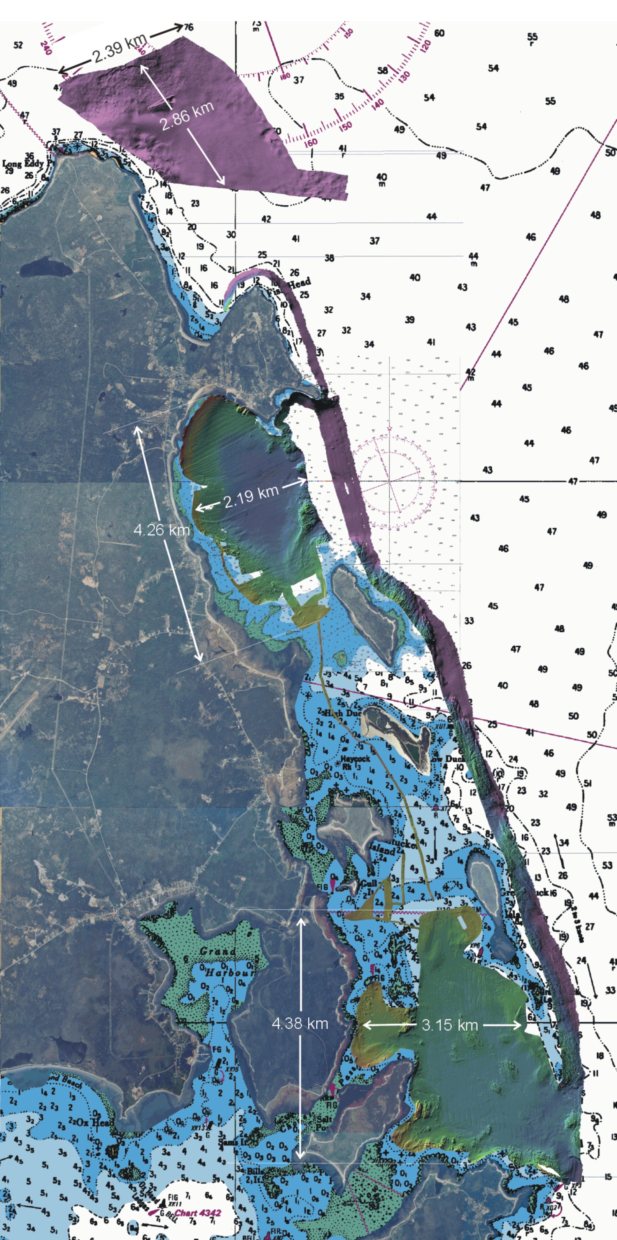

Northern Head

Transit Lines

Long Island Bay

Duck Island Sound
Figure 3. Location of survey areas.
4.2.1 Northern Head

The Northern Head survey was conducted for David Johnston of Duke University and the Grand Manan Whale and Seabird Association. Mr. Johnston provided OMG with coordinates of a polygon for the area of interested. Due to time constraints, only a portion of the polygon was surveys.

4.2.2 Long Island Bay

The survey in Long Island Bay was a continuation of a survey conducted earlier than summer by Russell Parrott of the GSC. OMG was provided with a Digital Terrain Model (DTM) of the area previously surveyed, which was loaded into the navigation/chart display interface. Survey lines were run, building on the area. Permission was given by one owner to survey inside a weir in Long Island Bay.

4.2.3 Duck Island Sound

Peter Lawton of the St. Andrew Biological Station, DFO, provided OMG with areas of interest for aquaculture, and possible lobster and scallop spawning sites. These were located in Flagg Cove and off Cheney Island/White Head, and into the deeper channel areas into Cow Passage, and between Edmunds Rock and northern Cheney Island. Surveying was done in between the aquaculture pens in Duck Island Sound, where feasible. In the northern part of Duck Island Sound, this was not possible due to anchorage lines and buoy obstructions.

4.3 Transit Lines

Survey lines were collected throughout the surveys, en-route from the dock at North Head to each survey area, and between survey areas. These were processed along with the other survey data.

5.0 Data Processing

5.1 Multibeam Bathymetry and Backscatter Processing

Lines were unraveled in real-time to an OMG format using processing software written by John Hughes Clark of the Ocean Mapping Group, UNB. Lines were gridded and mosaiced to determine the bathymetric and backscatter coverage, respectively. Holes resulted in some areas of data coverage due to dropouts in the outer beams of the swath.

Data processing was conducted using SwathEd for data cleaning, and other OMG binary software. Processing was performed at UNB, after the completion of the survey. Appendix A contains a detailed description of the processing steps and binaries used for creating the final map products.

5.2 Tide Corrections

Observed tidal measurements do not cover the entire survey period. For survey periods with incomplete tidal observations, predicted tides were derived for the North Head tidal station (44.0° 46.0’N; 66.0° 45.0’W), using WXTide32 Version 3.1, Copyright Michael Hopper (1998-2003). The predicted and observed tide heights were plotted (Figure 4). The average differences between predicted and observed tides were compared (Table 1). By observing the differences in height between observed and predicted, the missing data could be filled in through interpolation and extrapolation. Tables of the combined tide heights used for the surveys are included in Appendix B. Predicted tides used for processing the GSC survey in North Head were generated with the program Tides and Currents Pro for Windows version 3.0h by Nobeltec Corporation. These are included in Appendix C.

Table 1. Average difference between observed and predicted tides.

Julian Day | Average Difference (m)
199 | 0.1355
200 | 0.0953
201 | 0.0256
203 | -0.0548
204 | -0.0524
208 | -0.2038
209 | -0.0668

A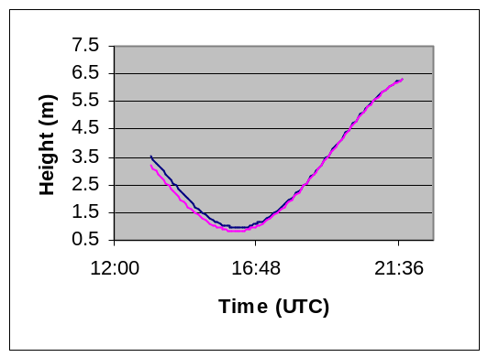 | B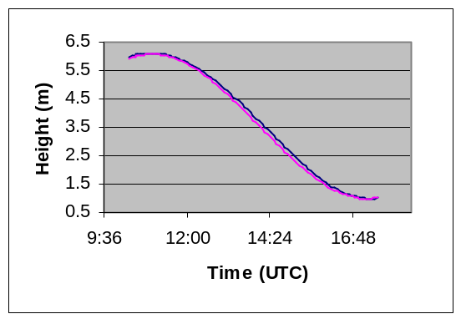
C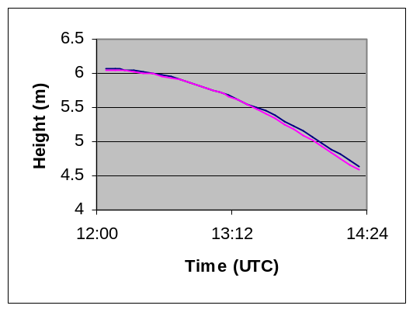 | D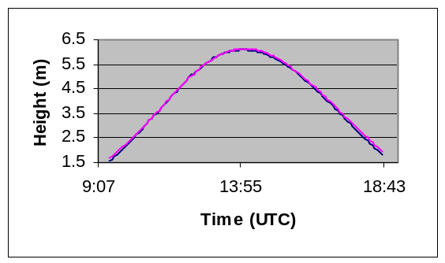
E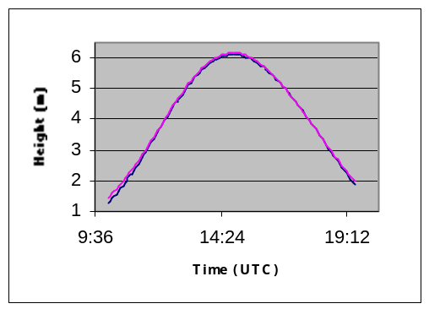 | F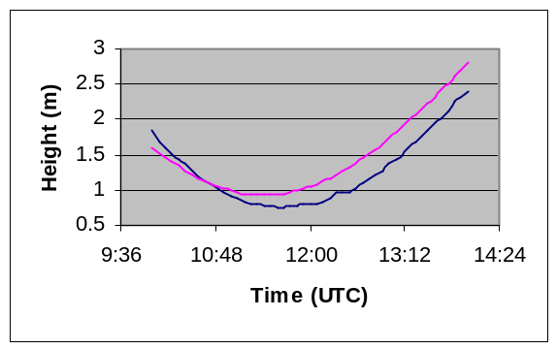
G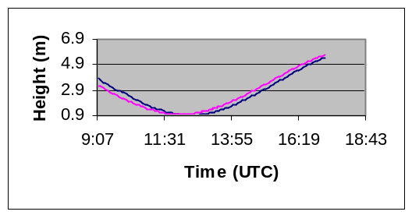

Figure 4. Comparison between observed (blue line) and predicted (pink line) tide heights for Julian Days 199 (A), 200 (B), 201 (C), 203 (D), 204 (E), 208 (F), and 209 (G).

6.0 Final Products

The resulting products for the Grand Manan survey consisted of a series of maps for each client, depicting an overview of the entire survey area (5 metre resolution), and a high (2 metre) resolution image of their particular area of interest. Each client was provided with a map illustrating bathymetric data, and a map illustrating backscatter. High-resolution images of the three areas are shown in Figures 5, 6, 7.

A 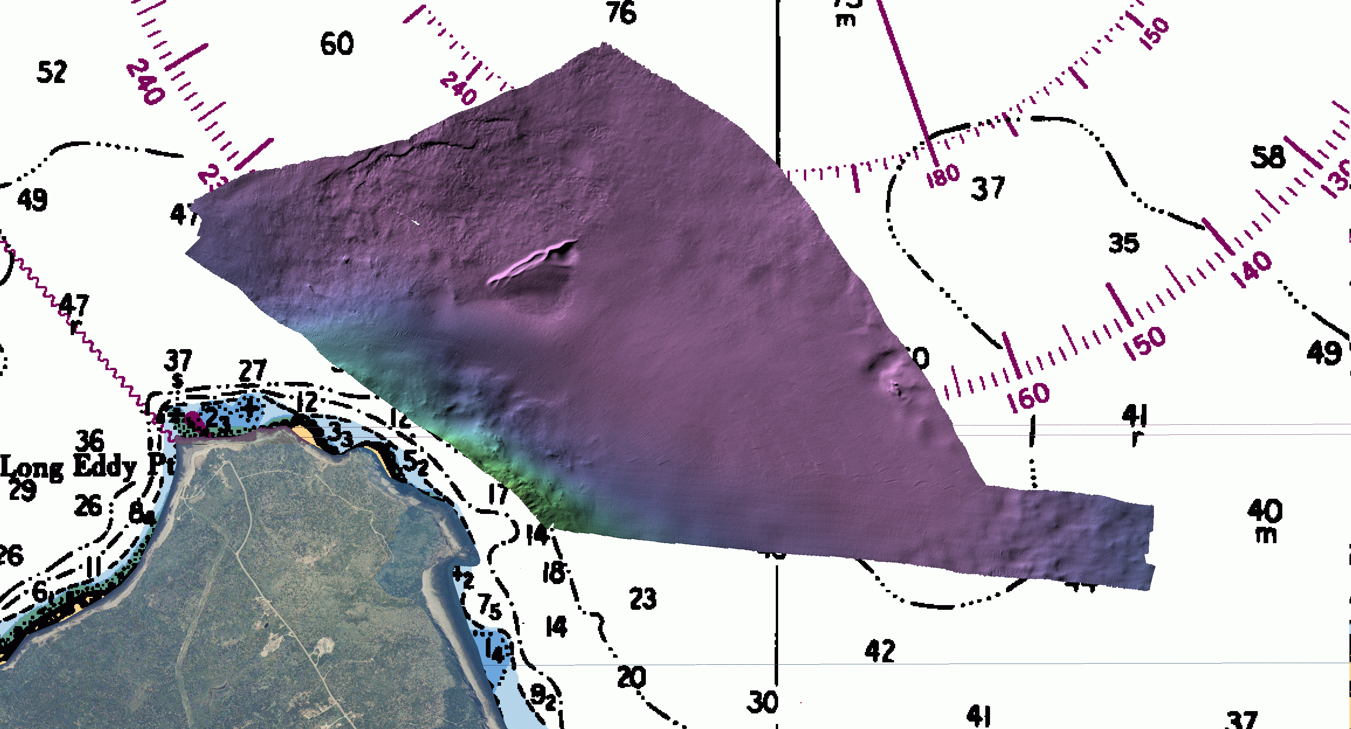

B 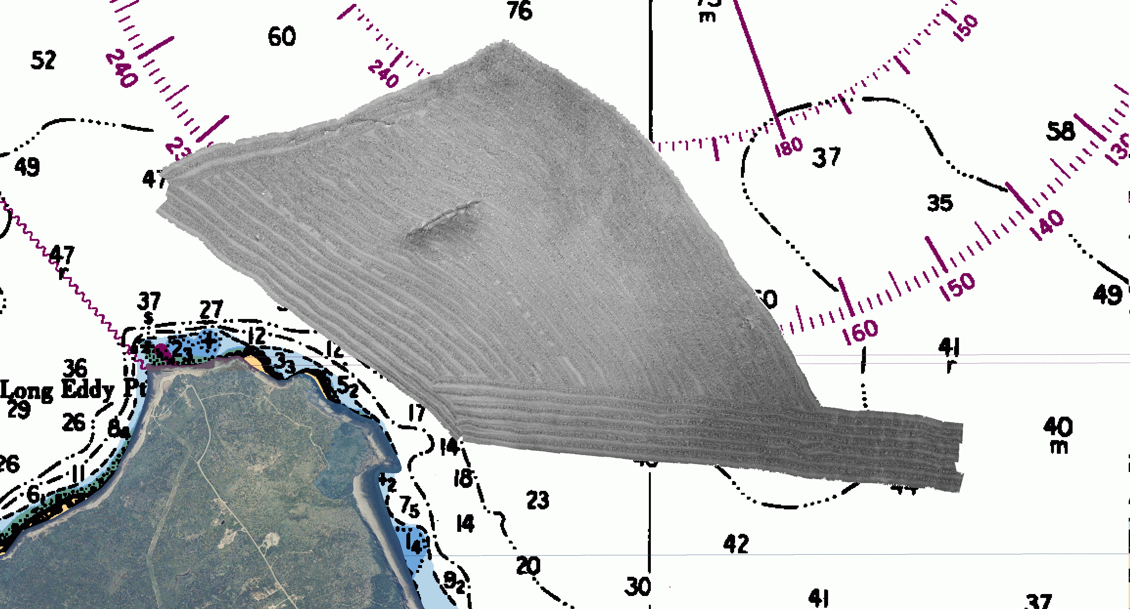
Figure 5. Processed bathymetry (A) and backscatter (B) for Northern Head.

A 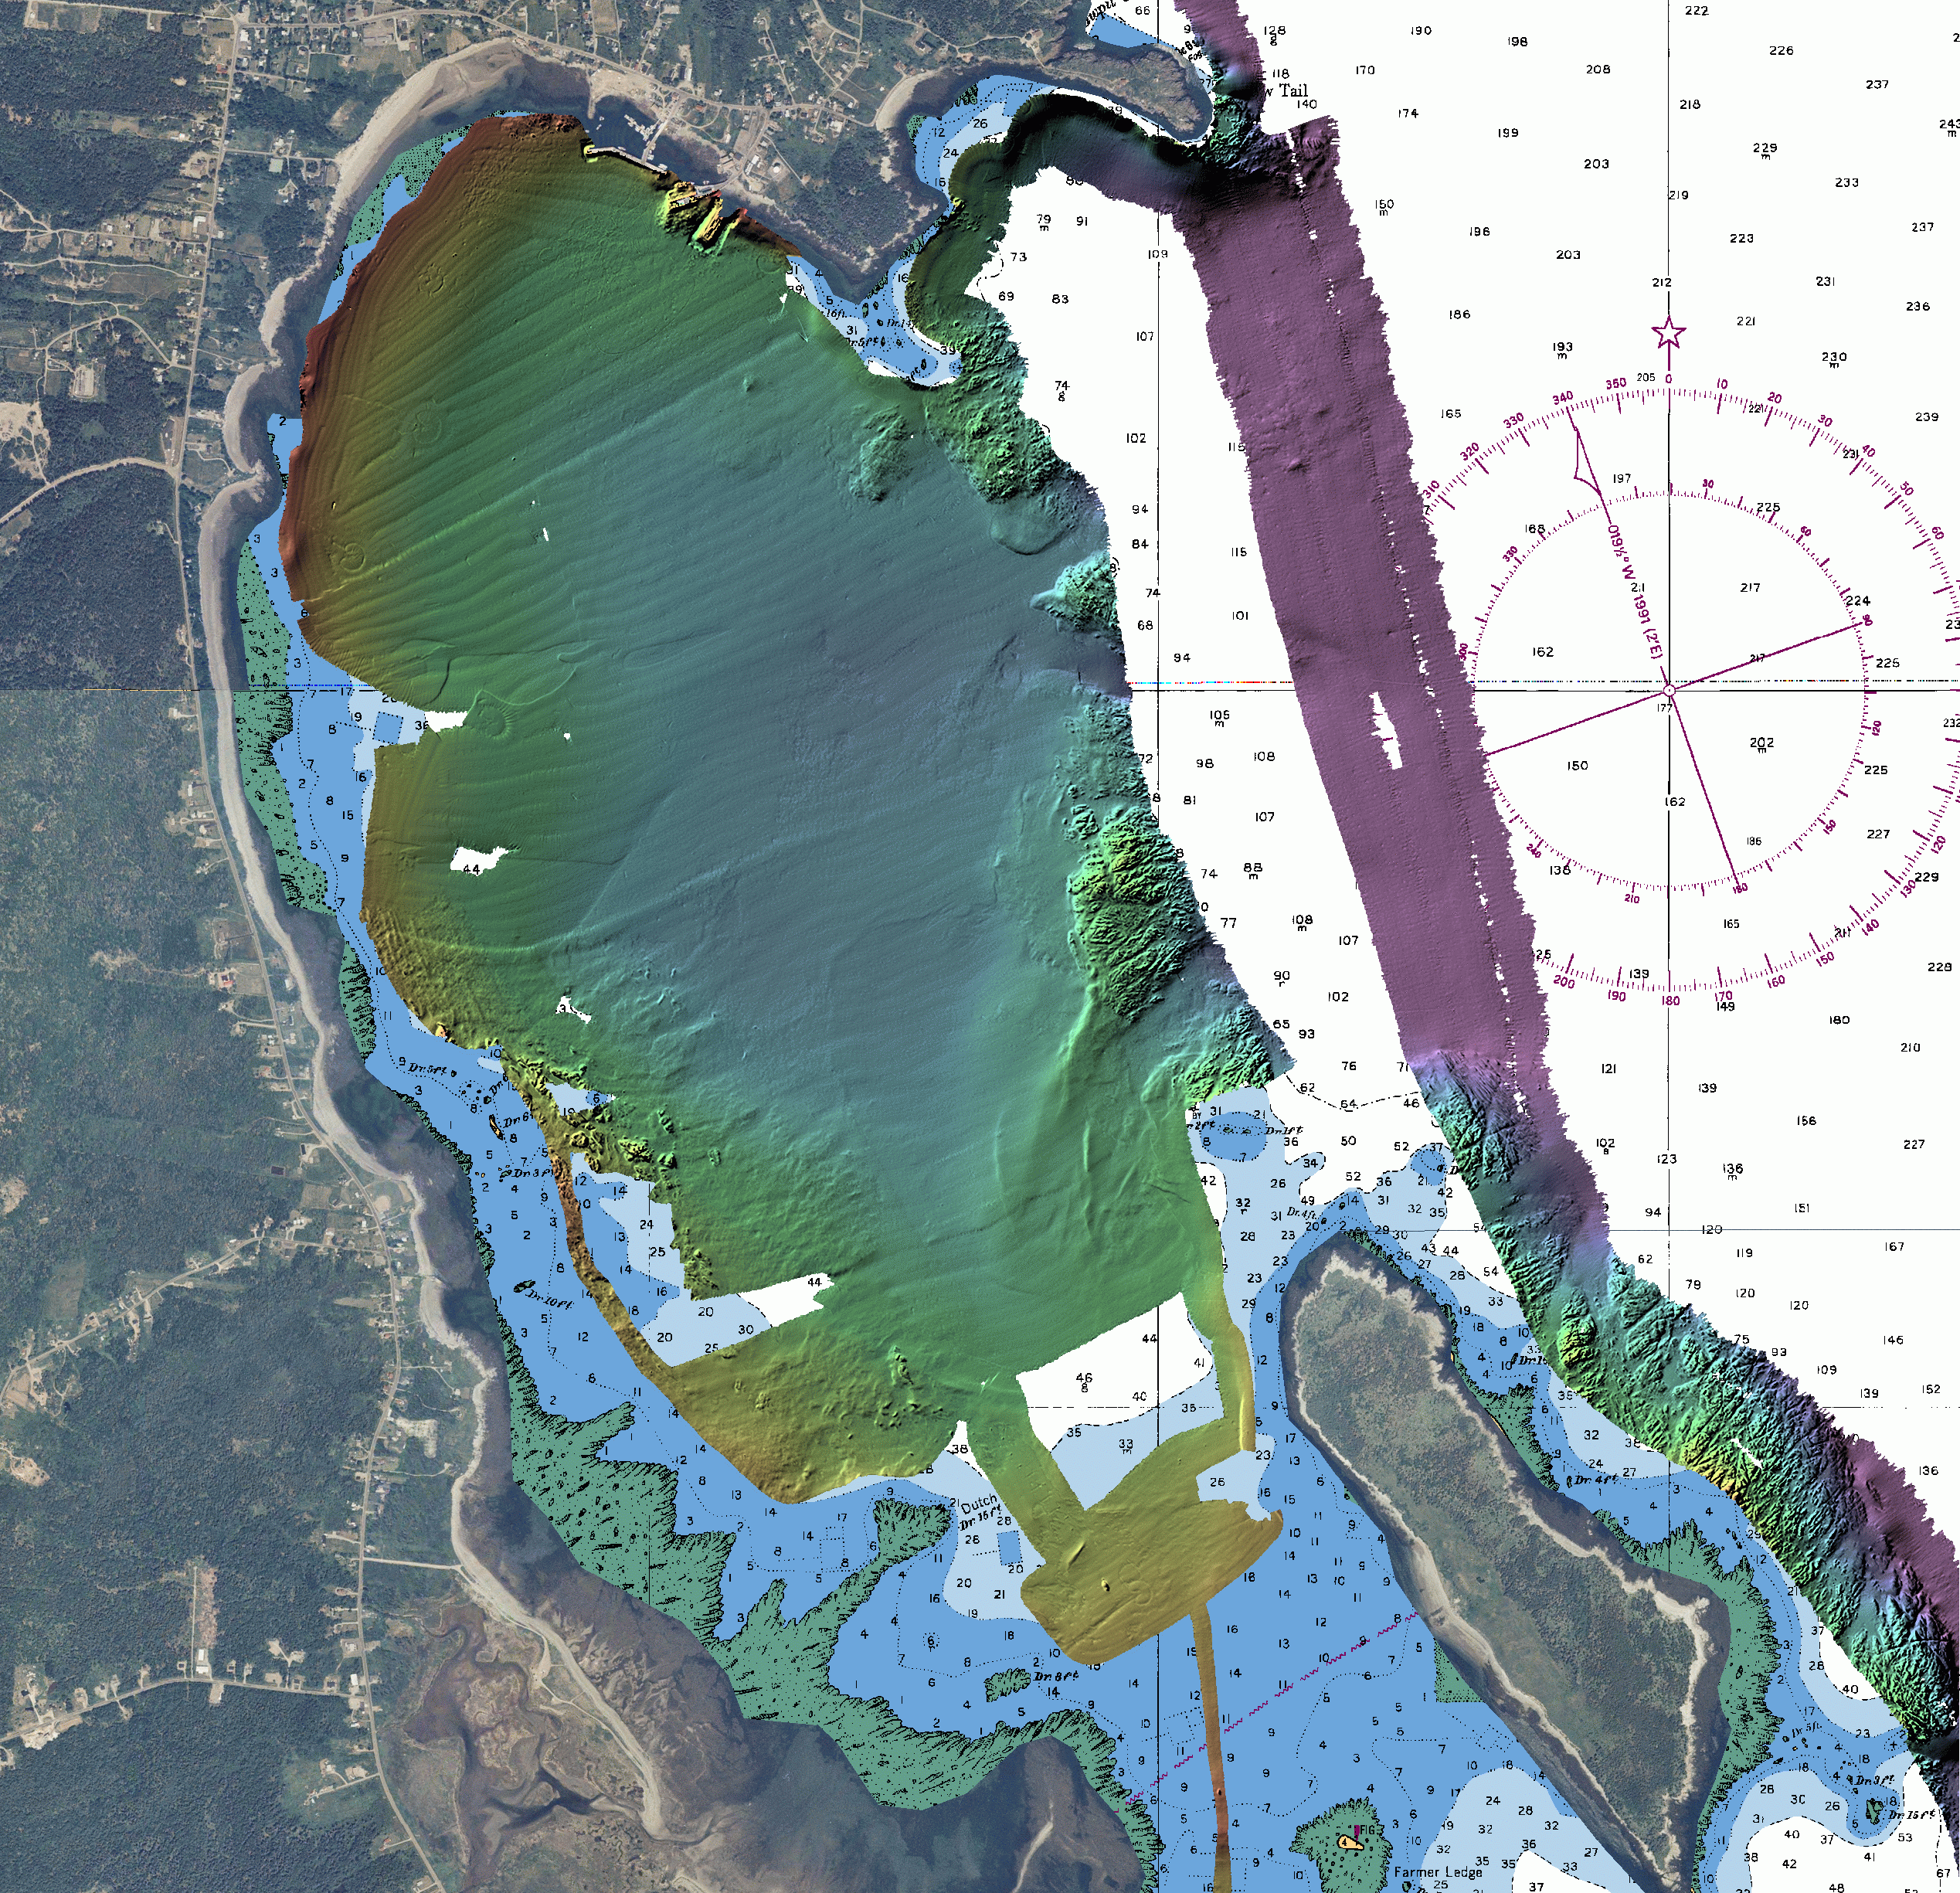 | B 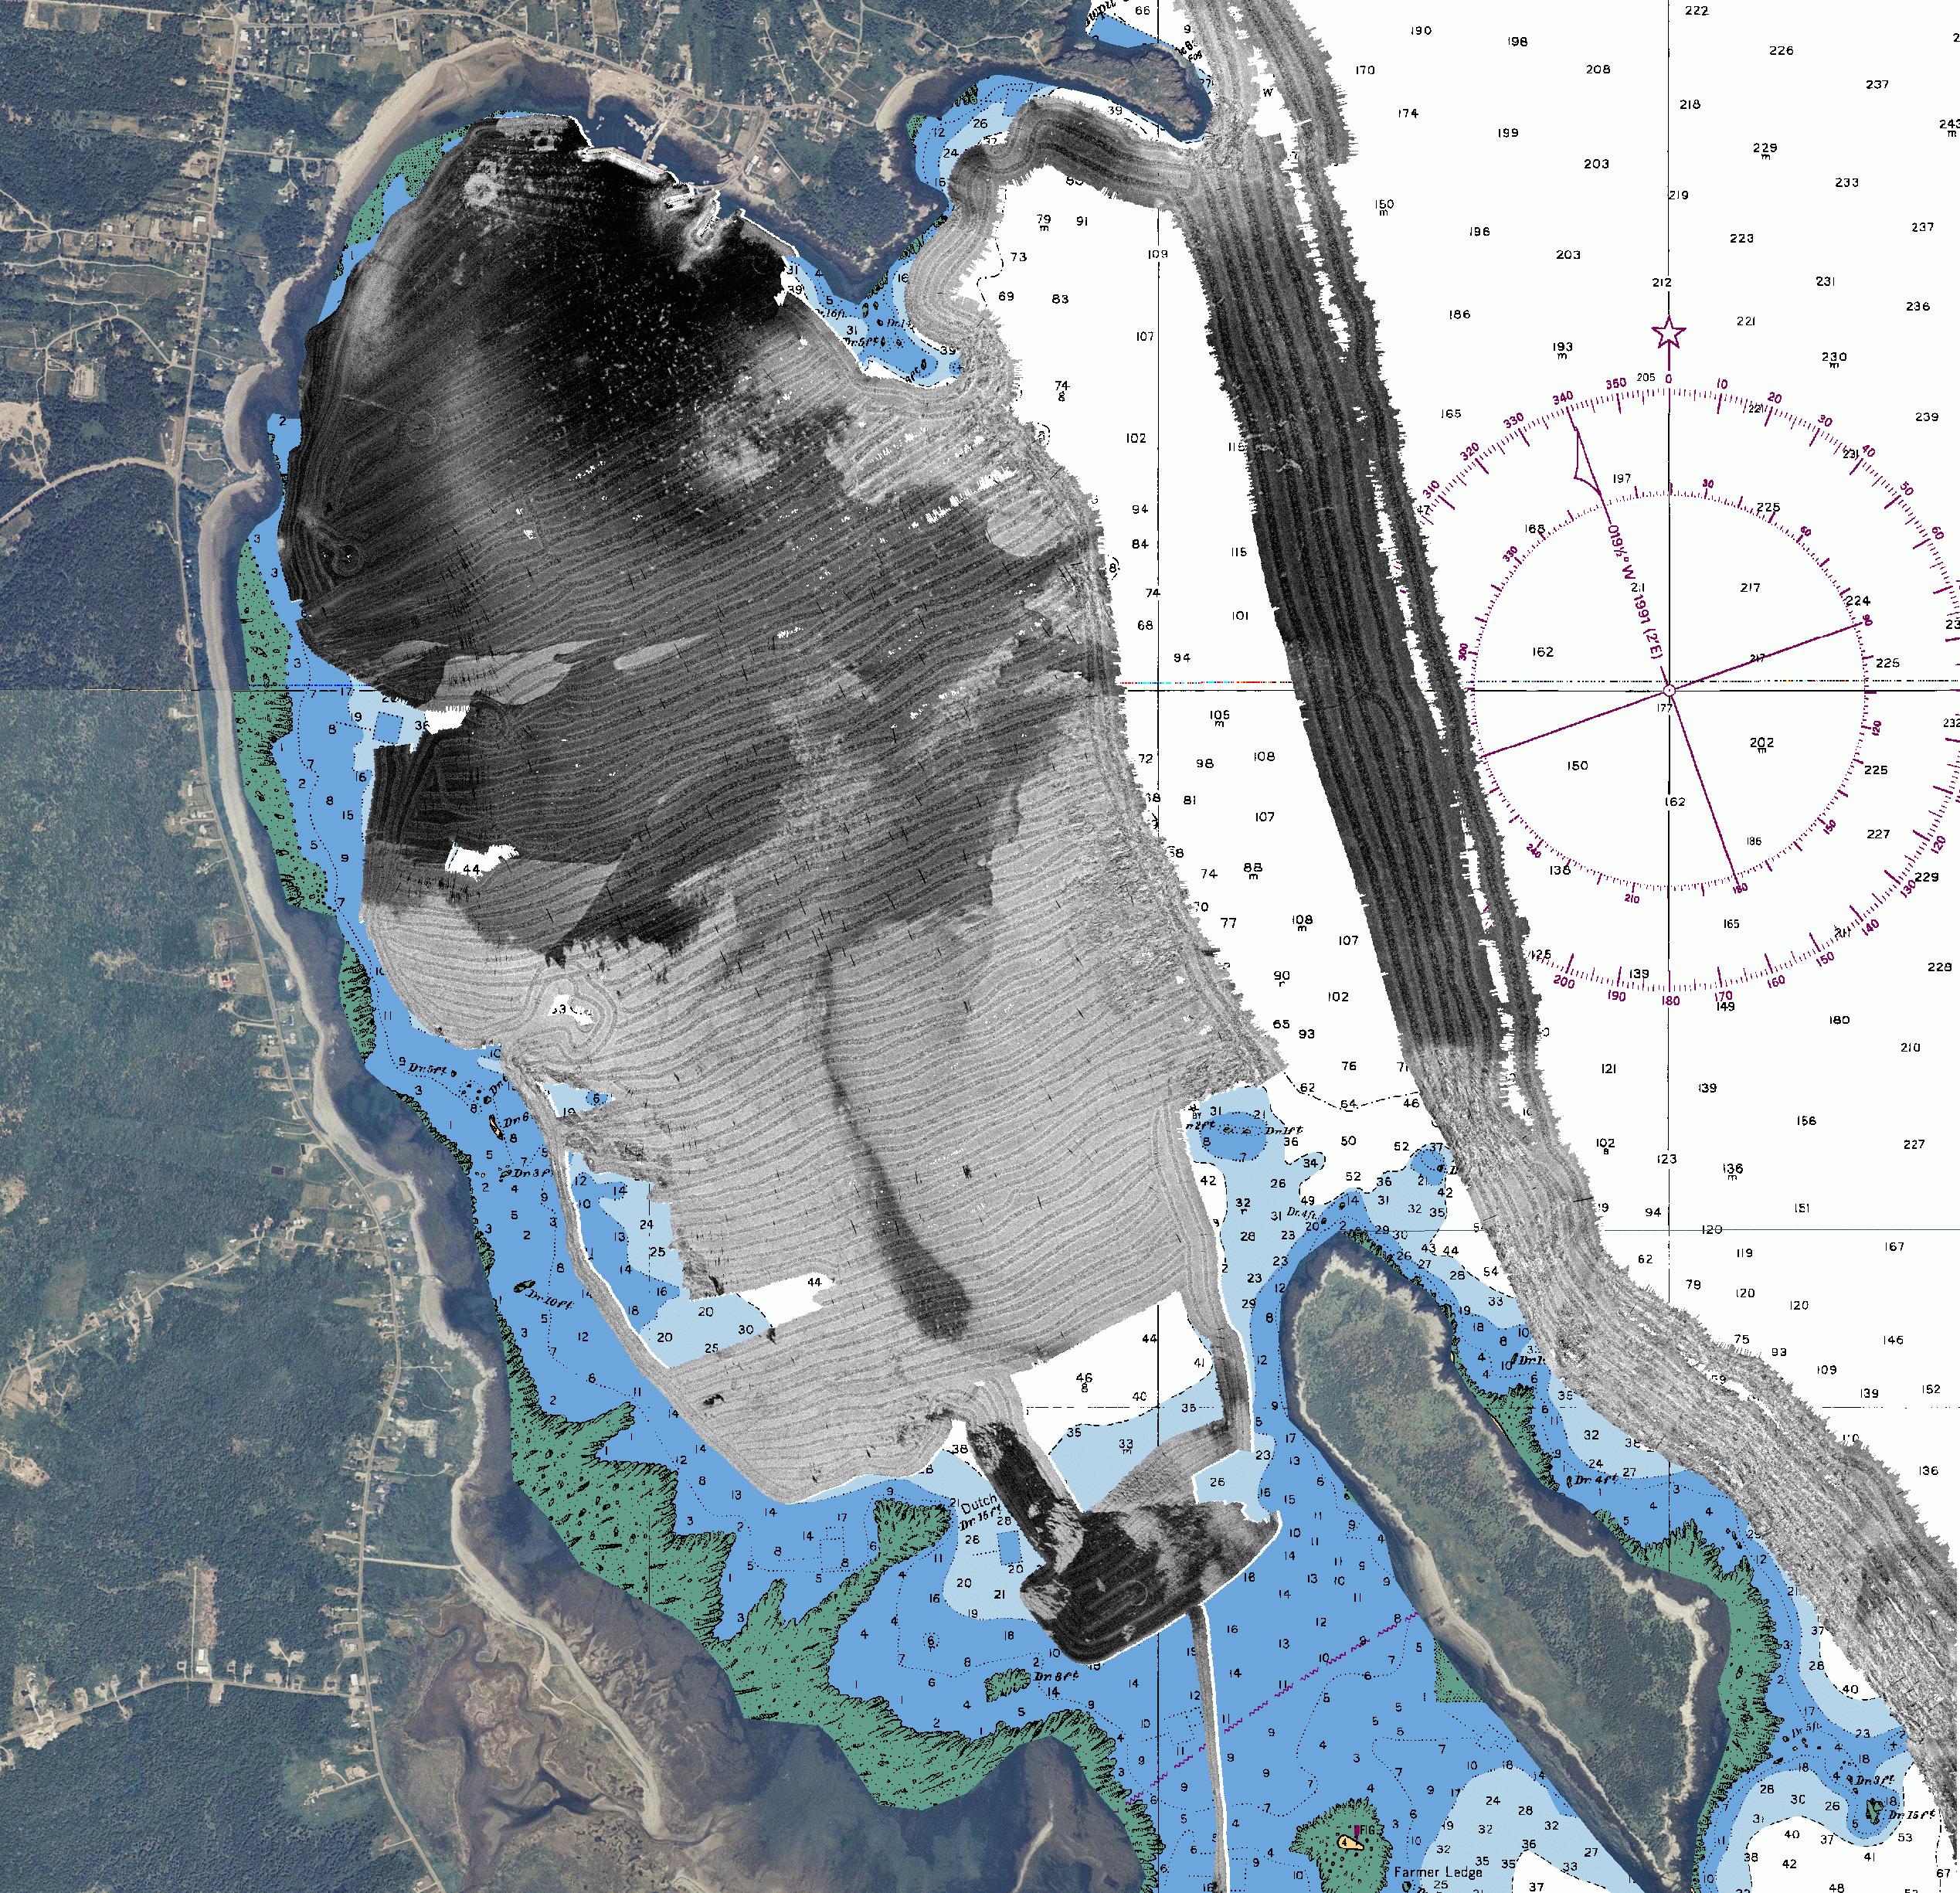
Figure 6. Processed bathymetry (A) and backscatter (B) for Long Island Bay.

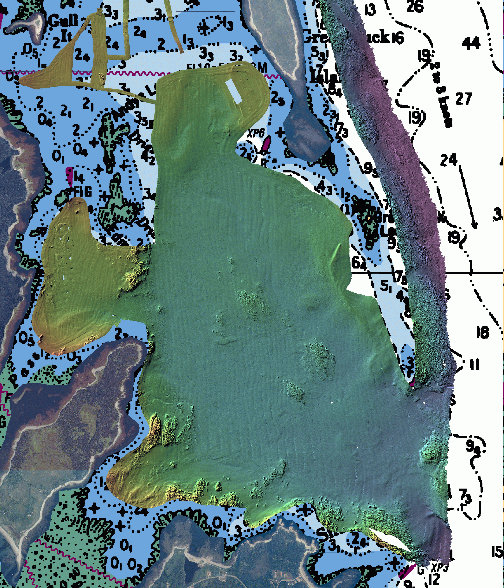 | 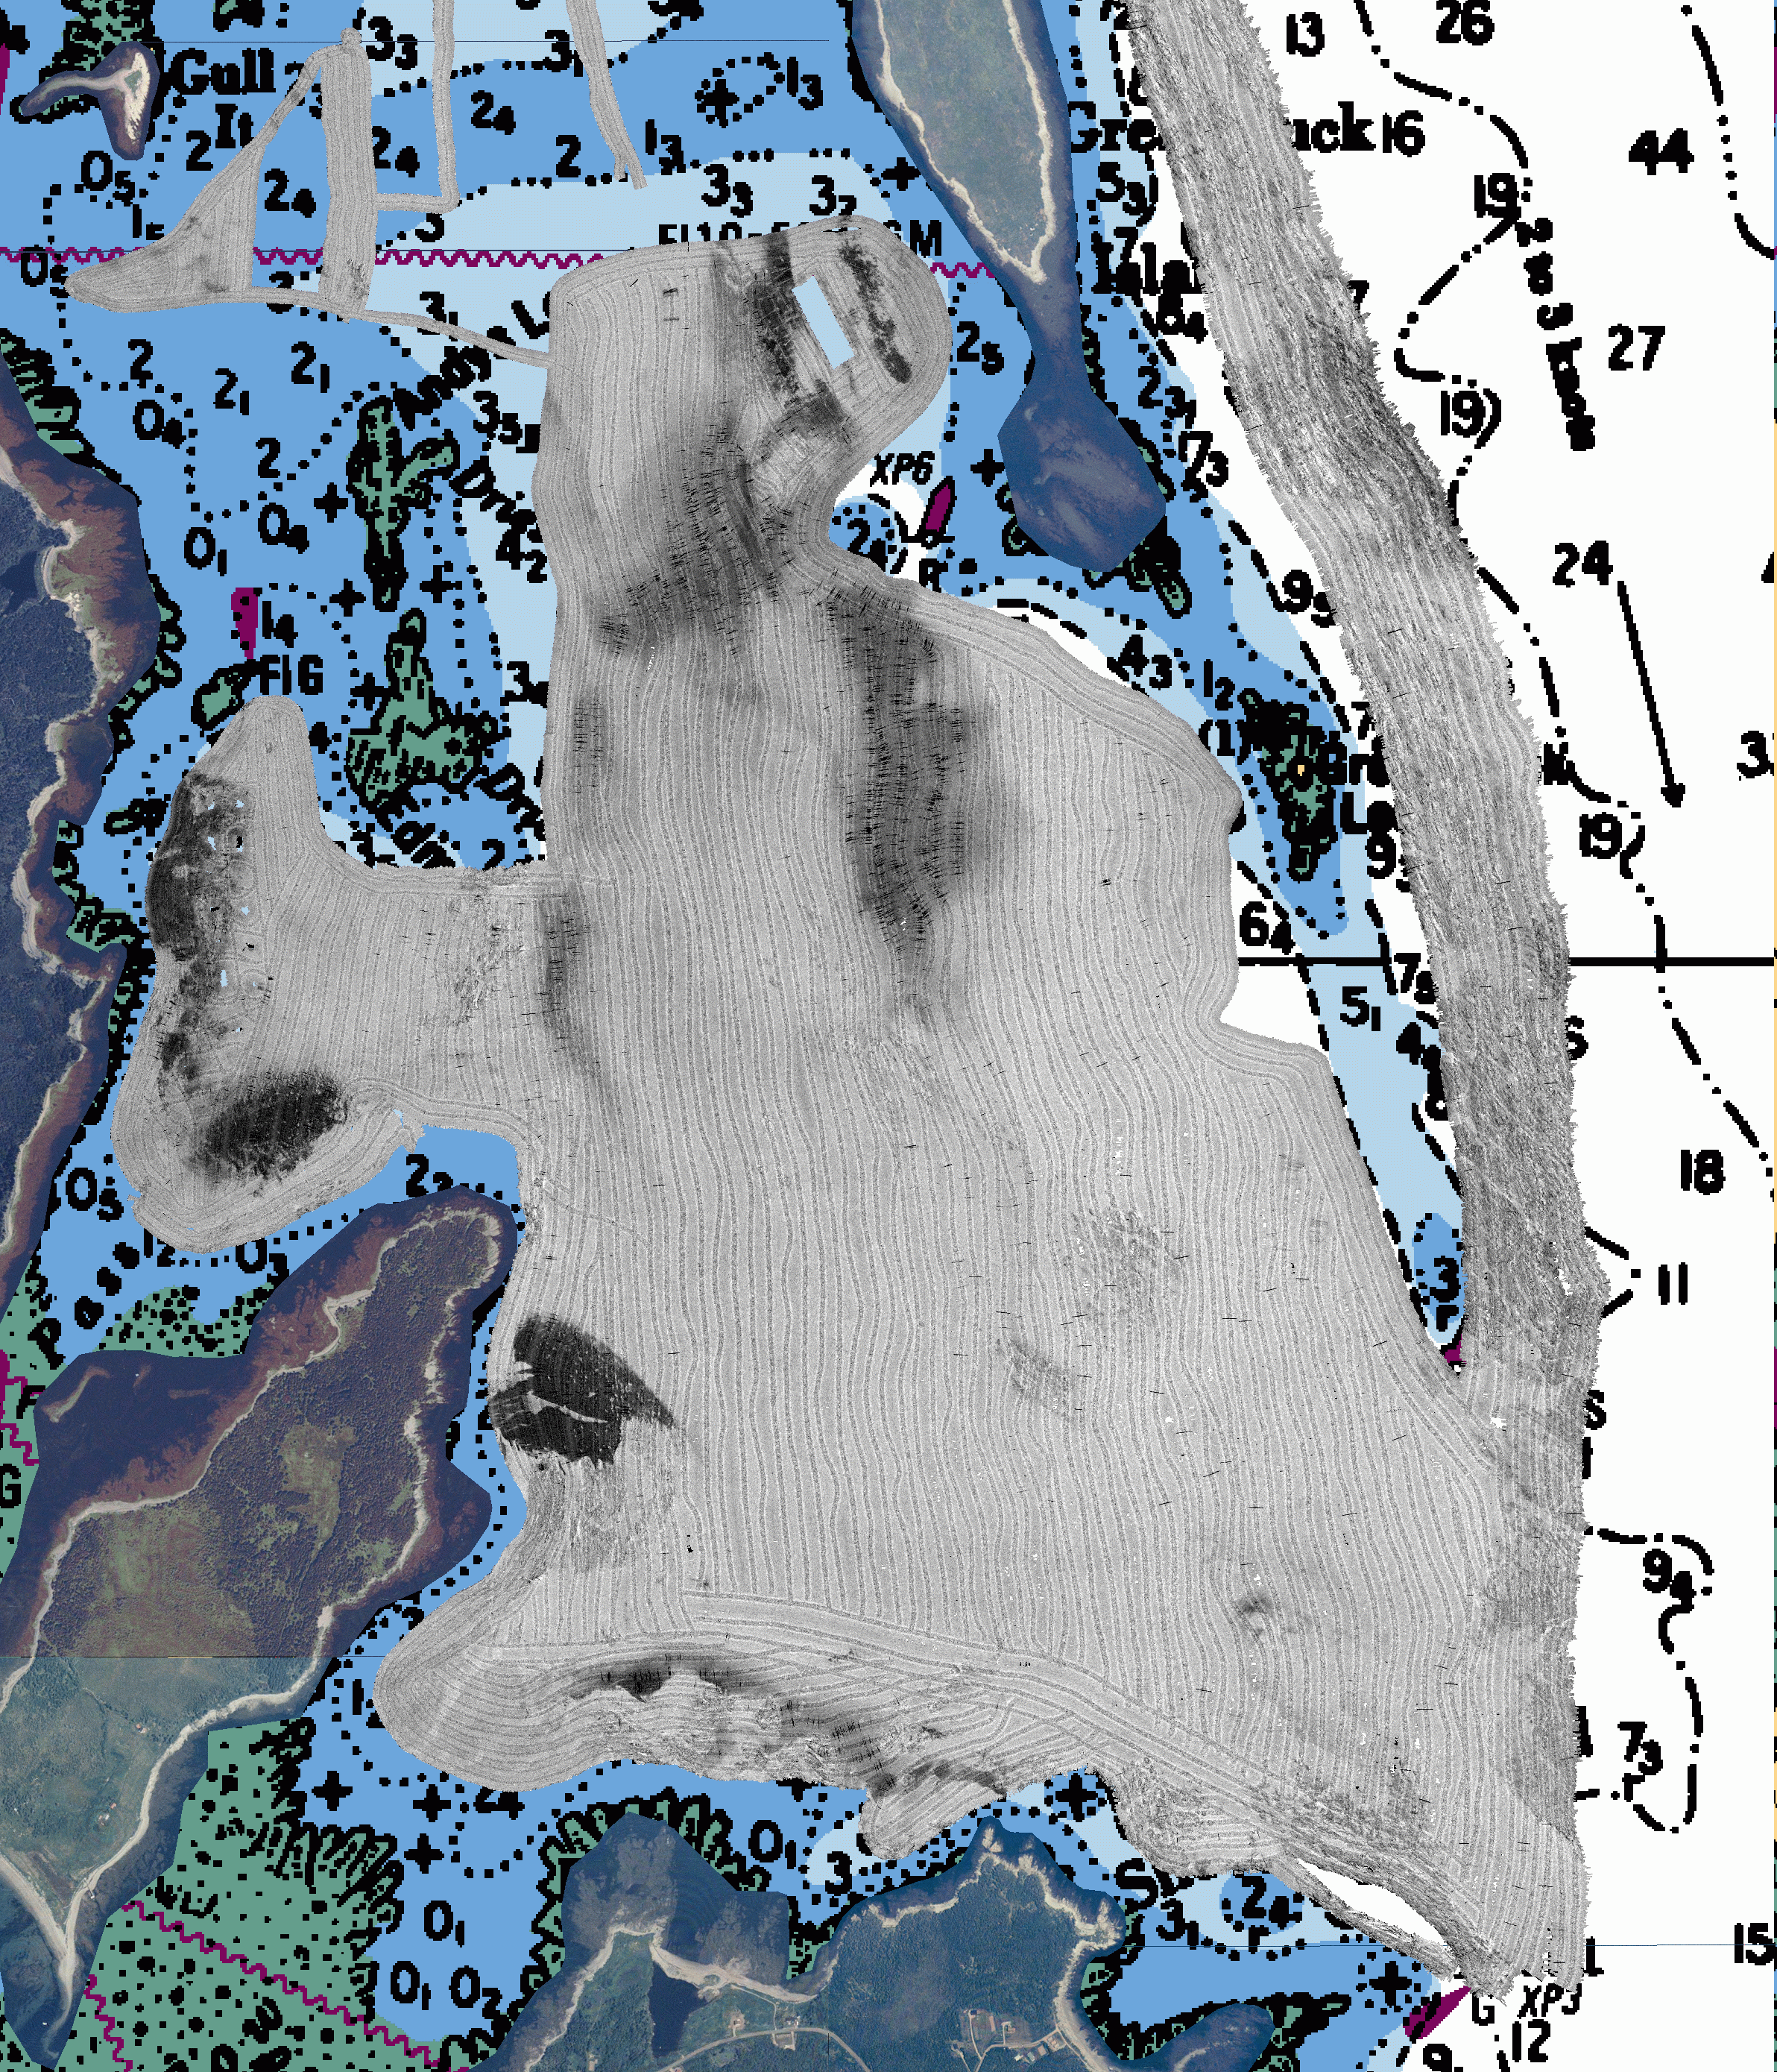
Figure 7. Processed bathymetry (A) and backscatter (B) for Duck Island Sound.
7.0 Log Summary

July 18, 2002
At the beginning of the day, a patch test was run within Flagg Cove. In the afternoon, surveying was conducted in Duck Island Sound. Data was unraveled and gridded onboard to ensure coverage was complete.

July 19, 2002
Surveying took place in Duck Island Sound. The sound velocity profile from July 18th was used, since there was no evidence of communication from the MVP. Attention was paid to the echosounder swaths to ensure that refraction wasn’t becoming a problem.

July 20, 2002
Surveying took place in Long Island Bay, with SVP from July 18. At the advice of Loren Fleet, the day was cut shore, due to weather concerns.

July 21, 2002
The day was spent tied up at dock, while a Brooke Ocean Technology technician repaired the SVP cable. It was found that the wire inside the cable was corroded and was, thus, cut back and reattached to the instrument. The SVP was tested and found to be working as normal.

July 22, 2002
Surveying continued as normal in Long Island Bay, in the morning, and in Duck Island Sound, in the afternoon.

July 23, 2002
Surveying started in the morning, in Duck Island Sound. Grounding occurred on Edmund’s Rock. The boat transited back to port and a diver was called to check the transducer face for damage. It was found to be fine, and surveying continued in the afternoon in Long Island Bay.

July 24, 2002
The day started early, surveying around Long Island Bay. After approximately an hour, the vessel transited back to North Head, where John Hughes Clark; Tracey Hawco, Research Projects Assistant; Linda O’Brien, Graduate Studies Secretary; and Kim Delorey, Secretary/Receptionist were picked up for a tour. Problems with the generator overheating and shutting off occurred. The diver was called back in and found that the filter was clogged with seaweed. After it was cleaned, surveying continued in the afternoon in Long Island Bay.

July 25, 2002
Surveying continued as normal in Duck Island Sound. Surveying occurred in and around the aquaculture sites.

July 26, 2002
Surveying as usual in Duck Island Sound and Long Island Bay.

July 27, 2002
Surveying off Northern Head. Problems occurred with the generator overheating and shutting off again. We traveled to Black Harbour, where Dale met us to fix the generator.

July 28, 2002
Surveying continued as normal off Northern Head.

Log sheets are included in Appendix D.

