How to export an ADCP Short-Tem Average (.STA) file to ASCII:
Open a file:
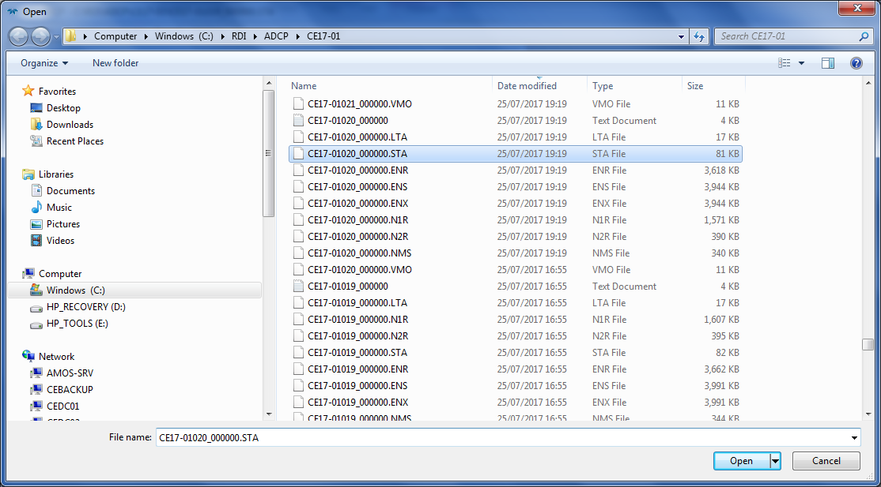
- Choose the STA
Make sure the data is being navigated using bottom track not navigation.
To check this, Right click in plot window, - choose Processing page and check that the Velocity Reference is “Bottom Track”. If it was the last time, it should continue to be for the next time.
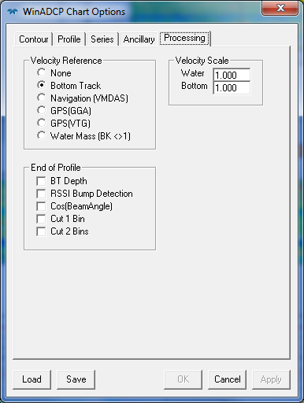
It is apparent if you look at the main plot:
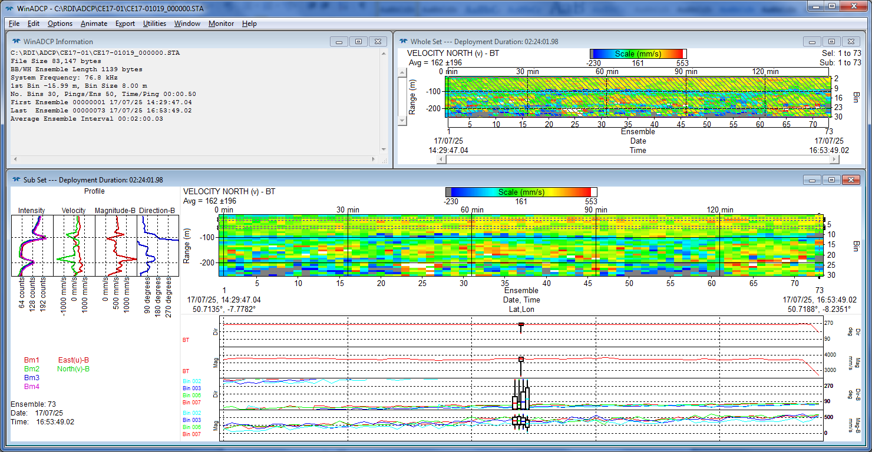
You can see in the lower right window, in its top left corner it says:
VELOCITY NORTH (M) – BT ---- BT means Bottom Track.
Press export.
Chose the tight hand tab – Series Ancillary
Choose the following boxes:
- File Type :
  - Txt (default)
- Bins:
  - All bins
- Series Data Types
  - All velocity
  - All correlation
  - All echo amplitude
  - All Percent Good
- Ancillary Data Types
  - All
- Bottom Track
  - All
- Navigation
  - All
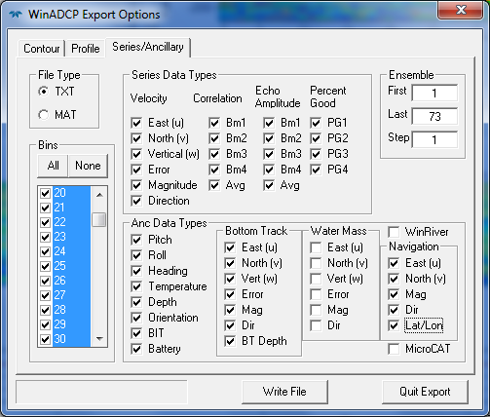

Then press write file and it will ask you for a name;
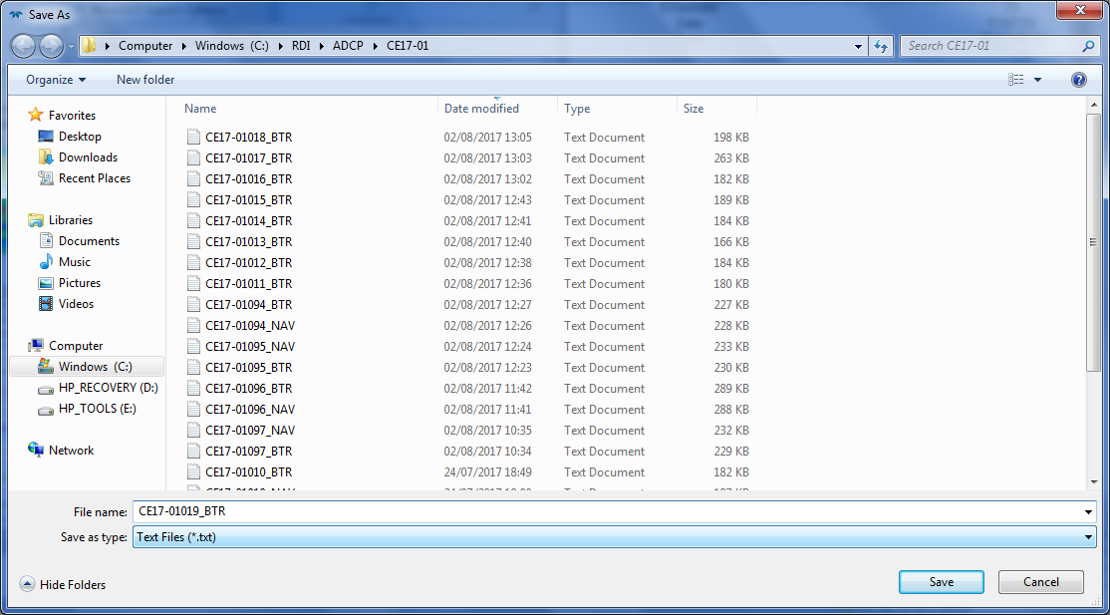
The name should be the same prefix followed by _BTR:

Repeat after every line is close (and the next one is logging) in VMDAS

